Easter Joy

To all supporters

Could there be a better way to celebrate Easter than to give a child back his sight ? Well, maybe there could be actually: how about giving two children back their sight , both from the same family – and their Mum too !

This is exactly what happened a few days ago in Mtumthama. Our surgeon , Amos Nyaka , found the family of blind children all suffering from unusual congenital cataracts . These could be treated, but in a delicate operation, requiring a trip to Blantyre. Through the generosity of Medic Malawi donors , that trip was paid for, and arranged by St Andrew’s Hospital , including a driver and transport for the long and arduous journey.

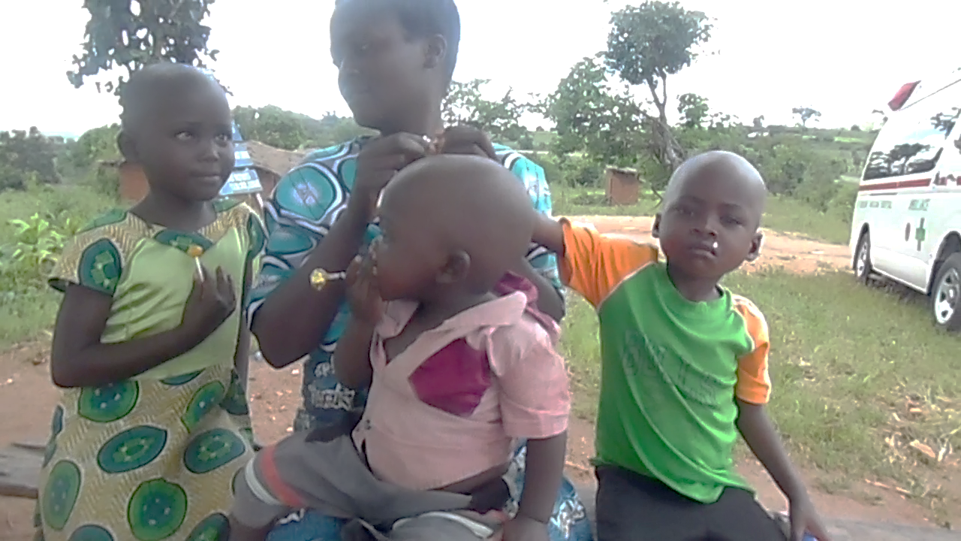

Idesi Jaziyele with Isa, her two year old, Charity (5 years) and Chawinga (8)

Their mother , Idesi , and Charity and Chawinga were all successfully operated upon, regaining 96% of vision. Sadly little Isa, also blind, was too young for surgery , but we will make sure that he is treated and cured of blindness as soon as he is old enough .

So that’s one very Happy Easter folks !

Microloans

As we help to build the future of the community , it has been great to introduce a scheme of microloans to enable people to set up small businesses. These loans are not just dished out. There is an application and training process , and candidates have to produce an Apprentice style Business plan. Unlike the Apprentice however, most are not fired and there are many many winners. About 80 families are being helped, organised into a community of borrowers, with the progress of their ventures monitored by Gilbert Phiri, a young man from AMAO who has accountancy training but has not yet been able to secure a permanent job.

This picture shows a training meeting, led by our outstanding administrator , Chris Zambira , who I thank for being the driving force of the scheme. Many of you will know the lady in the front row in the colourful yellow dress – Elizabeth – the marvellous lady who runs AMAO. She remains at the orphanage and we certainly wish her well with her business venture.

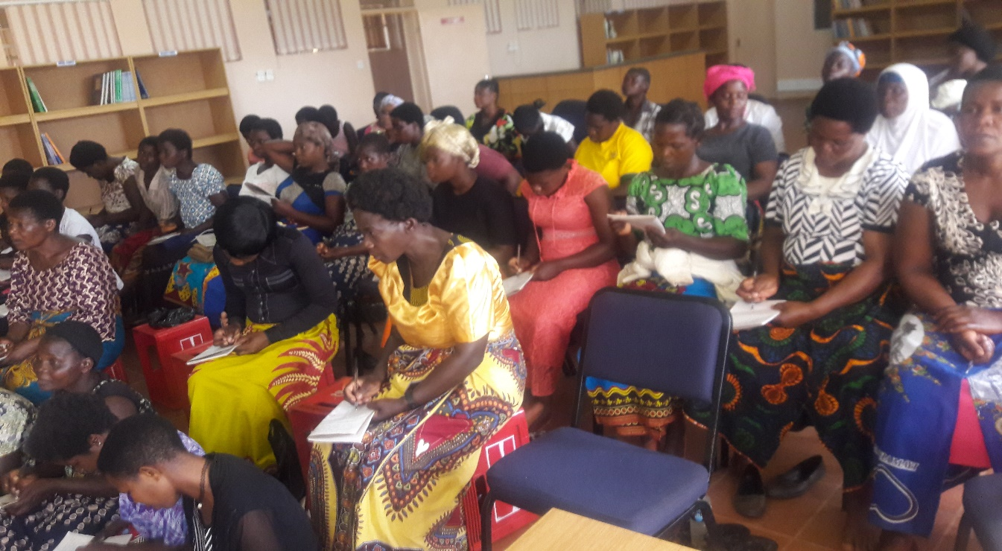
Elizabeth and others concentrate hard !

NRU

The Nutrition Rehabilitation Unit, the NRU, is a vital feature which Medic Malawi helps St Andrew’s hospital to offer. So many illnesses which present at the hospital , especially at this time of year (the ‘Hungry Season’ , waiting for new crops) , are actually the result of malnutrition. Peter Minjale , our long serving Clinician , once told me that we were probably the only place in Malawi where the medic could say “I will help the symptoms, and then you need to go just 50 yards over there where the nurses in the NRU will treat the causes”.
The NRU has a garden which produces vegetables for sale , and also helps to train visitors in good husbandry. And we have re-started the outreach education programme, where a nurse and our gardener, Brickson Phiri, follow the hungry back to their villages to check on their welfare, and to teach growing techniques in situ.

Data Thingies

You will have heard all about the data protection changes, which mean that we , in common with everyone else, need your consent to keep emailing you our stuff. The next email (please don’t to confirm this time-: it will confuse us!) will be about that, and it will have a very quick and easy reply to confirm you want to continue to hear the wonderful positive news from Mtunthama ,
where every penny is reaching those who need it,
where we are dealing with individuals, helping them to build their future
and where there is so much heart warming, uplifting good news for Easter and for the whole year .

Thank you for all your interest and support , and Happy Easter !

Peter and Stephen

