Brokenshire 'looking seriously' at giving 'greater weight' to neighbourhood plans
21 February 2019 by Mark Wilding
Housing secretary James Brokenshire has said he is looking "seriously and thoughtfully" at how neighbourhood plans can be given "greater weight" in the planning system.
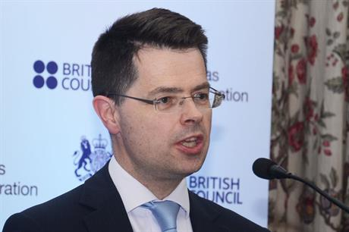
Housing secretary James Brokenshire
Speaking this morning at an event organised by the Onward think tank and social enterprise Create Streets looking at the role of housing and planning in creating "attractive places", Brokenshire said: "I believe in neighbourhood planning. I am reflecting carefully on how we can make it better and stronger," he said.
"I get the frustration I hear when sometimes a development may take place that is at odds with a neighbourhood plan that’s been put in place," he said.
After the speech, one audience member questioned the minister's commitment to neighbourhood planning.
Brokenshire replied that it was right to consider "how we can give greater weight to neighbourhood plans" and examine their relationship with local plans.
"I hear that and am looking seriously and thoughtfully at what we can do to strengthen that," he said.
"In no way think that I’m not committed to neighbourhood plans. Certainly, their time is still very much here. Take that straight from me."
Elsewhere, the minister said that "the biggest challenge confronting us is our housing market" and that his department was focused on "the B-word. Not Brexit, but beauty."
"Housing can’t just be a numbers game," he said. "We’re in the business of building communities not units."
Brokenshire said he was also committed to ensuring "we have a strong planning system" with planners who can demonstrate "capability as well as capacity".
Building high quality places will reply on a "strong cadre of professionals to do the work," he said.
Last week, chief planner Steve Quartermain said that the government has been listening to industry concerns over the shortage of planners and is to commission research into the issue.
The housing secretary also said the government and councils needed to work harder to make better use of public land.
"Unlocking public sector land is something we have sought to do over a number of years and haven’t been good enough in my view," he said. "We need to push ourselves more."
Last week, planning minister Kit Malthouse said that developers need to acknowledge the need for good design and factor it into their financial appraisals for new schemes.
Earlier this month, the chair of the Town and Country Planning Association and two planners were announced among the commissioners and advisers that have been appointed to the government's new task force aiming to boost the design quality of new developments.

