Contents
This Directory brings together; contemporary photographs of non-listed buildings within Wing in Rutland, comprising photographs of their settings, frontages and where appropriate important detailing, together with archive photography where available, and an ‘Author’s Commentary’ where it is thought necessary to add some detail which is considered relevant to the building’s architecture or its historical significance. There is also an indicator where buildings are believed to be ‘Local Heritage Assets’ and thereby supplemental to the Directory of Wing Listed Buildings also compiled in 2019.
David Seviour 2019
  Wing Village: A Directory of Non-Listed Buildings | 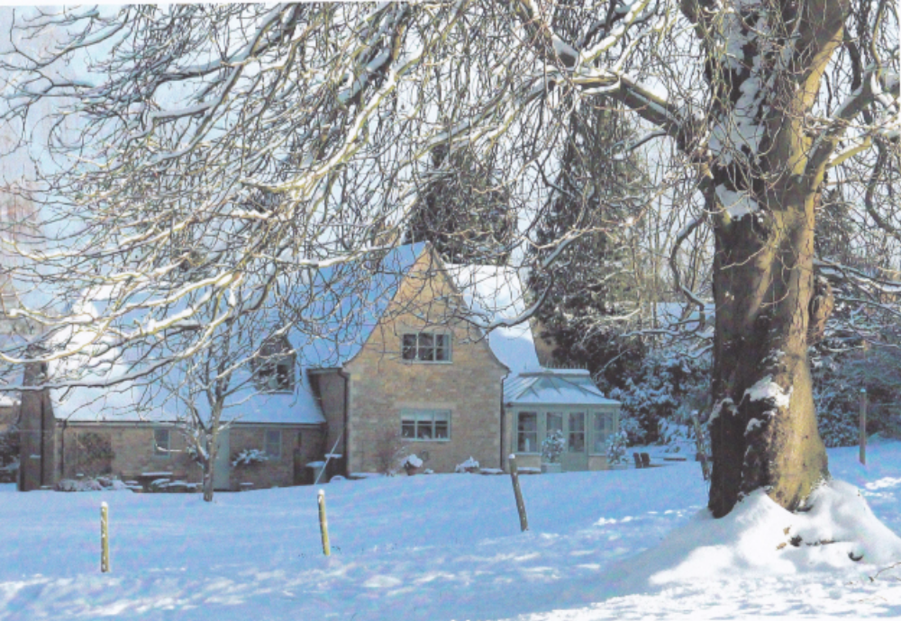

Page ………………………………….3 – 6 Introduction
Page ………………………………….6 – 24 Wing Hill, Reeves Lane & Westhorpe Close
Page ………………………………….25 – 48 Top Street
Page ………………………………….48 – 56 Morcott Road
Page ………………………………….56 – 59 Glaston Road
Page ………………………………….59 – 62 Mill Close
Page ………………………………….62 – 78 Church Street
Page ………………………………….78 – 81 Bottom Street
Page ………………………………….81 – 92 Middle Street
Page ………………………………….92 – 98 The Jetty
Page ………………………………….98 – 107 Preston Road & Station Road
Page ………………………………….107 – 108 Conclusions
Page ………………………………….108 – 111 Sources, Footnotes & Appendices

Wing Neighbourhood Plan Steering Group
Housing Policy Group
Non-Listed Buildings/Structures in Wing
Purpose
This paper seeks to set out a consolidated and readily accessible reference index of Non-Listed buildings and structures within the Parish of Wing and to further provide images of same together with supplementary detailing imagery as a contribution to the development of a Wing Village design statement and Design Guide.
This paper also constitutes a companion Directory to ‘Wing Village: A Directory of Listed Buildings’, (David Seviour 2019) and is part of a series of documents; ‘A History of Wing Village And Its setting 1066 – 2018’, ‘Wing Village: A Walk Through History’ and ‘3,3a,and 3b Top Street, Wing, formerly and chronologically; The Red Lion Inn, The Noel Arms and The Cuckoo Inn: Summary of the property transactional history’, produced by the same author in 2018/2019.
Introduction
There are 140 separate residential hereditaments within Wing Parish of which there are 30 separate Historic England National Heritage ‘Listings’, covering 35 buildings and structures within the Parish boundaries. These latter buildings are clustered, but not exclusively so, within the Conservation Area Boundary which is primarily drawn around the old village settlement of Top Street, Reeves Lane, Church Street, Middle Street and Bottom Street. See hatched line on map at Appendix I.
The boundary of the village for new development purposes is larger than the Conservation Area Boundary and much smaller than the Parish Boundaries. See hard line on map at Appendix I and Appendix II. This development boundary also excludes the residential settlements located within the Parish Boundaries at Station Road, Preston Road, and Glenbervie Farm, albeit that these settlements are within the agreed boundary of the Neighbourhood Plan which is coterminous with the Parish Boundary, Appendix II.
From the perspective of a Wing Neighbourhood Plan there are two key considerations in relation to the presence of Listed Buildings and the Conservation Area:
- The Planning (Listed Buildings and Conservation Areas) Act 1990 which states at Section 66; “In considering whether to grant planning permission for development which affects a listed building or its setting, the local planning authority or, as the case may be, the Secretary of State shall have special regard to the desirability of preserving the building or its setting or any features of special interest which it possesses.”
- The National Planning Policy Framework, May 2012, states at Section 12 how emphasis should be placed on the significance of heritage assets or their setting and defines these terms at Annex 2 as follows; “The value of a heritage asset to this and future generations because of its heritage interest. That interest may be archaeological, architectural, artistic or historic. Significance derives not only from a heritage asset’s physical presence, but also from its setting.”
Hence, given the unusually high number of Listed Heritage Assets within the defined village envelope for development purposes and the existence of Listed Buildings/structures within the Parish Boundary but outside of the Conservation Area Boundary, it could be argued that the broader village “setting” and its treatment is crucial to the protection of those assets and not just the treatment of the Conservation Area as currently defined.
In addition, there are a significant number of Non-Listed buildings, or parts of buildings, dated to the 18th, 19th, and early 20th Centuries which could be viewed as ‘Heritage Assets’ and in some cases were clearly missed during a rapid and incomplete ‘Listings sweep’ of the village by the local authority in 1984 as it sought to play catch up with concerned legislative requirements.
It could also be argued that any village Design Statement pursuant to a Neighbourhood Plan, whilst demonstrably acknowledging the eclectic mix of late twentieth century and early twenty-first century architectural designs within the village envelope, nevertheless, should be predicated by the prevalent features of the Listed Buildings and the features of locally determined heritage assets.
Consequently, it is crucial for the Neighbourhood Plan not only to be fully cognisant of the numbers, locations and settings of the Listed Buildings and their perceived Heritage Listed value together with accurate visual records of these buildings, settings, construction materials, and detailing, but also to have an equivalent record of the other Non-Listed buildings impacting those settings.
Such clear record of heritage assets and their contemporary settings needs to predicate both any village Design Statement and any neighbourhood planning policies which might relate to; sites chosen for any new developments, the nature of such new developments, the conversion of existing non-residential buildings into homes, the potential conversion of existing larger houses into apartments, and the demolition of existing houses and the increased density of such new buildings on those plots, together with some aspects of extensions and property alterations over time.
It should be noted that neither of the two Directories deal with internal design, nor with the ecological benefits/disbenefits of insulation, heating or other services falling within the purview of Building Regulations and related design codes.
Information
What follows below is a photographic record of Non-Listed Buildings and their immediate settings. This should be used in tandem with the contents of the Wing Listed Buildings Directory to inform the compilation of a Wing Village Design Guide and thereby establish the notion of empathetic design in relation to any proposals that materially impact the existing built environment of the village through changes to street scenes/settings. It should also be used, in similar fashion, to predicate the proposed insertion of any new buildings within or adjacent to the existing built environment.
Such approach is wholly consistent with the views of residents and as reflected in the ‘Housing Policy Statement’ formulated from the results of the Wing Neighbourhood Plan Village Questionnaire for use in the Neighbourhood Plan referendum:
“Any developments must protect historic sites, open spaces and views within and around the village of Wing, and must not damage the environment but, instead, lead to improvements in the natural environment. The following sites must be protected:
• The Maze
• Village Playing Field
• Allotments
• Churchyard
• Green verges / banks alongside the streets
• Fields within and outside of the village
Any developments must be cognisant of the architectural heritage within the village and sustain the tradition in terms of appearance, spacing and design. However, there is some support for moderate contemporary design that is sympathetic to the paradigm.” Jon Roberts’ Report 10/3/2019 to Housing Policy Group, and NP Steering Group Approval, 27/3/2019.
The methodology adopted for the photography is to set out contemporary (2019) photographs for each Non-Listed building or structure showing its ‘setting/street scene’, its ‘full frontage’, and if appropriate a close up showing an item of particular ‘architectural or historical detail’. Where the building or structure has been the subject of available early photography then a further photograph has been provided for ‘historical setting’. There is an ‘Author’s Note/Commentary’ each of the photographs.

Access to Wing from the west – junction at Wing Hill, Top Street, Reeves Lane.
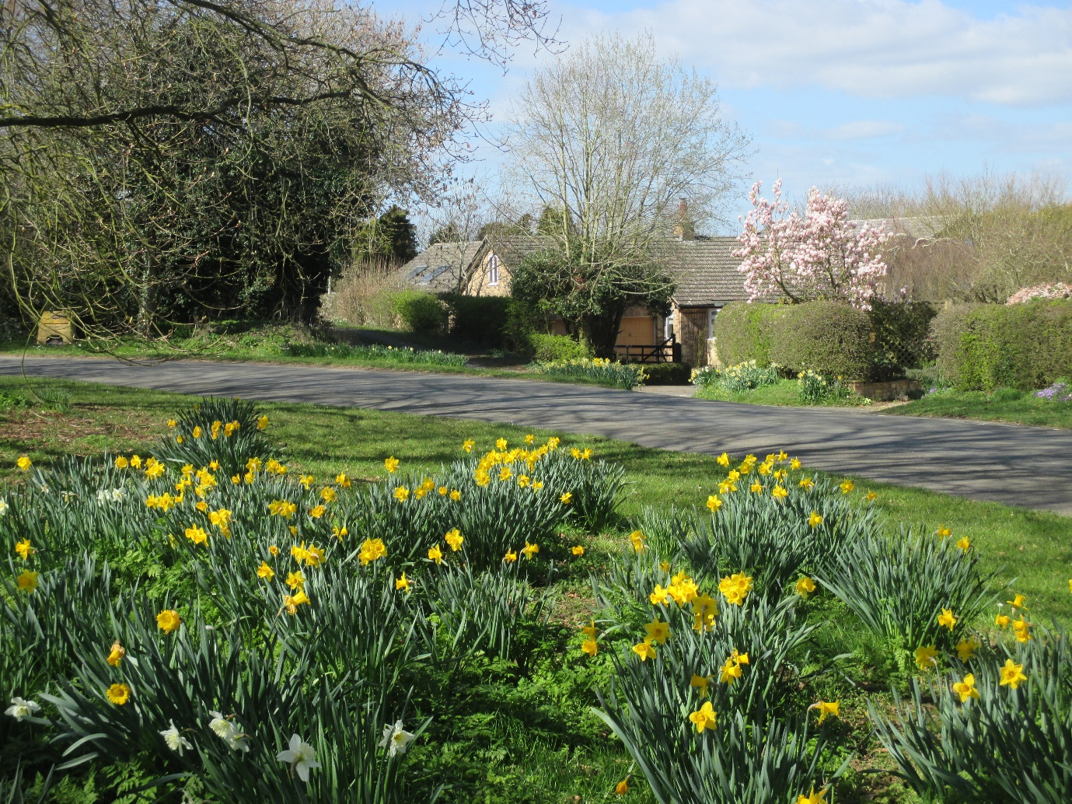

Wing Hall accessed from Wing Hill
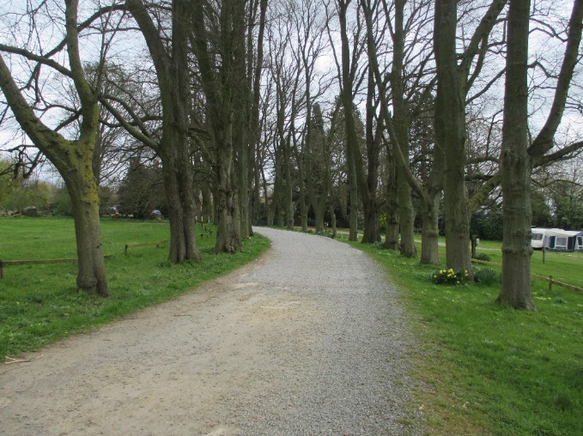
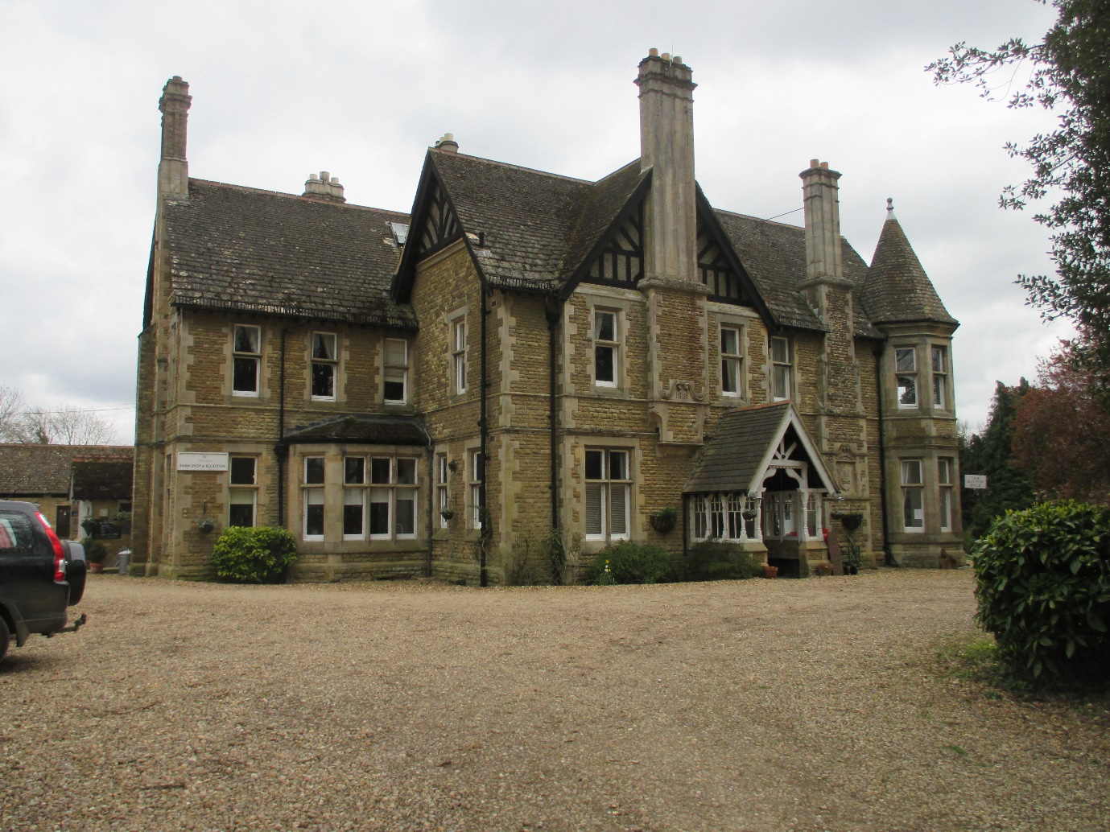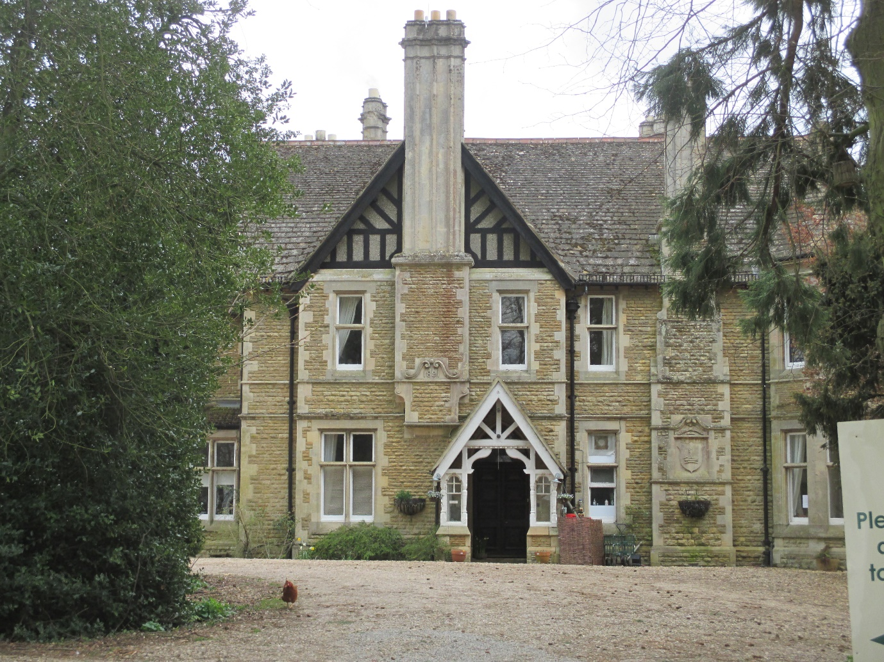
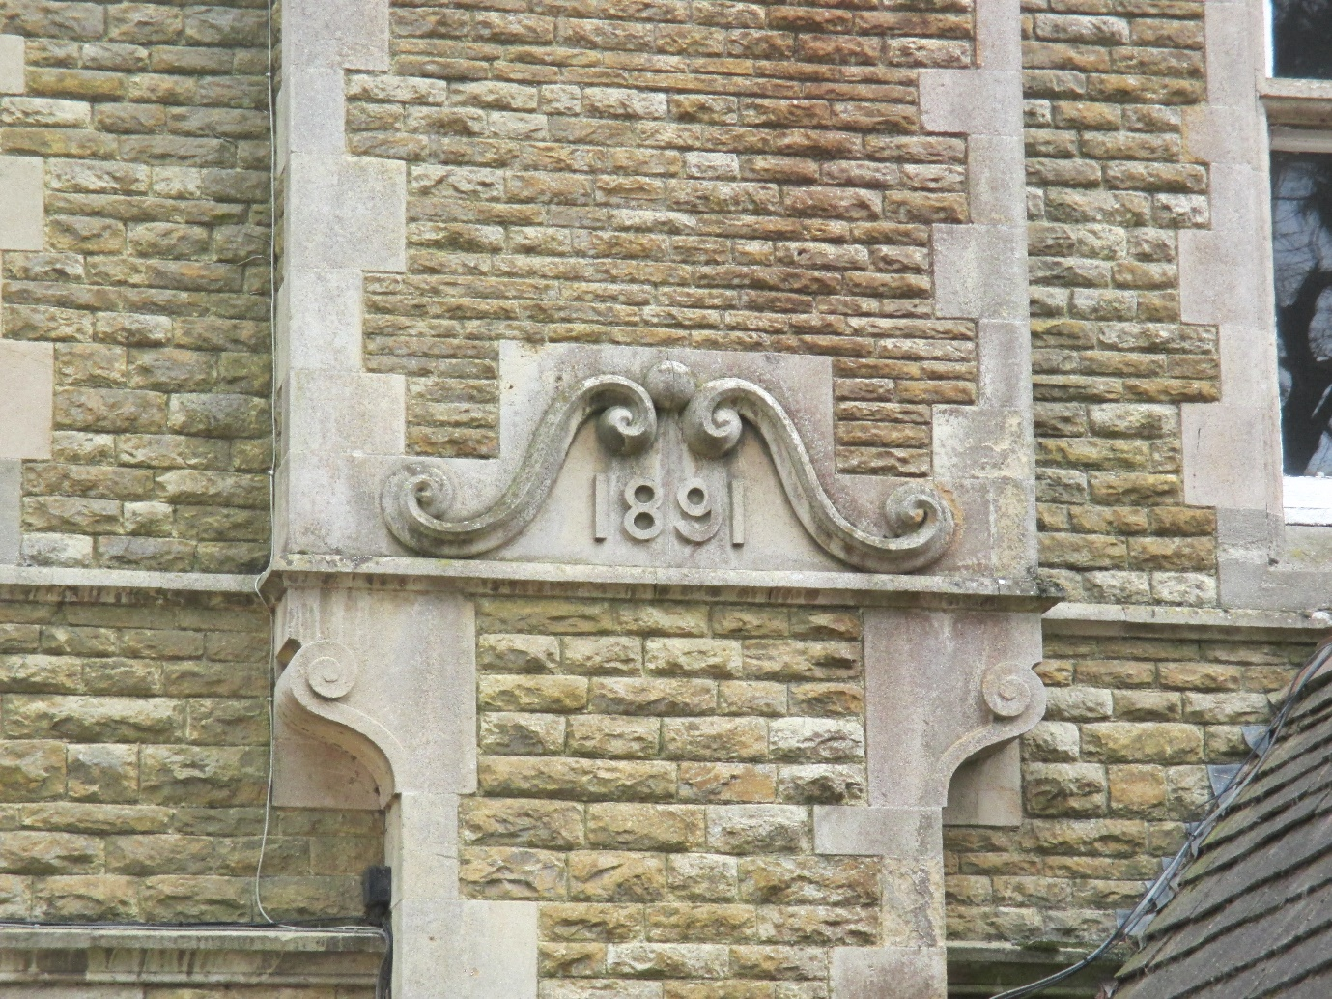
Author’s Property Notes
Old Wing Hall, accessed off Top Street, which is Listed, was built by George Wyatt Worrall in the 1880’s incorporating cottages along the Middle Street frontage dating to the 1770’s and ownership by the William Sheild family dynasty who were based at Cedar House (also Listed), whereas George’s brother, Edward Worrall, built the new Hall (above) on the opposite side of Top Street in 1891 and it is unlisted.
The western approach to Wing is environmentally predicated by open views of some distance to the west, the new Hall’s tree-lined green entrance fields on the eastern side of Wing Hill, and the Listed wall running along the north side of Top Street from Reeves Lane to Middle Street.
The whole of this environmental ‘entrance’ to the village from the west deserves protection.
Reeves Lane
Reeves Lane hosts an eclectic mix of homes and architecture, facilitated by somewhat relaxed conservation planning laws throughout the 1960’s, 70’s and the beginning of the 80’s, together with the successive development of land on its western side once in the single ownership of the occupants of Westcott House (a Listed building). Four new homes were created south of those at Westcott and Stonehouse. Two of these sit inside the Conservation Area. This was matched by an equally eclectic mix of architectural styles on the Lane’s eastern side, land originally in the ownership of the Sheild family estate and encompassing Paradise Lane which was extinguished with the division of land into eight new-build plots from Top Street to the newly created Westhorpe Close in its southern half and all outside the Conservation Area. Infill extensions/conversions and newbuild, account for four homes, including the original Westhorpe Farmhouse, in its northern half, all inside the C. A.
Top (southern end) of Reeves Lane at Junction with Top Street
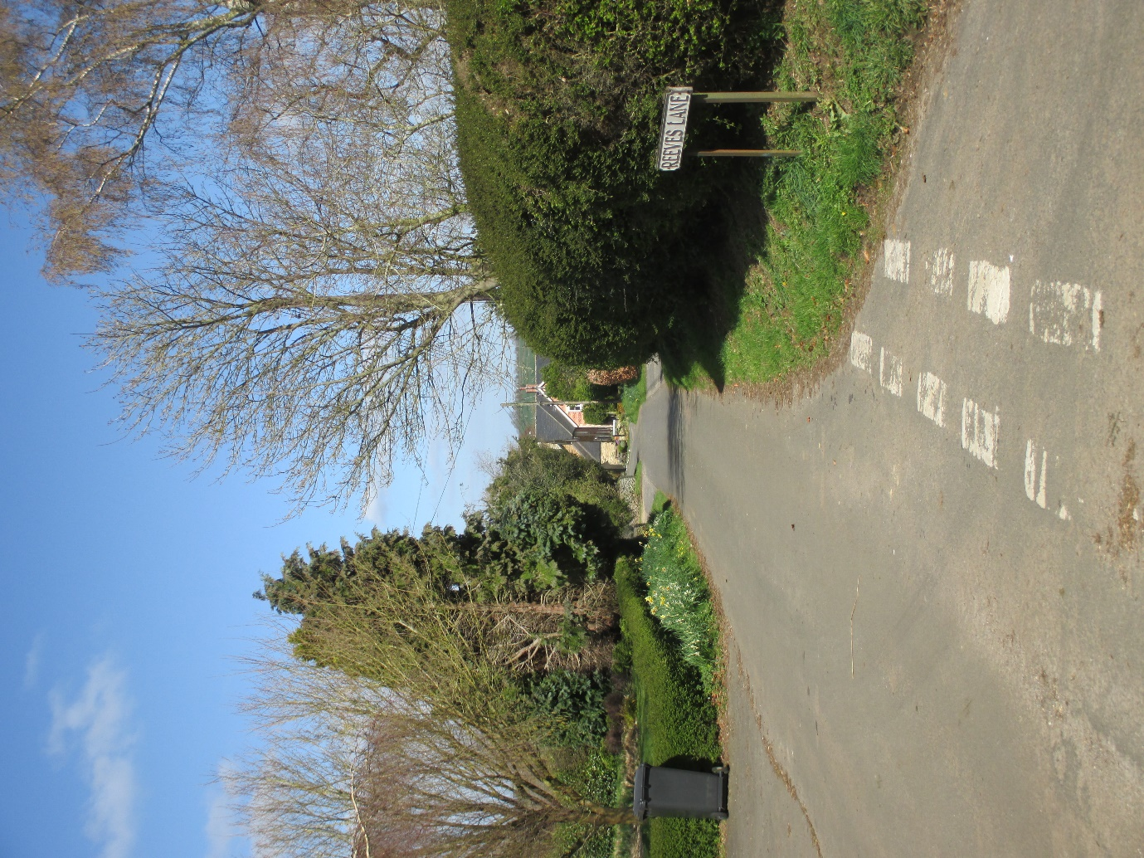
10 Reeves Lane.
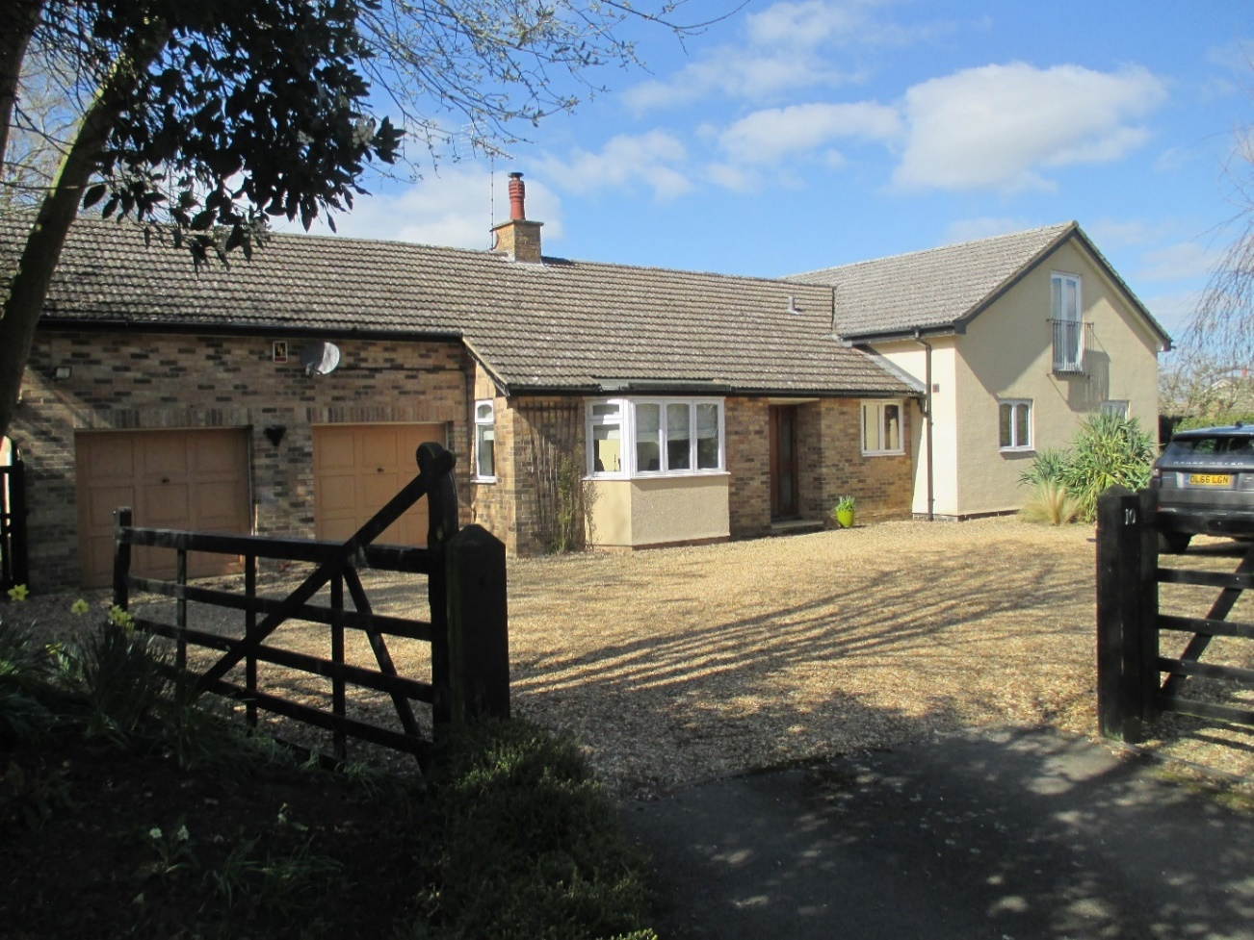
First property on left from southern end junction with Top Street. Bungalow with modern two storey and single storey extensions; flat concrete roof tiles, brick and rendered sections, originally built in the 1970’s with later additions, probably in two stages. It sits outside the C.A.
8A Reeves Lane
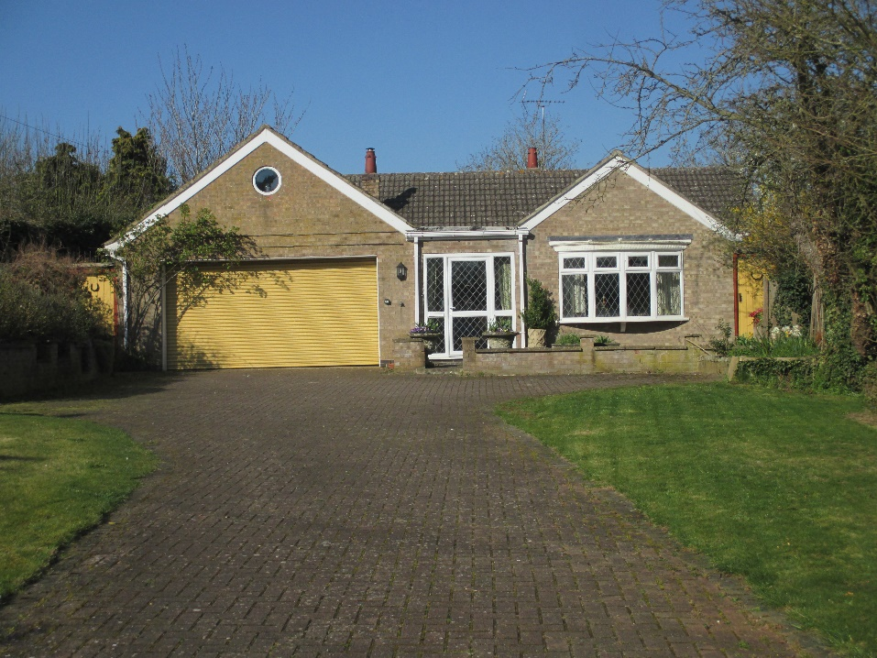
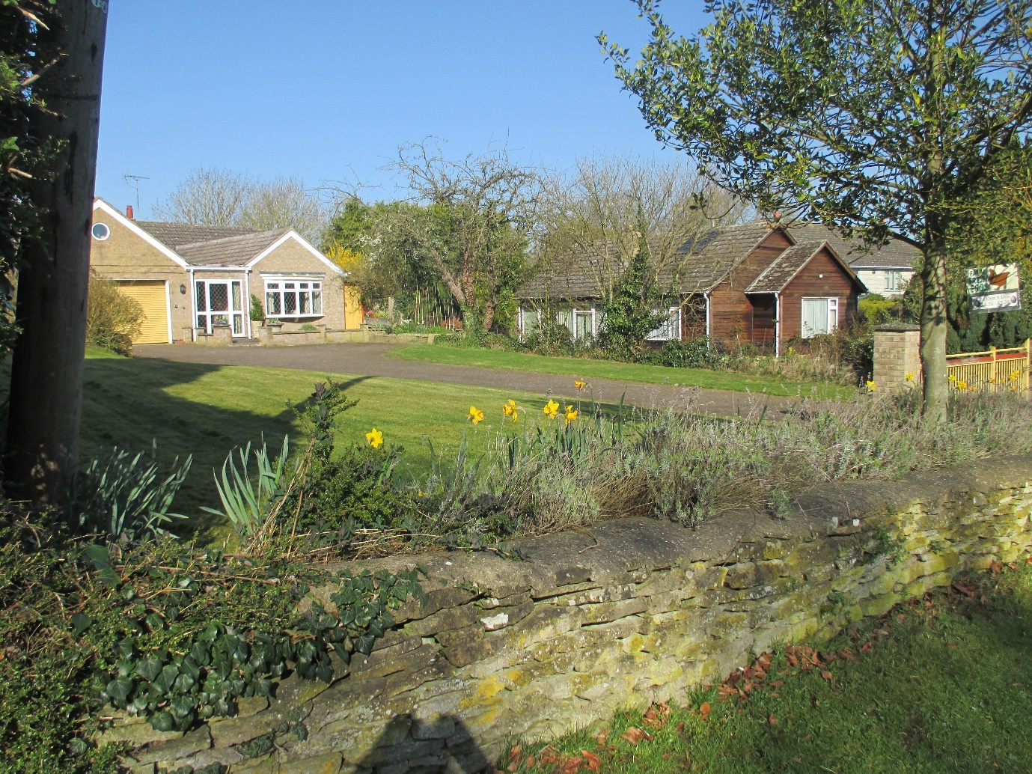
The second property on the left is a relatively large bungalow with a large frontage plot and land at the rear containing barns primarily accessed off a ‘green’ lane, close to the Top Street junction and running along the southern boundary of 10 Reeves Lane.
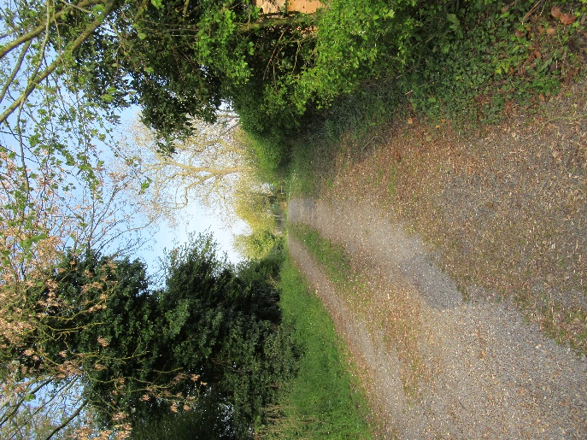

This lane is in the ownership of the Parish Council, providing access to the village Allotments (formerly it’s local roadstone pit) from its southern side and was conveyed to the village in an Enclosure Act of 1772, such Act also guaranteeing access to adjoining land for “agricultural”, and one presumes associated usage. The barns and land, on the lane’s northern side, have been used for poultry houses and egg production.
Built in the 1970’s, the property has sandstone coloured brick and flat inter-locking concrete tiles applied to the roof. Other than the brick colour there are no architectural concessions to other village architecture. The property sits just outside the Conservation Area.

8 Reeves Lane

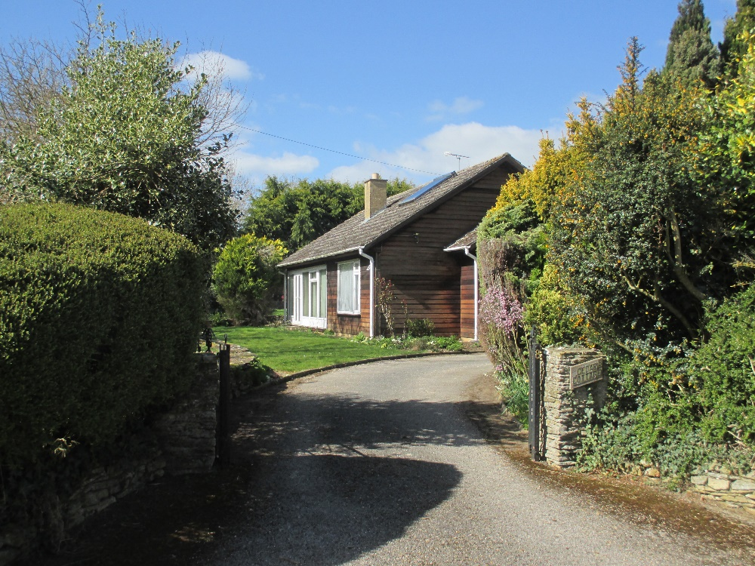

Third property on left from Top Street junction, Scandinavian style timber clad bungalow, flat concrete tiles to pitched roof which has weathered sufficiently to suggest a shingle roof. Built in the 1970’s it sits outside the C.A. The only architectural reference point within the village are the ‘Swedish’ houses on Morcott Road (see below).

7 Reeves Lane
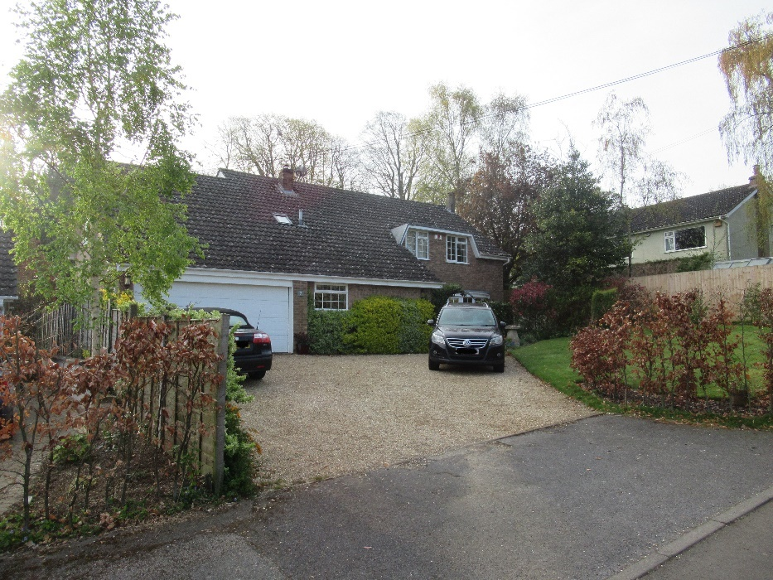
First property on right from Top Street, built in 1973 outside the C.A., and extended over its garage in 2010, creating extensive plain roofscape at eye level. It is two storeyed and constructed with sand coloured brick, interlocking concrete tiles, a flat roofed dormer and wooden framed fenestration, the principle ground-floor window being bowed with wooden kneelers.
5 Reeves Lane
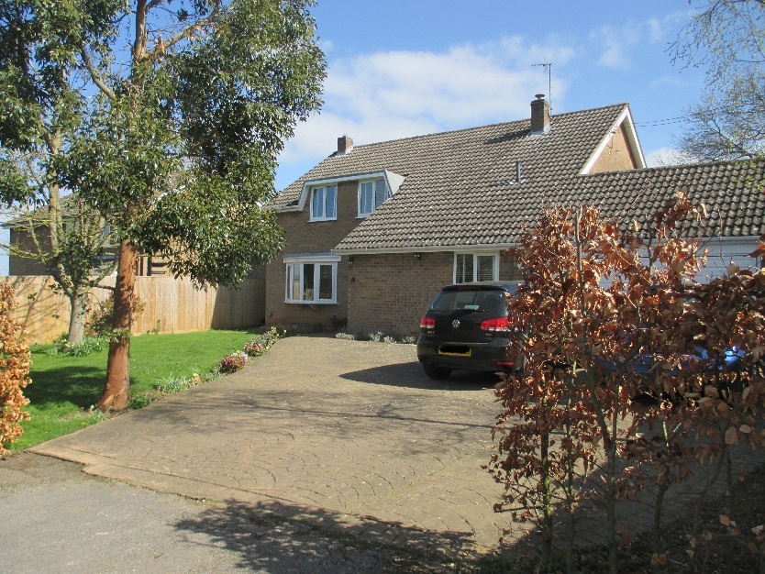
Second property on right from Top Street, built 1973 outside the C.A., two storey, sandstone coloured brick and interlocking concrete roof tiles, with timber window frames, and modern 70% chamfered dormer windows to first floor with flat upper edge and curved bay on wooden kneelers to ground floor. Integral garage creating extensive plain roofscape at eye level.
1 Westhorpe Close
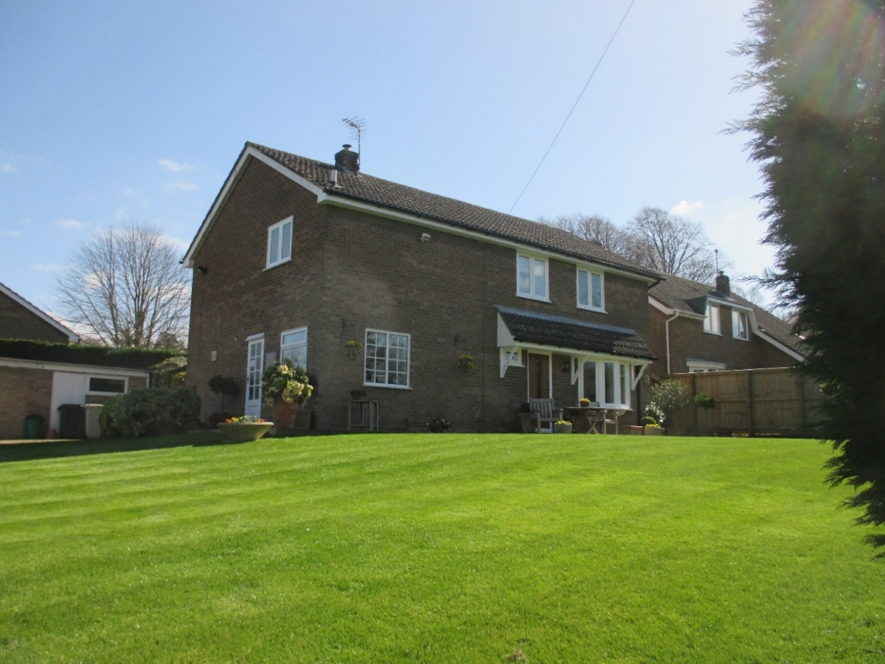
Built in 1973 outside the C.A., on corner plot between Reeves Lane and Westhorpe Close, sand coloured brick with concrete tiled roof and a frontage facing west towards Reeves Lane but vehicular and main pedestrian access off northern elevation facing towards Westhorpe Close (below). Front door with extended canopy over curved bay on wooden kneelers. Detached garage and open plan landscape.
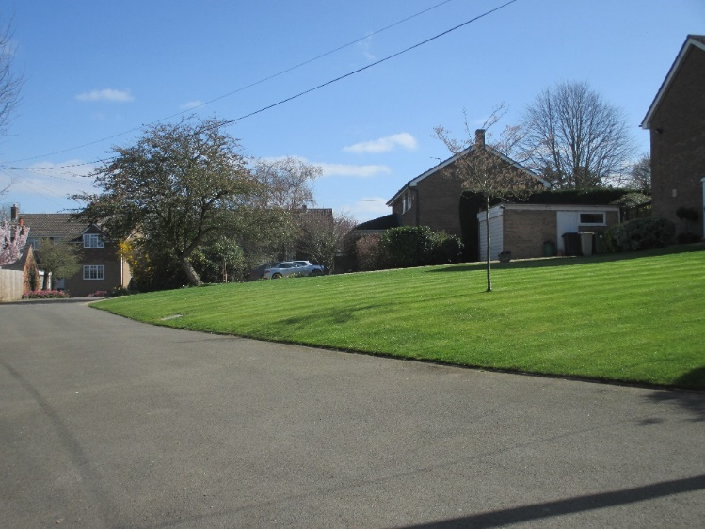
2 Westhorpe Close
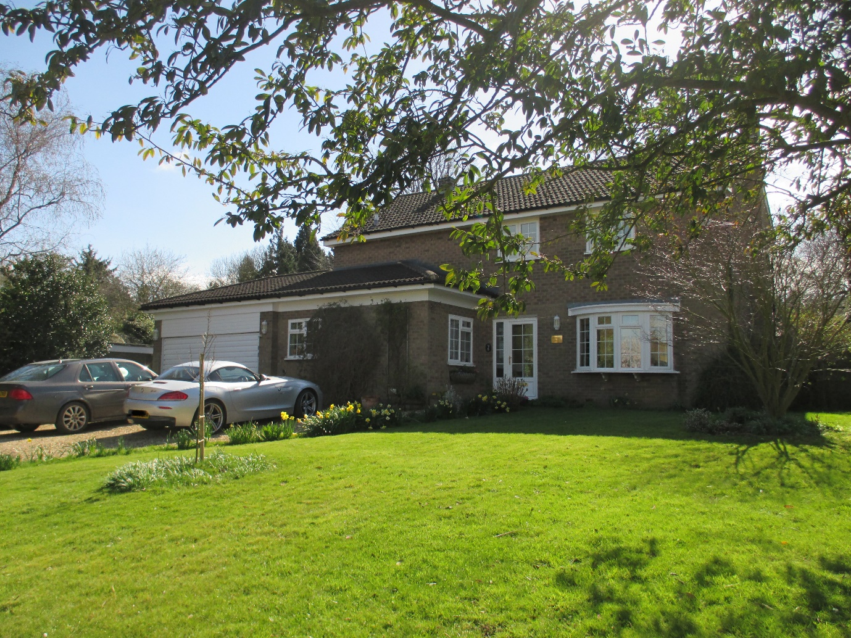
Built in 1973, outside C.A., brick with concrete tiles, and attached garage but with differentiated frontage reducing visual impact of both roof tile and brick expanse. Curved bay to ground floor on wooden kneelers.
3 Westhorpe Close
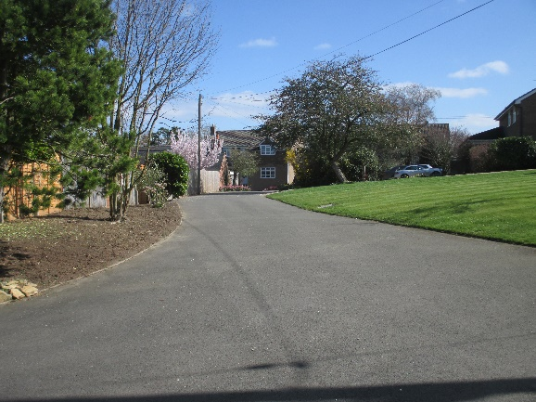
Secreted in the eastern right hand corner of the Close and built in 1973, outside C.A., this property and its neighbour, at number 4 Westhorpe Close, straddle the old building lines of Paradise Lane, adjacent to the remaining agricultural field (now part of Wing Lodge in Middle Street) once part of the Cedar House Sheild estate and the former peripheral buildings once part of Westhorpe Farm. Constructed in sand coloured brick and concrete roof tiles it has the same general characteristics of all the properties constructed in Westhorpe Close in 1973.
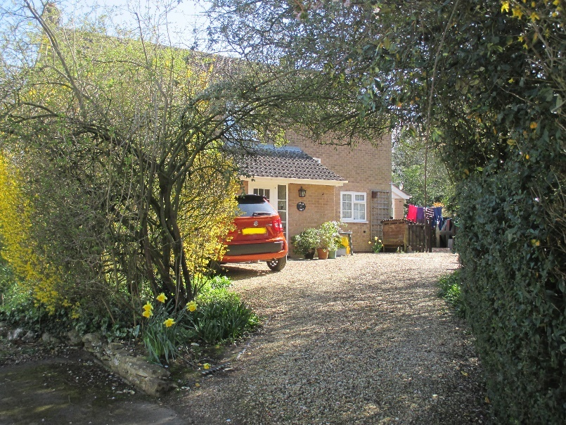
4 Westhorpe Close
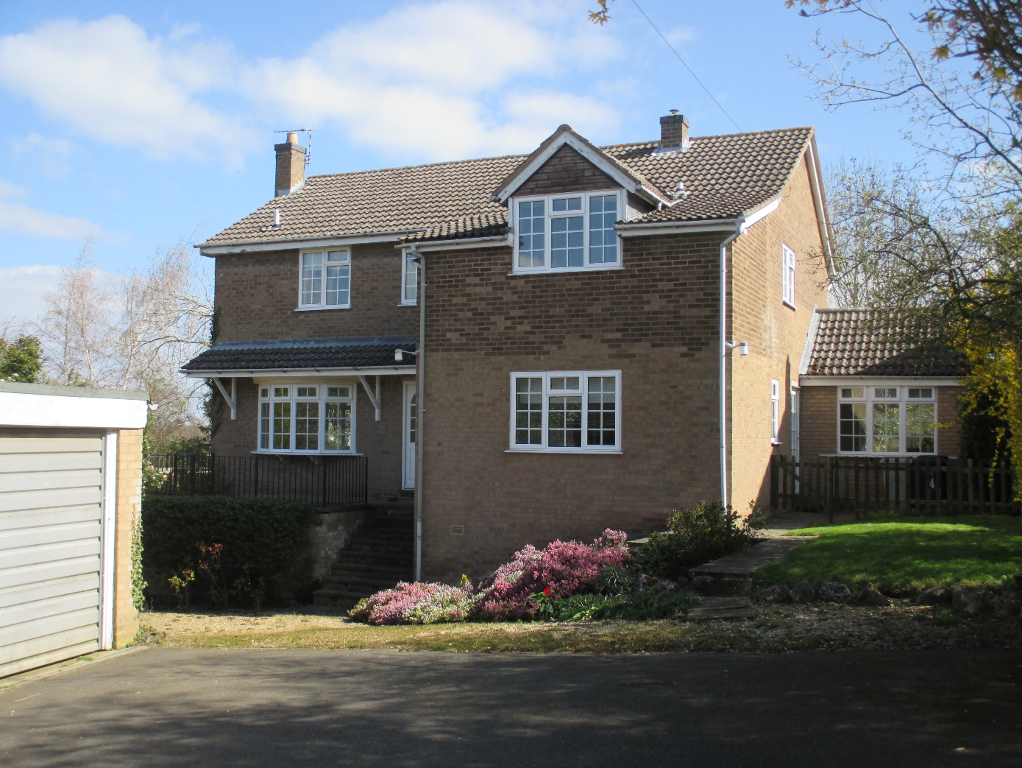
Built in 1975/1976 outside the C.A., whilst sharing some of the characteristics of the other 1973 built properties in Westhorpe Close, such as; sandstone coloured bricks, interlocking concrete roof tiles, a canopy across the front door and front bay-window, which is on wooden kneelers, it has some fundamental differences. These might relate to the landform at this point (sharply falling away and in effect partly creating a three storey structure) or might relate to the specific commissioning of a larger building (it belongs to the Church and was once used as a vicarage). It has a more conventional dormer to the front elevation, an attached but separately accessible ‘office’, a detached garage and possesses an older detached red brick and slate stable which probably once related to the Westhorpe farm complex and a Paradise Lane access as indicated on the 1886 OS Map of Wing.
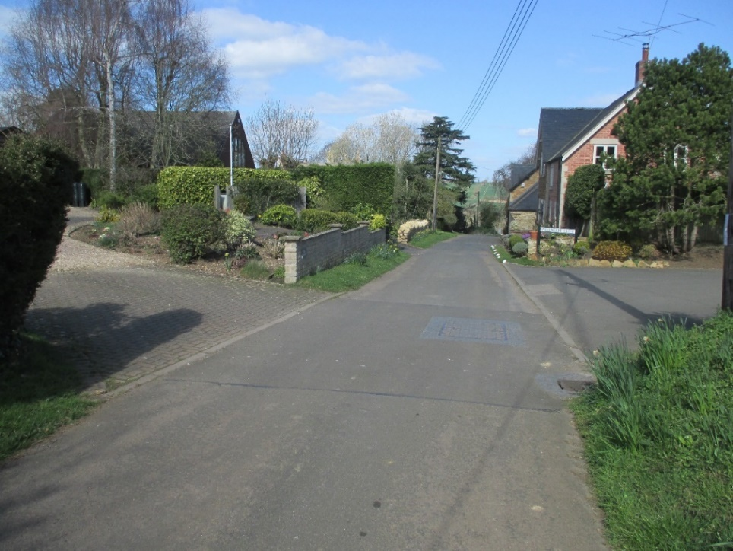
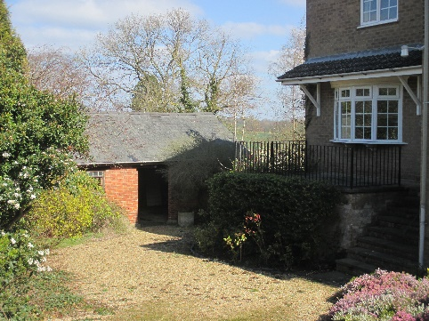
View of Reeves Lane looking north from the Westhorpe Close access.
All the properties in Reeves Lane from this point in the northerly direction shown are within the Conservation Area. Two of them are Listed.

6A Reeves Lane
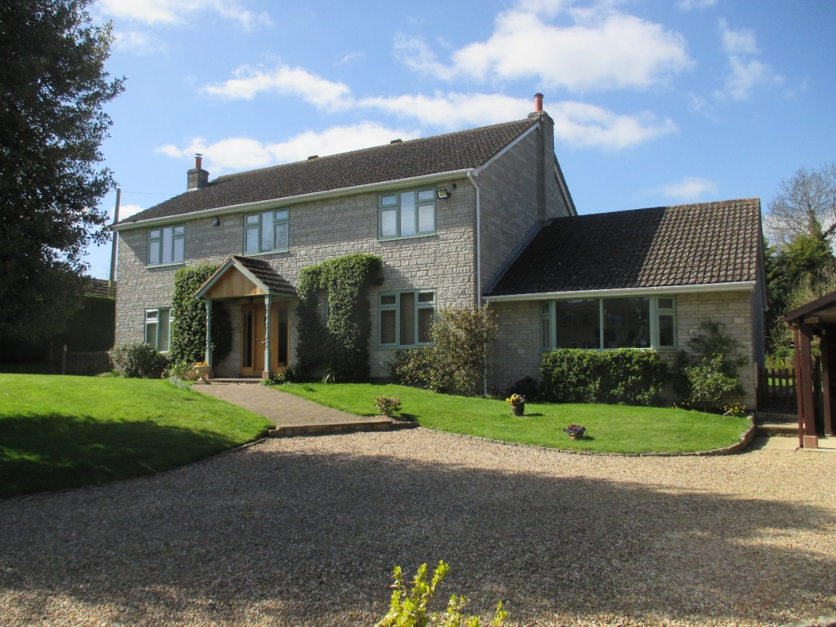
Fourth property on left from the junction with Top Street and opposite Westhorpe Close. Built in 1989 inside the C.A., this property introduces another, and completely different set of architectural characteristics given its grey granite-stone materials rather than the limestone vernacular of Rutland and that of the Conservation Area within Wing. It also possesses a large plot frontage as compared to most other properties in Reeves Lane. The reference point for the roofing materials appears to be the Reeves Lane properties constructed in 1973.

High Trees, 6B Reeves Lane
Assembled on site in 1994, High Trees is a ‘Hosby House’, that is a product produced by a Danish company which set up in the 1980’s to manufacture prefabricated houses with high insulation ratings. Hence the property occupies a different architectural tradition to the timber clad ‘Swedish’ houses on the Morcott Road gifted by Sweden as a contribution to meeting Britain’s housing problems after the end of the Second World War. High Trees constitutes innovative architecture and manufacture, against the grain of the local historic vernacular and more consistent with 21st Century energy conservation and experimentation.
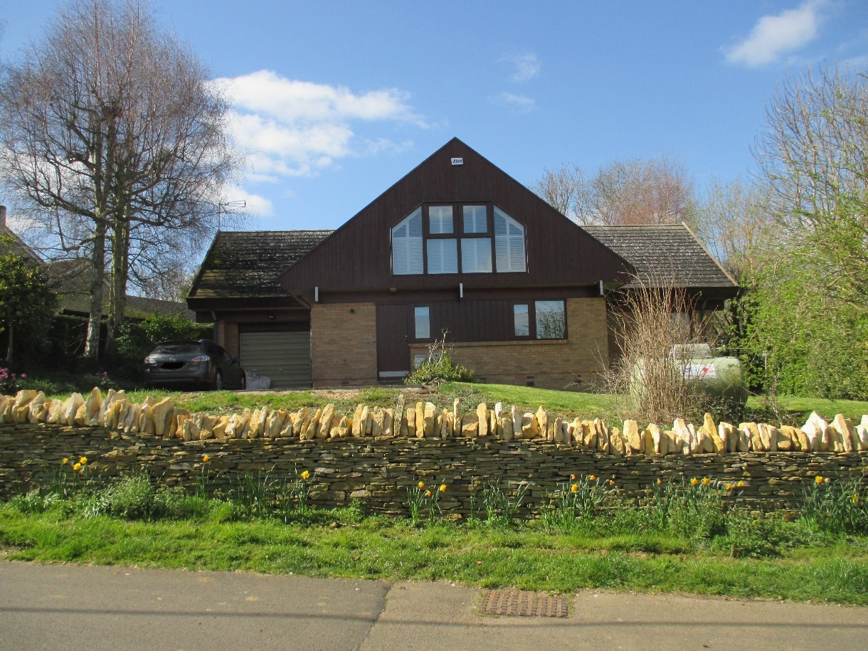
Interestingly, the limestone coloured bricks together with the brick-work style do provide a suggestion of that vernacular style deployed through the limestone blocks within Wing’s Listed buildings of the 19th Century, as does the weathered roofing material in relation to the “stone tiles” of Wing’s Listed buildings of the mid-18th Century. The frontage fenestration and timber cladding is in modern style. The front boundary stone wall appears to be longstanding and the more recent vertical capping stones are consistent with older capping stones from around the village.
4 Reeves Lane
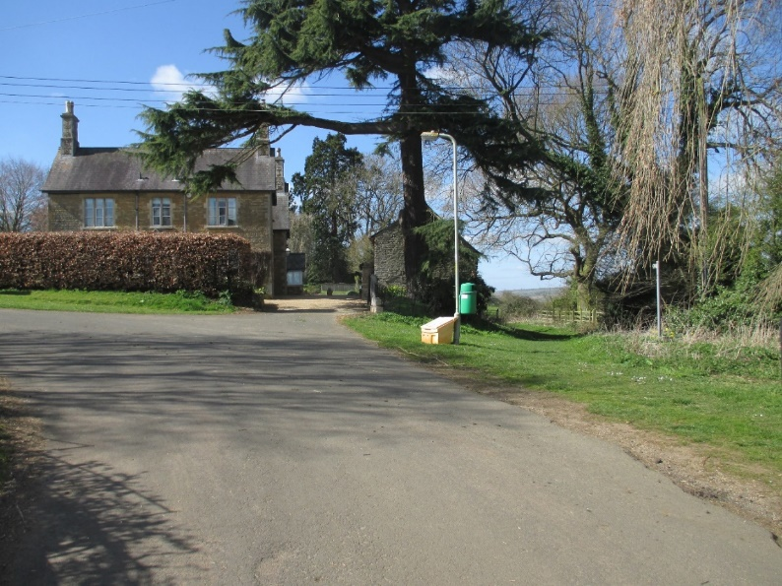
The last house on the left-hand side before Bottom Street, called ‘Stonehouse’, was probably built over three different periods; a core building in the 18th Century (or earlier), the Victorian frontage together with a range of outbuildings as currently presented, and a very much later but passably sympathetic 20th/21st Century rear extension.
Two parts of the house plus a range of outbuildings appear on the 1886 O.S. map for Wing. The frontage is largely constructed from limestone blocks of the Victorian period with ashlar quoins and has a traditional slate roof.
The house occupies a prime location on a large plot in the north-western corner of the village with extensive uninterrupted views over the Chater Valley. Like a sentinel piece of architecture occupying the southwest corner of Wing, the visual substance of Stonehouse marks the entrance to the village from the former 17th Century Manton Bridle Road, once the most direct route to Manton Junction Railway Station, and now one of the most used footpaths towards Rutland Water.
Stonehouse constitutes an unlisted Local Heritage Asset. It’s neighbours, Westcott at number 6 Reeves Lane and Westhorpe Farmhouse, diagonally opposite at number 3 Reeves Lane, are Listed Buildings dating respectively to the late 16th and mid 17th Centuries.
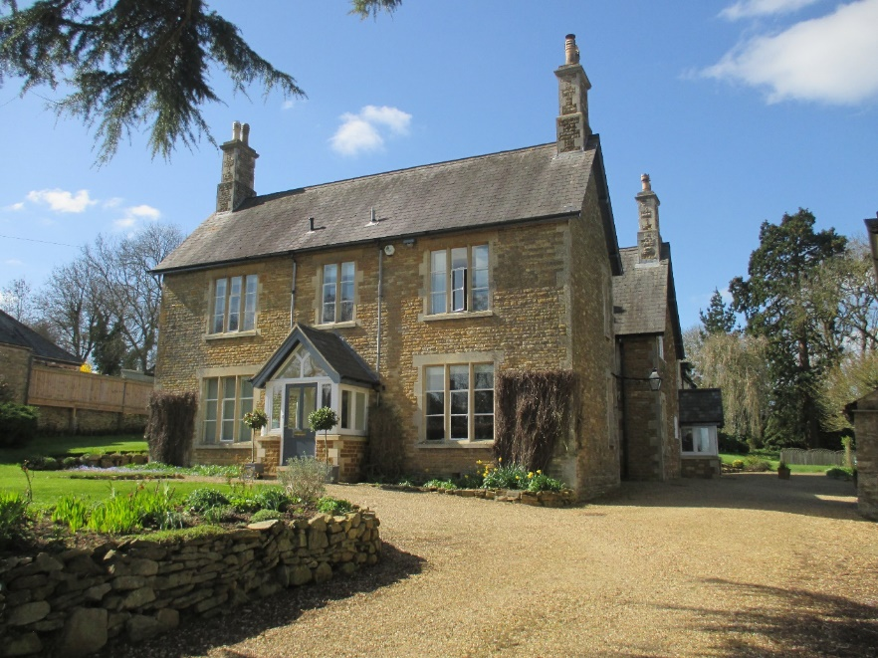

3B Reeves Lane
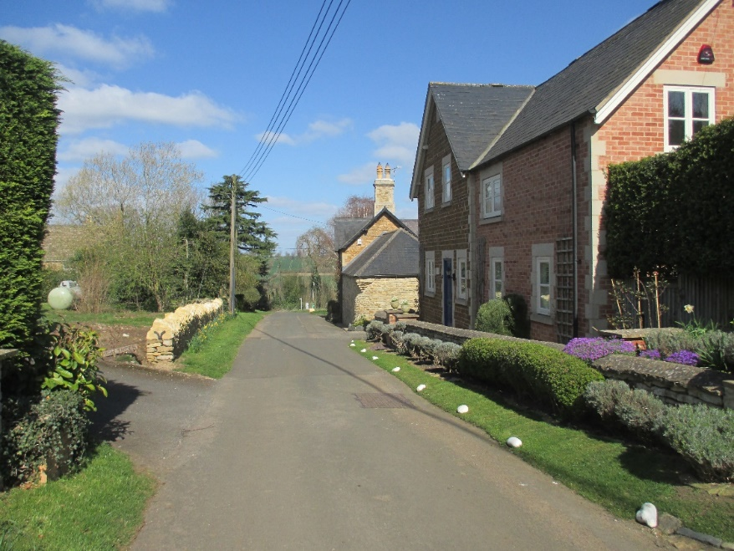
Retracing our steps, the third house down Reeves Lane on the right hand side from Top Street, and the first house down after Westhorpe Close, 3B Reeves Lane was built in the year 2000. It occupies the site of former Westhorpe Farmhouse (Listed) outbuildings and appears to incorporate part of one of those buildings. Here and there throughout the village there are odd limited examples of red brick having been used historically in conjunction with limestone and or ironstone. 3B is an excellent example of that combination being used to create a modern house with a different but empathetic design. Ironstone, limestone mullions and quoins, red brick and slate. The windows are also reminiscent of some of the windows in the Listed Buildings; Westhorpe Farmhouse, City Yard House, Sundial House, Wingwell Farmhouse and 7 The Jetty (also see Glaston Road entry below). The red brick echoes that used in the old barn/stable at 4 Westhorpe Close and at 3A Reeves Lane.
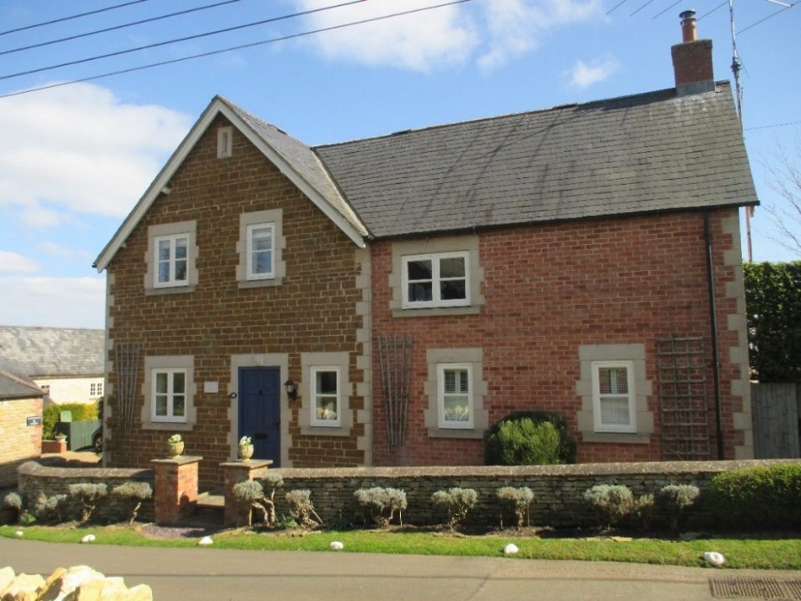
3A Reeves Lane ‘The Stables’

This house was constructed in 2000/2001 partly on the site of a barn once part of Westhorpe Farm. Westhorpe Farmhouse at 3 Reeves Lane incorporating what was once a significant stone barn, is Listed and part dates to the 17th Century and part to the 19th Century with some later brick extensions. 3A is accessed from a drive between 3 and 3B Reeves Lane, which in 1883 appeared to be the main access to the farmyard.
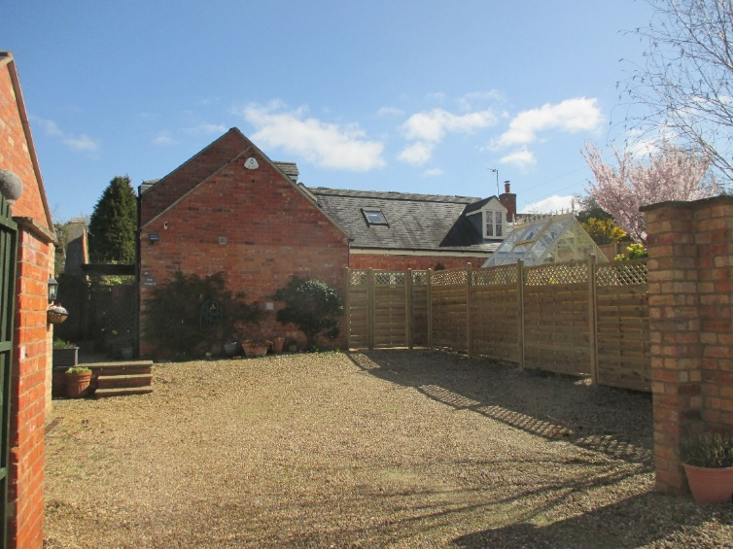
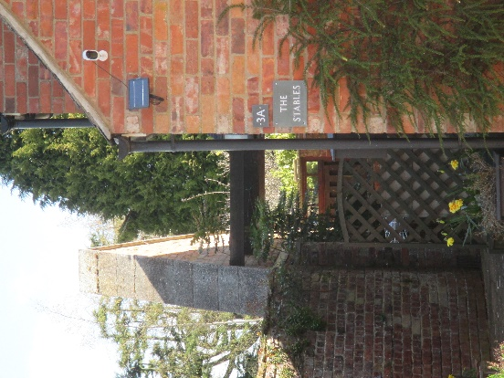
The house is built of red brick and slate with sections seemingly dating to different and earlier periods, the result of re-used older materials from the demolition of original farm buildings, which perhaps explains the name. It is also located mainly on the original footprint and in close-proximity to the small red brick barn/stable at 4 Westhorpe Close, contemporary gardens and new access arrangements changing the original Paradise Lane/Westhorpe farmyard arrangements and obscuring this relationship.
There is also a supported but freestanding stone and brick gable wall, part of much earlier date, the stone copings suggesting it was once part of a thatched building prior to the later brick farm-building, and now forming part of 3A’s northern boundary. This may have been part of the outbuilding range that once ran along the boundary with Paradise Lane as shown on the 1886 OS map and which was demolished and formed the footprint of the main part of the new house.
The house is located inside the Conservation Area and its dormers are more in-keeping with other Conservation Area dormer architectural characteristics.
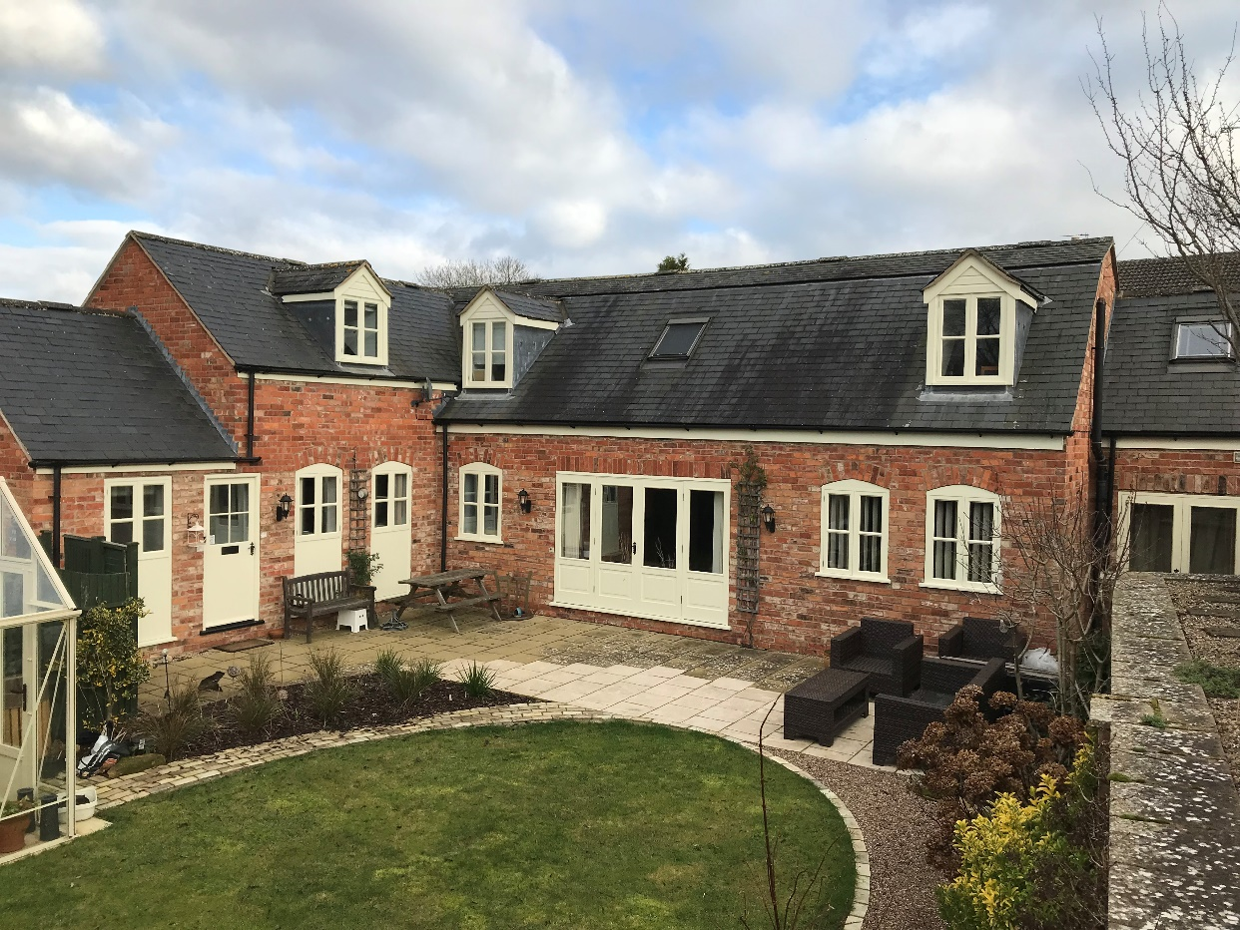
1 Reeves Lane

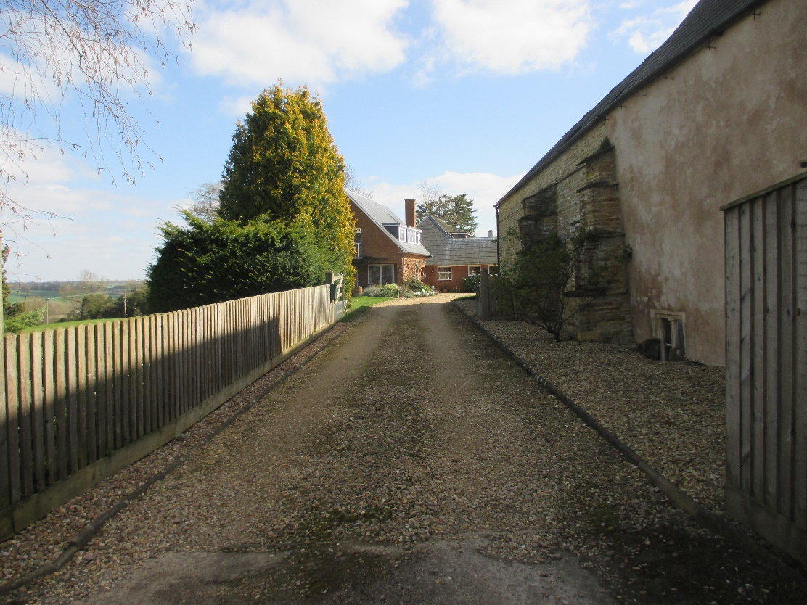
This house was built in the 20th Century and is accessed by the last drive on the right hand side of Reeves Lane after Westhorpe Farmhouse and before Bottom Street. It stands in a large plot overlooking the Chater Valley with Bottom Street serving as its northern boundary. Constructed in brick and slate it has two storeys but with a style and floor-plan area suggestive of a bungalow or large lodge/chalet architecture of the ‘Swiss/Austrian’ type but without timber cladding. The flat roofed dormers and balcony also suggest a 1970’s experimentalist architectural period.
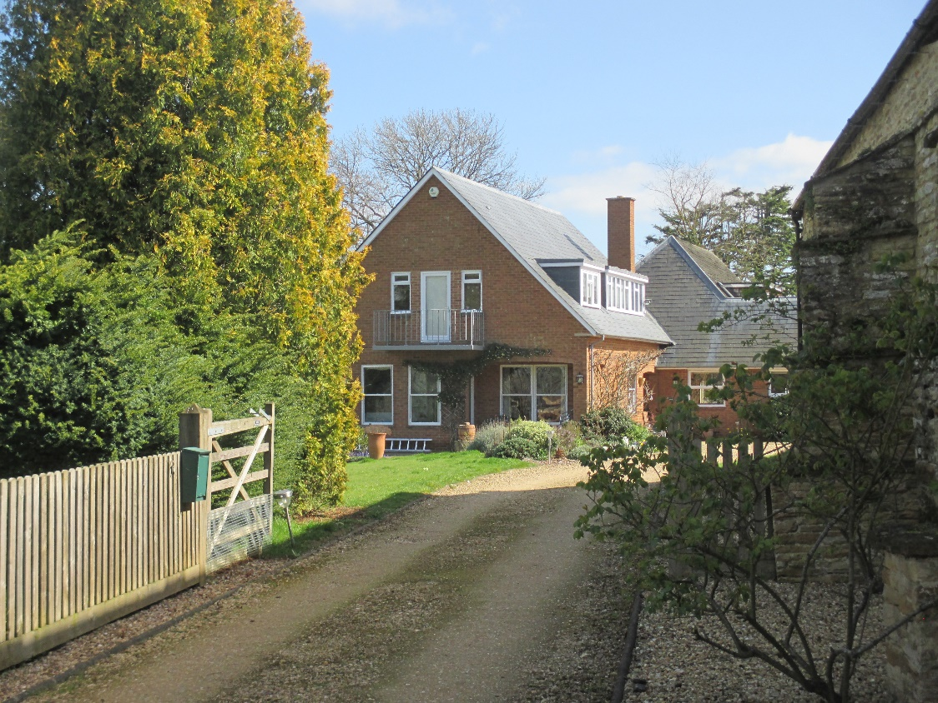
Below, a view from Reeves Lane along Bottom Street with the boundary of 1 Reeves Lane on the right. The Chater Valley falls sharply away on the left.
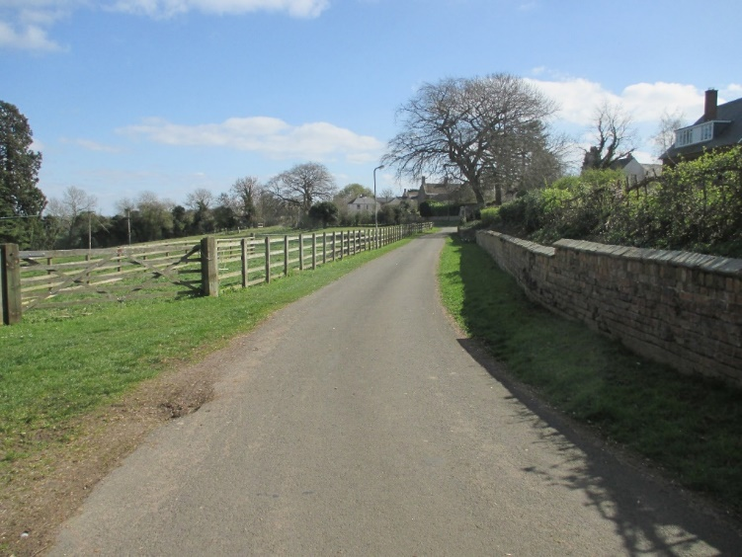
Returning to Top Street and the western access to Wing, we next turn east along Top Street.

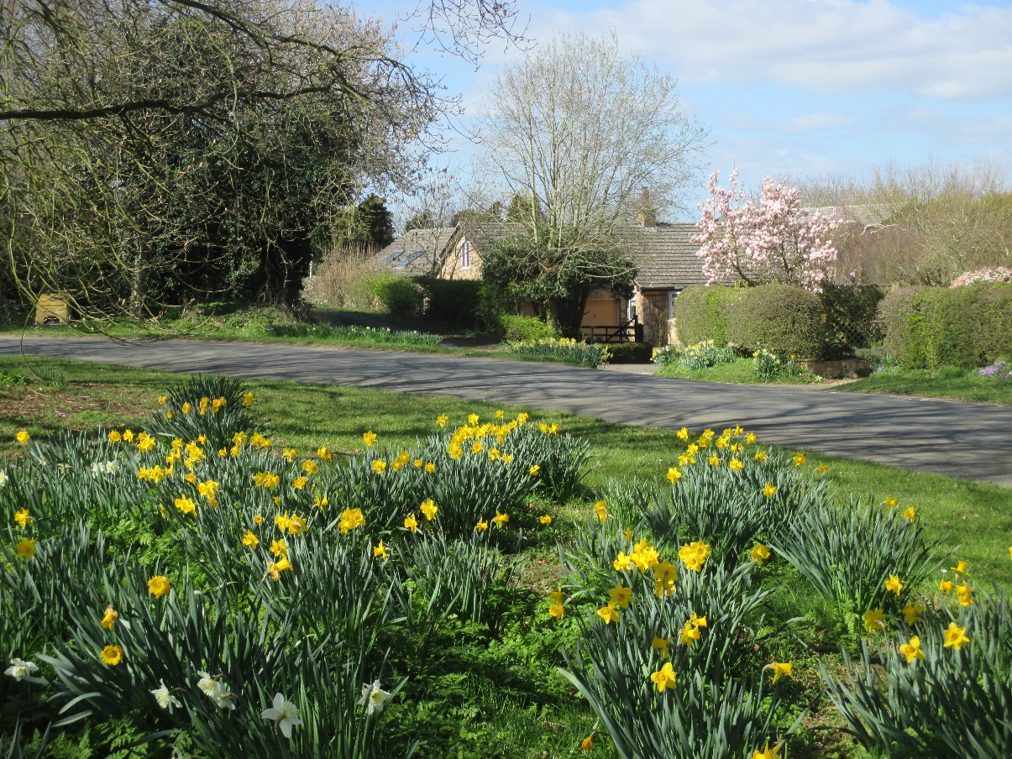
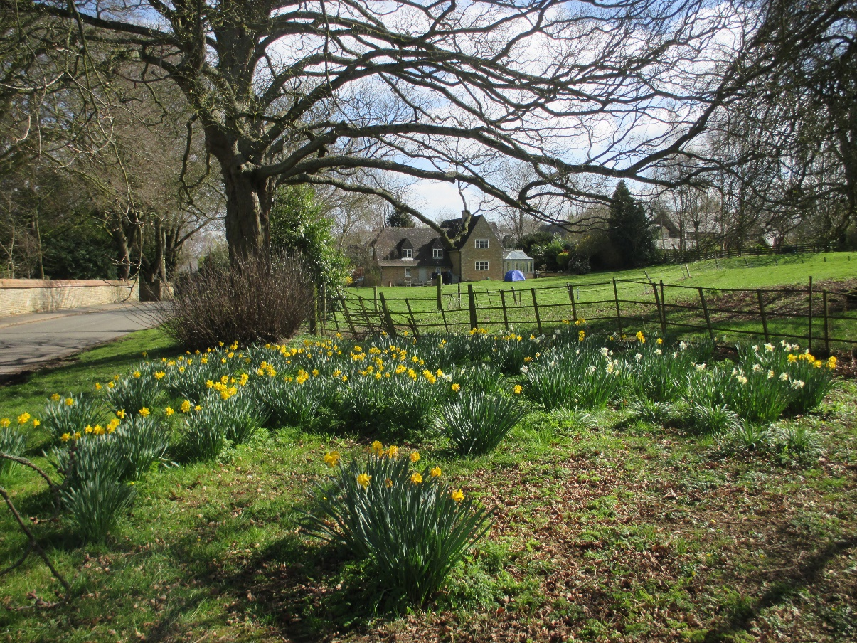

Directly ahead on the right (as shown above) is Tannachie House, 1981, with its garden and paddock. Accessed off a private lane from Top Street, it was built on land then in the ownership of the Worrall family and now forms part of a four house development, two (Tannachie House and Lantern Cottage) closest to Top Street, being inside the Conservation Area, and two with larger garden plots, Autumn House and Woodcock House, being built later in the ‘back-land’ outside the Conservation Area.
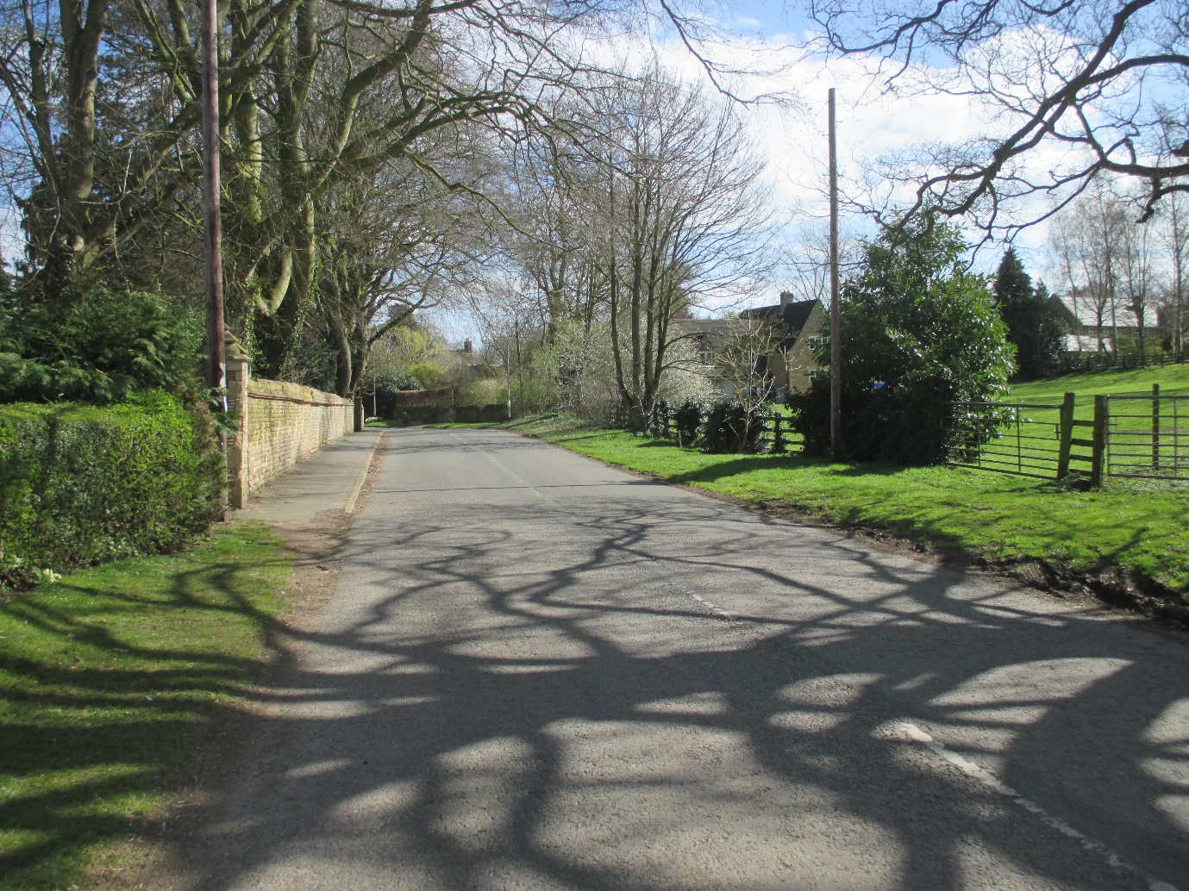
Immediately on the left, just before the start of the Old Wing Hall (Listed) protected boundary wall (as shown above) are the two ‘twin’ houses, 14 and 12 Top Street, which constituted the starting point of the Top Street/Reeves Lane 1972/1973 development and which is outside the Conservation Area.
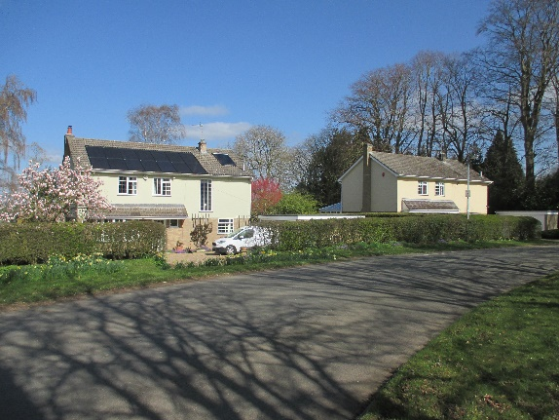
Taking all the 1972/1973 houses together it is clear that the Conservation Area Boundary, in respect of Reeves Lane and Top Street, lacks cohesion and consistency, as does the apparent Rutland County Council Planning responses to the settings surrounding Listed Buildings.
14 Top Street
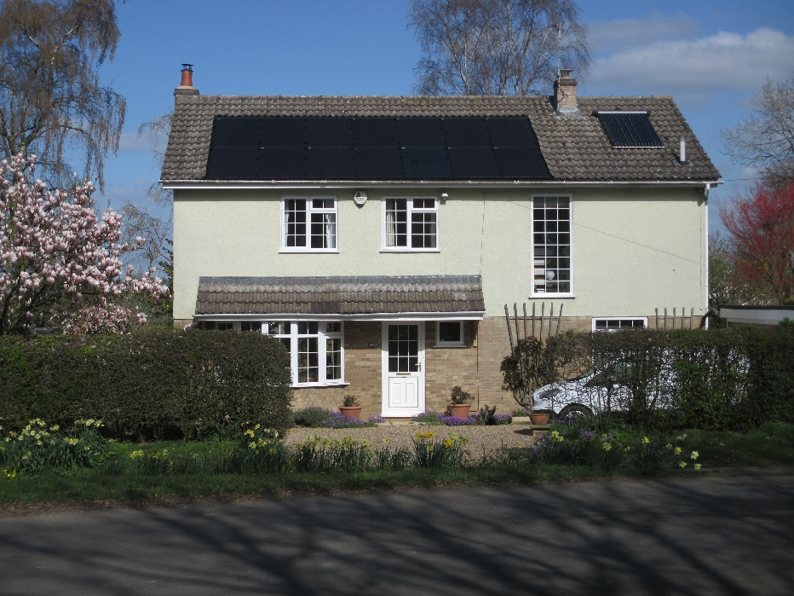
Built in 1972, in sandstone coloured brick but half rendered, together with inter-locking concrete roof tiles, it has the front door/ground-floor bay window canopy configuration consistent with the Reeves Lane properties of this period. The staircase window (relieving the blank wall characteristic of the other Reeves Lane properties) was retro-fitted as was the roof-top photovoltaic and solar water heating units. There is a detached flat-roofed garage.
12 Top Street
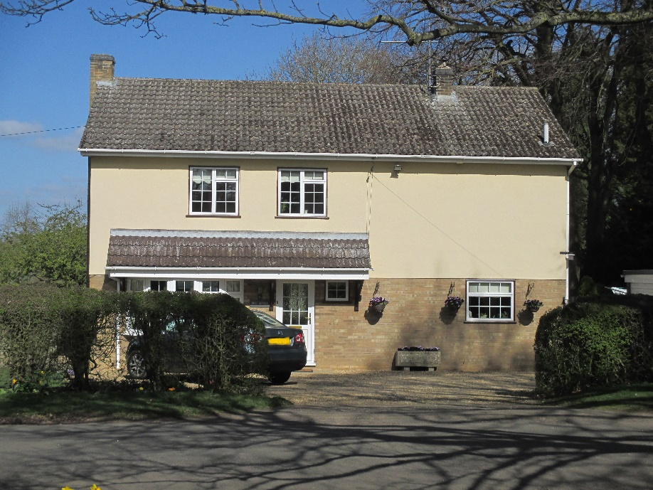
10 Top Street
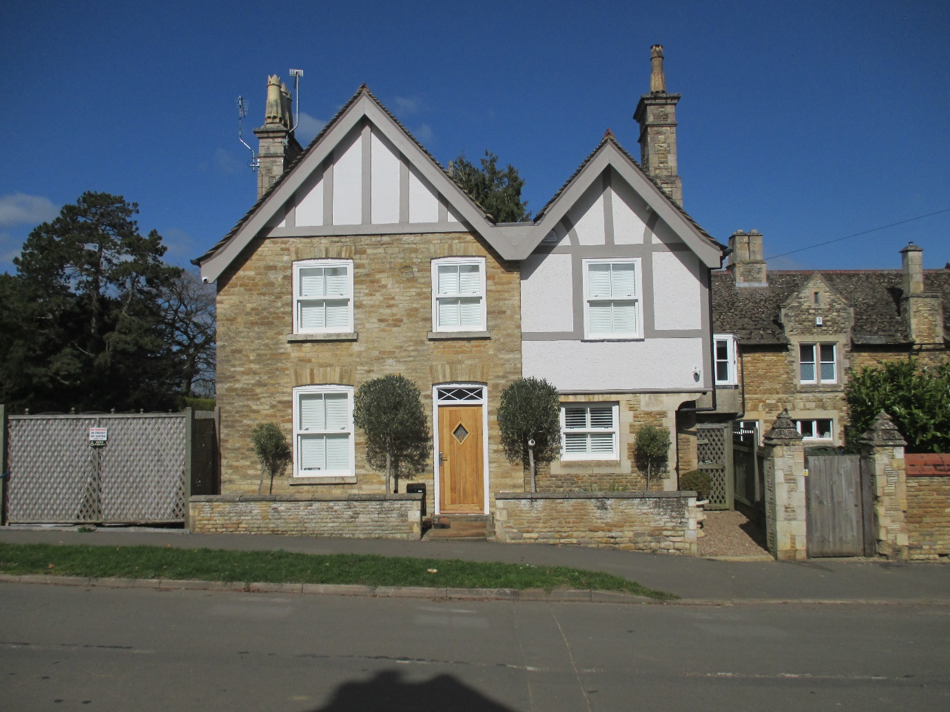
At the end of the Old Wing Hall protected boundary wall (Listed) on Top Street, adjacent to Old Wing Hall (in background of photograph), opposite the King’s Arms public house (Listed), and flanked to the east across the head of Middle Street by the protected wall of Garden Cottage (Listed) there is the former ‘Butlers House’.
It was formerly part of the Worrall estate and built around 1900/1902, although it may have incorporated part of a much earlier building from the Sheild family period as suggested by the right hand section straight line joint, its quoin stones and corbelled upper storey, together with its later rough-faced rendering. The left-hand section is also of later ‘Victorian’ stone blocks. The roofscape (of slate) and its facias are reminiscent of properties just a few yards along Top Street dated to 1892.
This house constitutes a local Heritage Asset in terms of imposing street scene, historical value and the integrity of the ‘group’ setting of related Listed Buildings and walls. It is another unlisted example, symptomatic of the lack of interpretive historical cohesion in all the Listed Building citations executed hurriedly in 1984 which then carries over into present day planning considerations as seemingly piecemeal decisions despite the existence of the Conservation Area.
6, 4, 2, Top Street
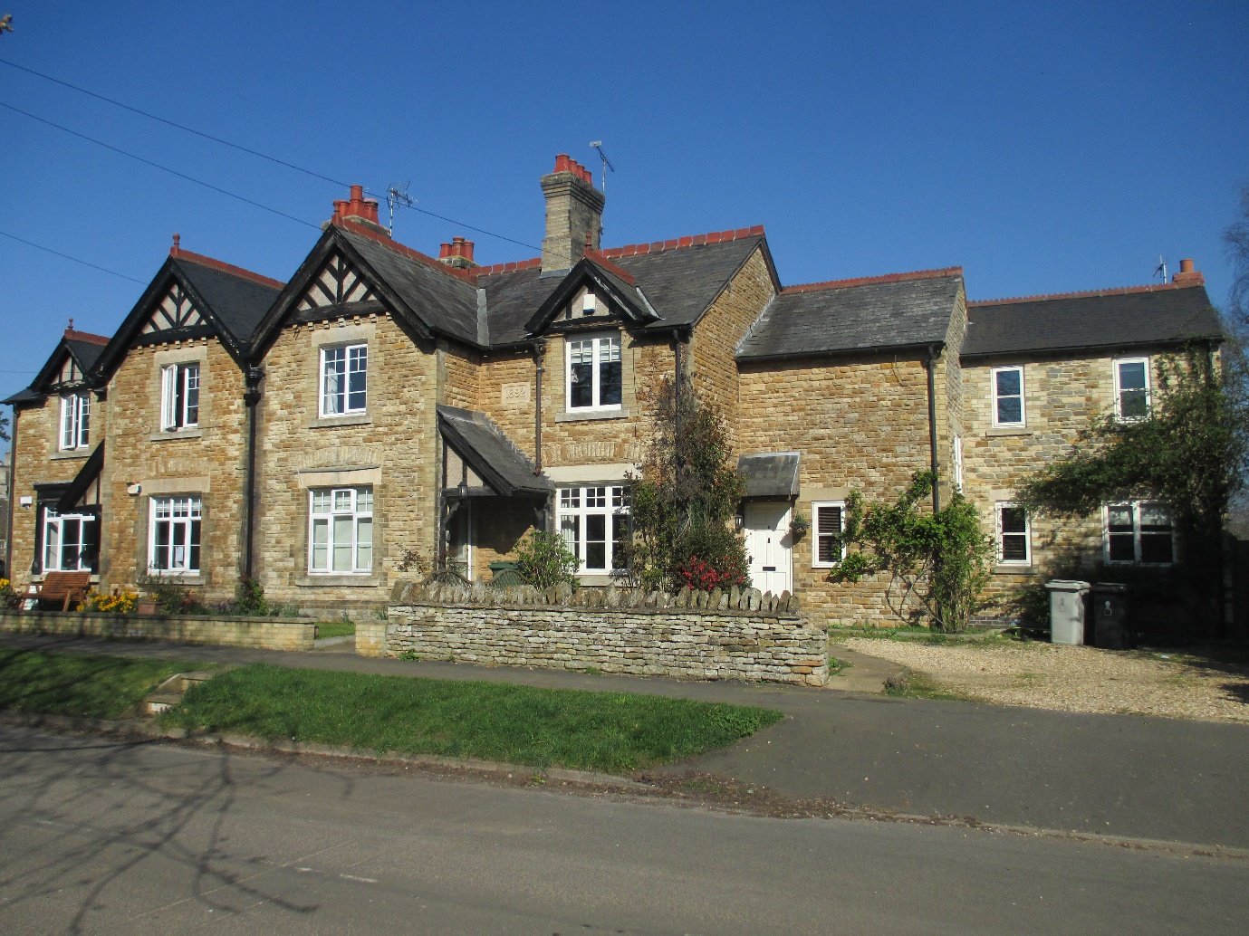
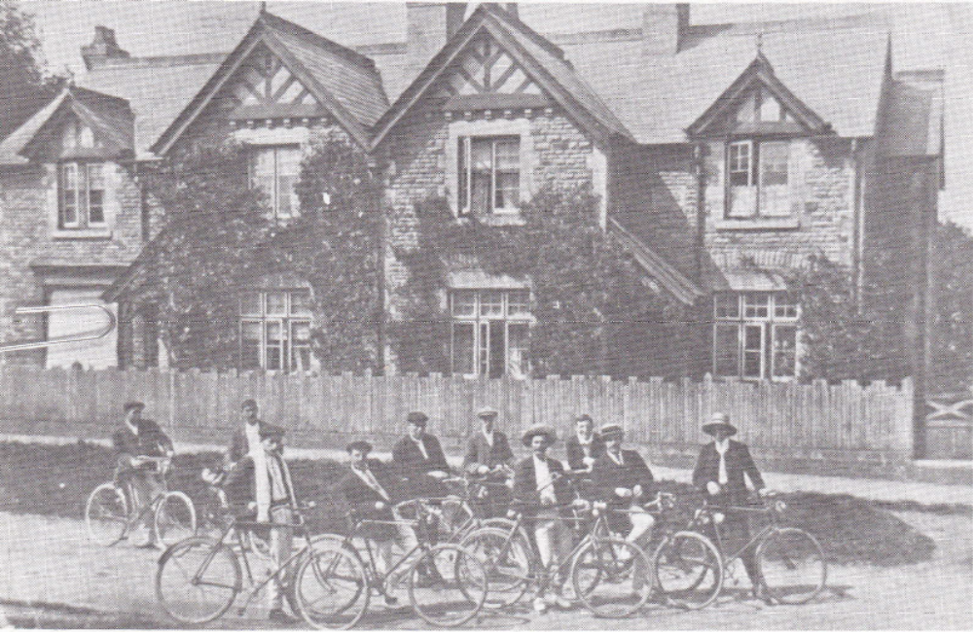
This run of three properties on the right-hand (north) side of Top Street when facing east, starting with 6, which was once a post office and shop (left), and ending with number 2, just before the stone bus shelter and farm yard development at Church Cottage, comprise four bays originally constructed by Edward Worrall in 1892. The last bay on the right was later partially separated and extended with two stepped additions. They are all constructed of limestone with some ironstone and have slate roofs. The newer built extension/s have clearly tried to match the stone (precisely in the first case, which might be a much older extension) and there was also an attempt to mimic the red ridge tiles but in a slightly less elaborate design. The old photograph (‘The Villages of Rutland’ Rutland Local History Society Vol 1) dates to 1905. This red detailing echoes the red capping to the limestone wall boundary running along the north side of Top Street in front of Old Wing Hall (Listed).
Modern, double glazed windows have been installed with an overlay glazing bar template based on the original window designs.

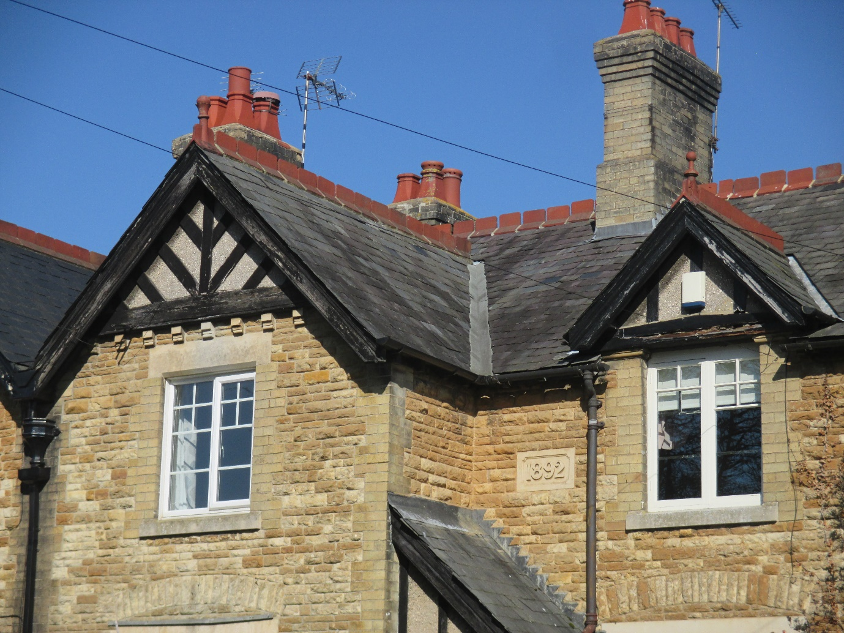
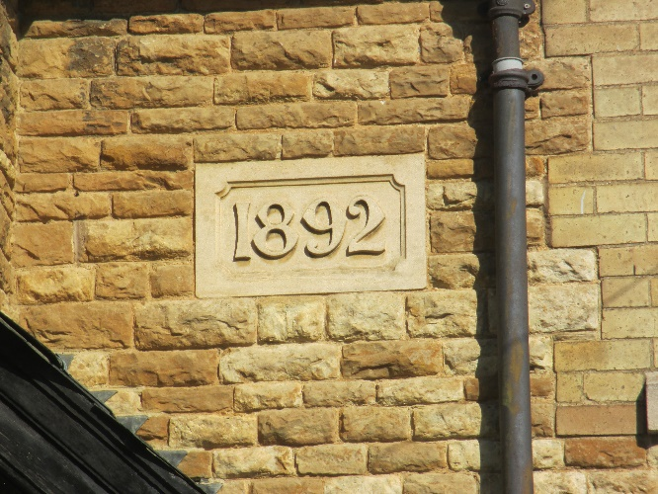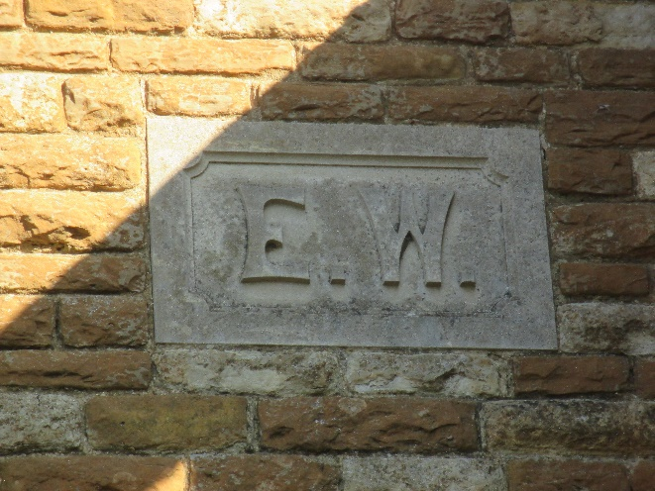
These buildings, like ‘The Butlers House’, warrant ‘Local Heritage Asset’ status because of their historical significance in the development of manorial holdings within the village and because their architecture predicates the street scene consistent with the last chronological phase of Wing’s Listed Buildings.

Top Street Tannachie House
Retracing steps back along Top Street to the private lane leading off in a southerly direction, Tannachie House stands on its western corner, with Lantern Cottage standing on its eastern corner (see below). These two properties built in 1981 and 1993, constitute modern infill, are within the C.A., and have used Conservation Area design elements - lantern dormer windows with Listed casement sizing, red-brick corbelled eaves in the one case, and shaped coping stone capped gables with limestone corbels & ashlar quoin detailing in the other. The stone for Tannachie House was recovered from an old local barn. The results are in harmony with the village Listed Buildings of the 18th and 19th Century periods. There is also closer proximity of frontages to street-scene, again consistent with many of the Listed Building settings around the village dated to the 17th and 18th Centuries.

Top Street Lantern Cottage

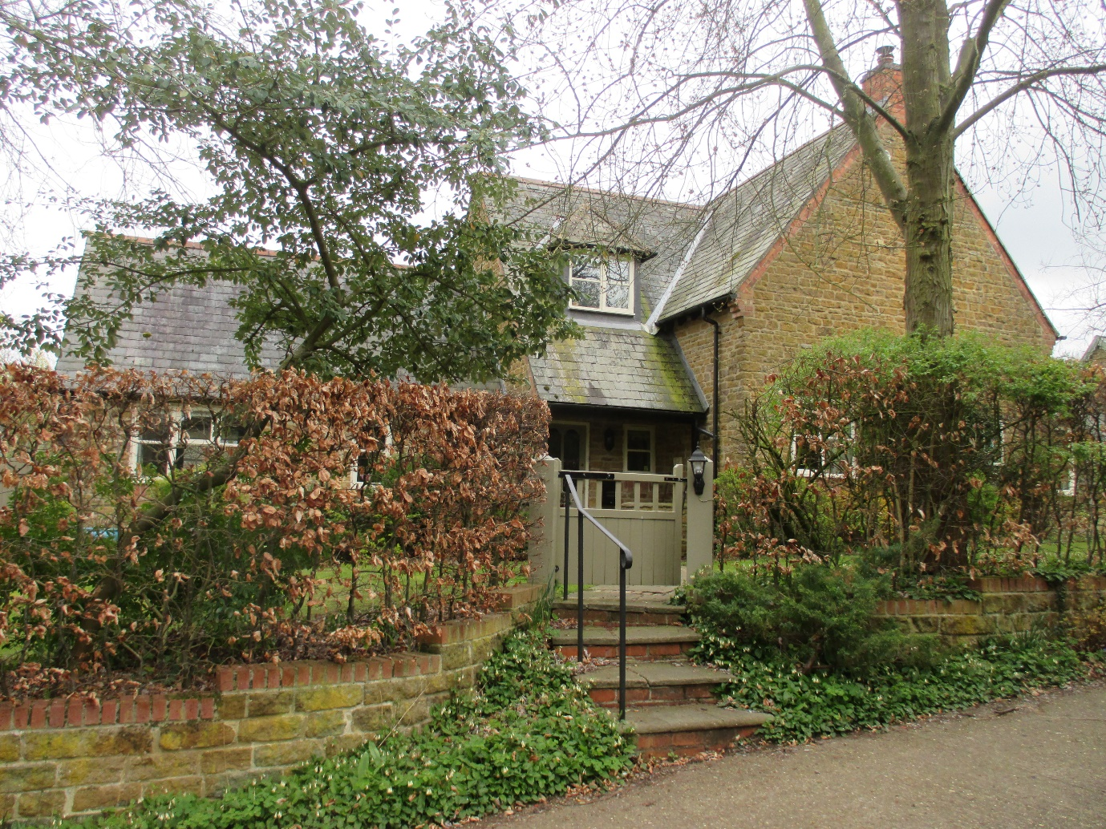

Top Street Autumn House

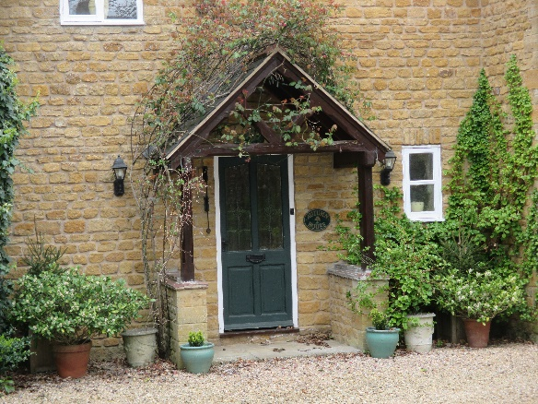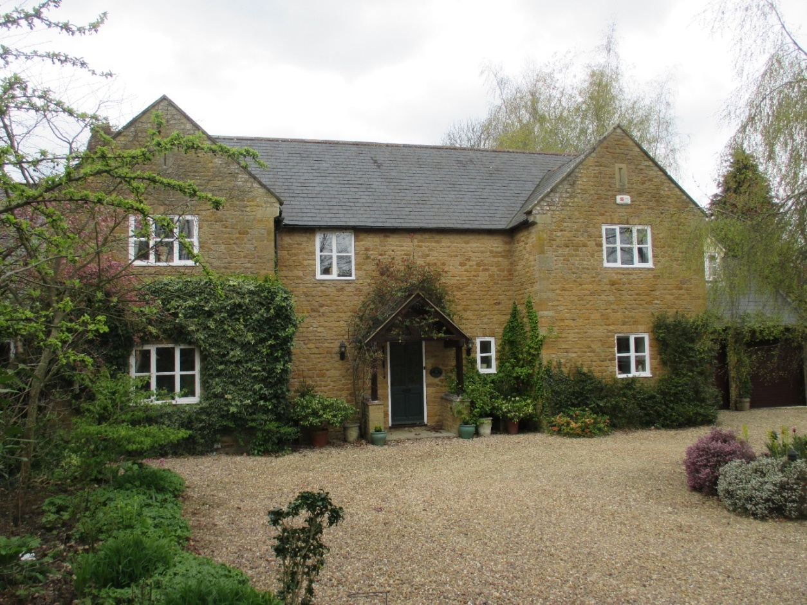
Sitting south of Tannachie House on the private lane but outside the C.A., Autumn House, built in 1993 in limestone/ironstone with a slate roof, is also an admirable piece of architecture in its adoption of Listed Building materials, together with some detailing which accommodates the local vernacular style. These comprise raised gable coping stones suggestive of the thatched roofs once prevalent amongst the 17th and 18th Century Listed buildings around the village, stone gable recesses suggestive of former barn vents, a lantern dormer, and 2/3 light casement windows with single glazing bars reminiscent of Westcott.

Top Street Woodcock House

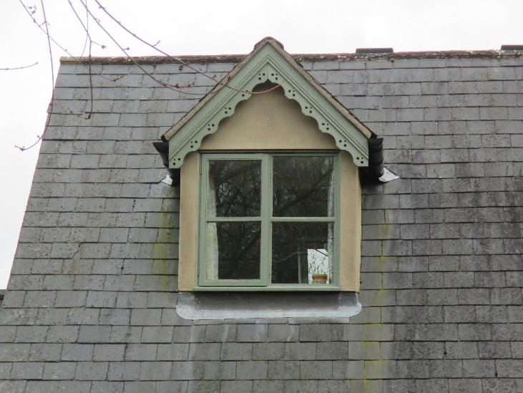
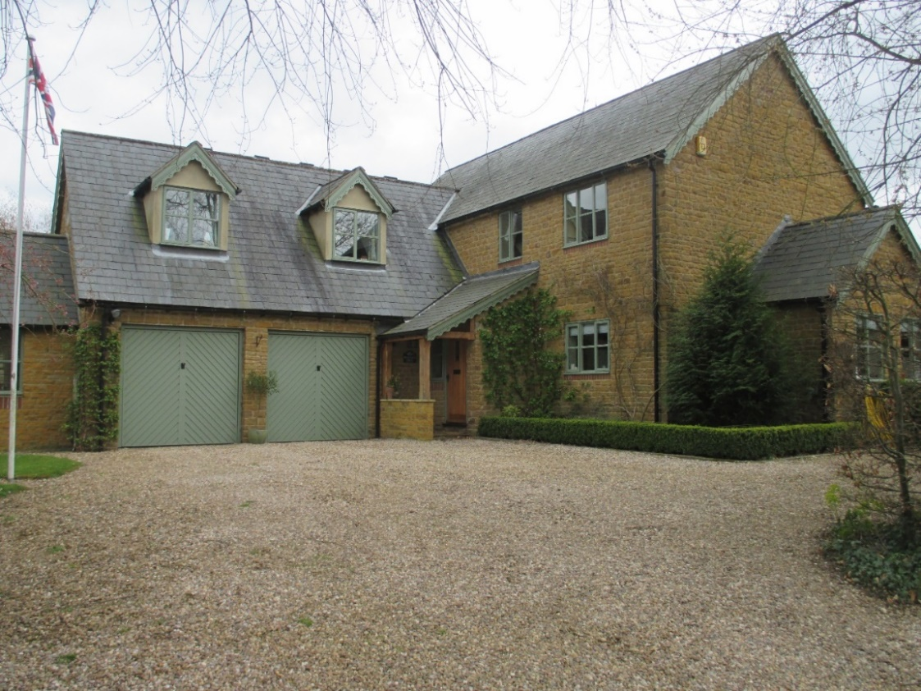

Woodcock House is also outside the C.A., from the same period, of a more modern external configuration, but built of limestone and slate with dormers. The overhanging facia weather-boarding is more redolent of a late 19th Century style, echoing to some degree the overhanging eve ‘barge-board’ facias of the 1892 Edward Worrall cottages along Top Street and the gable eaves at 1 Church Street. Fenestration matches the vernacular style – square two and three light casements with central glazing bars of the ‘Sub-Medieval’ phase.
Top Street

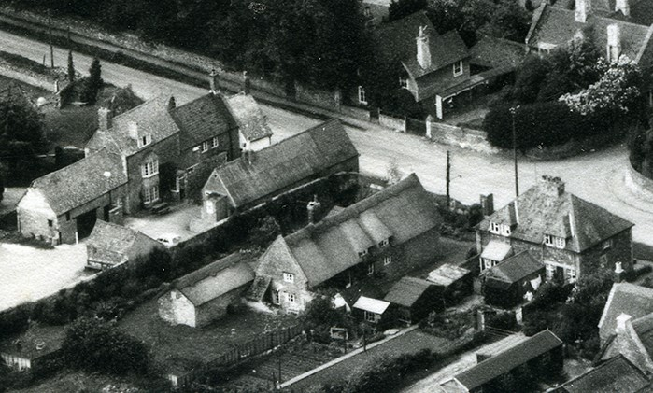
Returning to Top Street from the private lane and turning right (east) past City Yard House (Listed) and The King’s Arms shown in the top left-hand side of the above 1960’s aerial photograph (Listed), 9 & 7 Top Street are shown in the bottom right-hand side.
9 & 7 Top Street

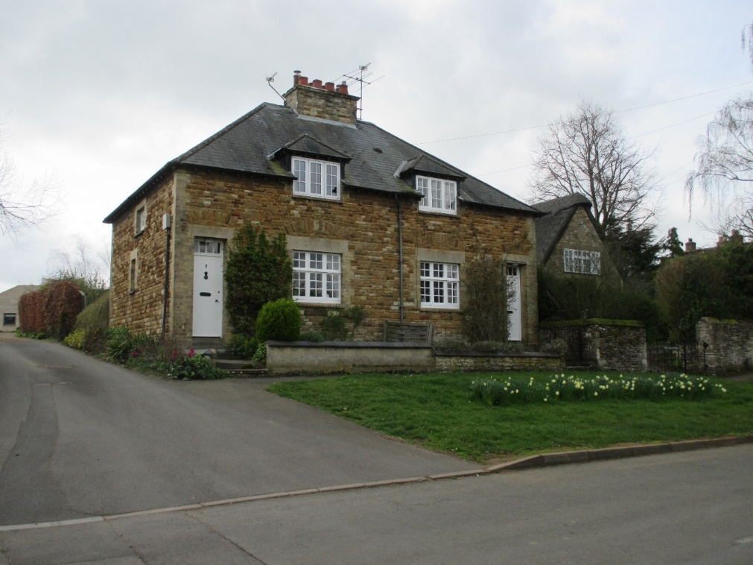
Immediately east of The Old Forge, on the southern side of Top Street and inside the C.A., 9 and 7 are also cottages like those opposite, built during the Edward Worrall period of substantial Worrall estate ownership within Wing Parish. Now in private and individual ownership, they are constructed from Victorian era limestone and ironstone blocks with limestone quoin and window detailing, slate roofs, and lantern dormers which are set crossing the eaves line, a characteristic found in a few other buildings within Wing (see below).
As with the cottages opposite, they constitute Local Heritage Assets and appear in very early photographs of Top Street, just beyond the Poplar trees as below, and see their window detail (also below).
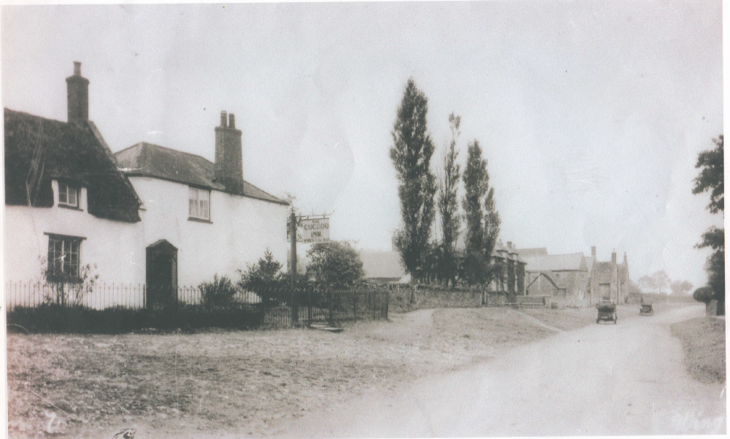
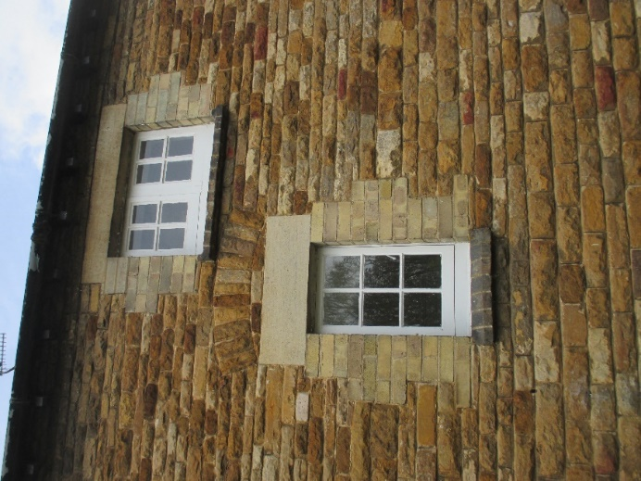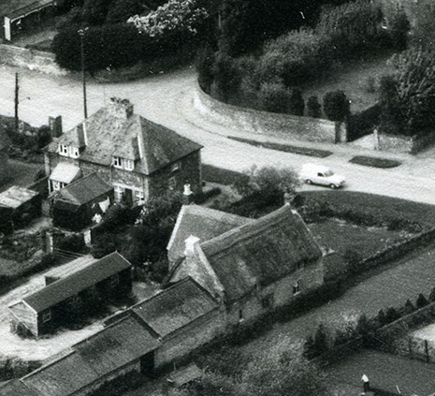
5A and 5B Top Street
The private drive, shown above on the left of 9 and 7 Top Street in the contemporary photograph and of the land between 7 Top Street and Wingwell Farmhouse (Listed) at 5 Top Street in the 1960’s aerial photograph , now also provides access to two 21st Century houses developed at the head of this drive on land formerly part of the Wingwell Farmhouse land-holding, but lying outside the C.A. boundary
5B Top Street
5B is an architecturally modern ‘passive house’ constructed partly of limestone in the local vernacular, with precision limestone door and window sets, and is partly of precision cedar timber cladding, with a slate roof.
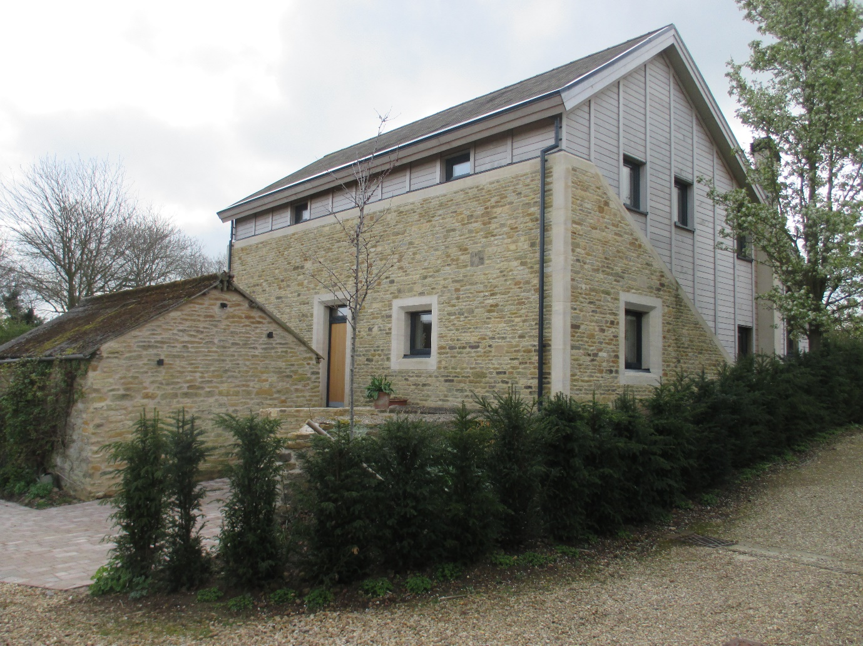
Related external work is still in progress but the complementary relationship between the stonework of an existing outbuilding on its frontage and the new stonework is empathetic and hence the treatment of that building will be fundamental to the final design impact of the new frontage. The detailed external finish has the capacity to be an exemplar in terms of the cutting edge of modernity expressing and embracing the historic vernacular. (For similar examples in this latter regard see ‘Wing Village: A Directory of Listed Buildings’ (Second Edition 2019) update on Garden Cottage, Top Street, and the entries for 3A and 3B Top Street.
5B’s southern perspective is only viewable from the garden of 5A Top Street, as below. It sits well in the landscape and has avoided unrelieved blank roofscape at eye level through stepped rooflights.
All three pieces of land (Wingwell Farmhouse, 5A and 5B Top Street) were part of the Wingwell Farm (Listed) landholding until quite recently. Wingwell Farmhouse sits inside the C.A., whereas 5A and 5B sit outside the C.A.
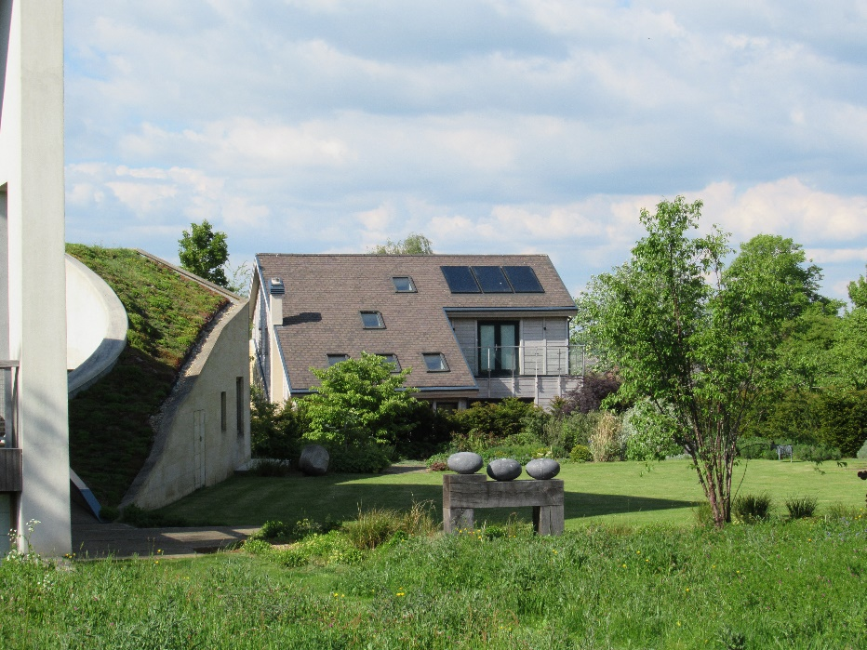
5A Top Street
5A is also a modern architectural conception incorporating some ecologically desirable principles. It deploys limestone as a major ingredient of its construction but whilst some of the external freestanding walls and part of the western side of the house are in rough-hewn blocks akin to Wing’s limestone “coursed rubble” vernacular, the limestone used on the northern and publicly visible exterior walls is polished, suggestive of the ashlar vernacular which has more selective use around some of Wing’s Listed window bays. The house doesn’t readily lend itself to full architectural appreciation from its main access.
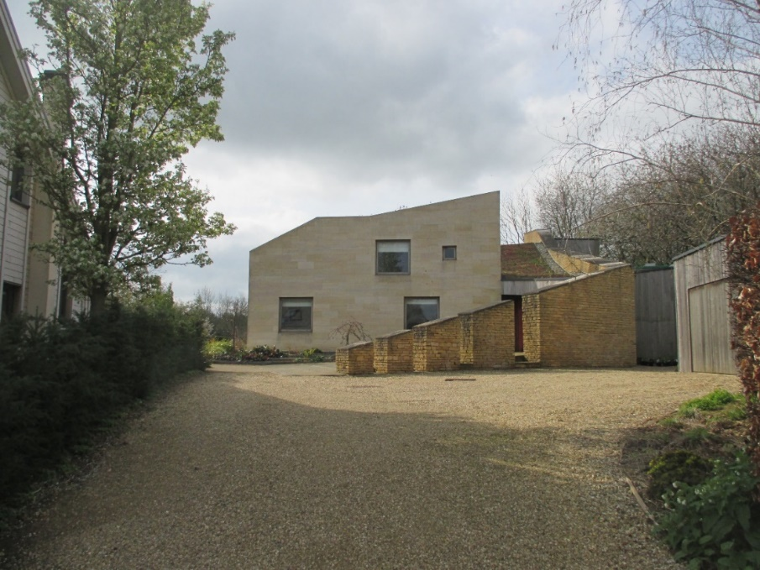
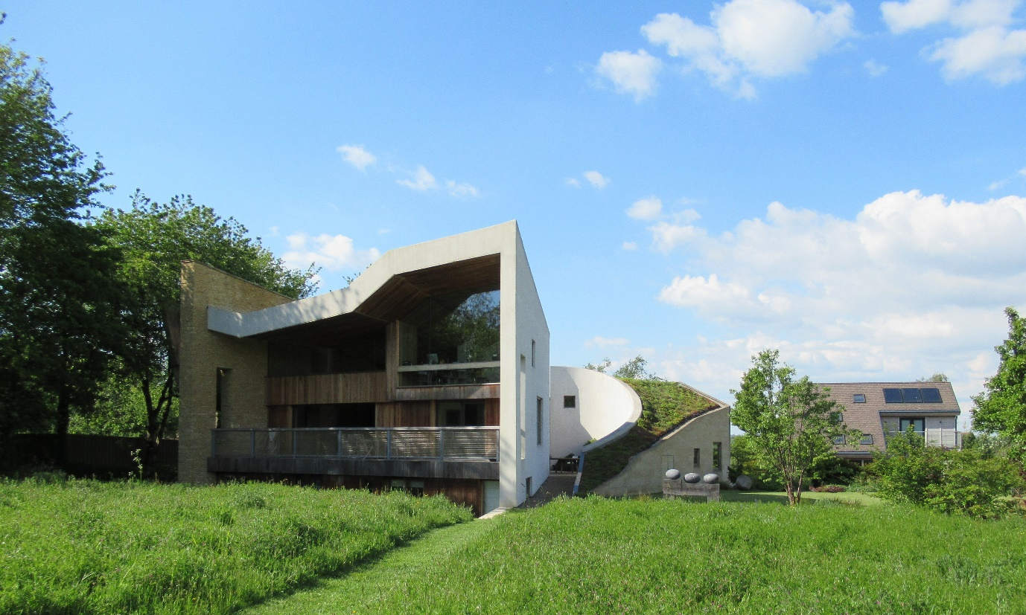
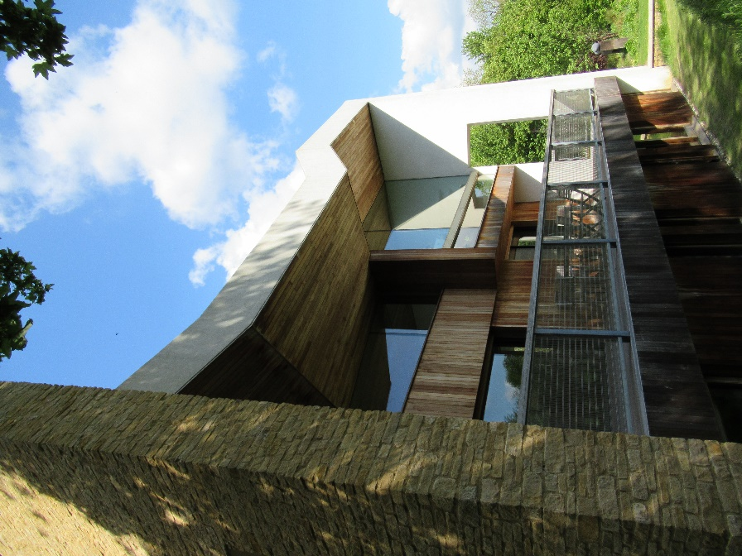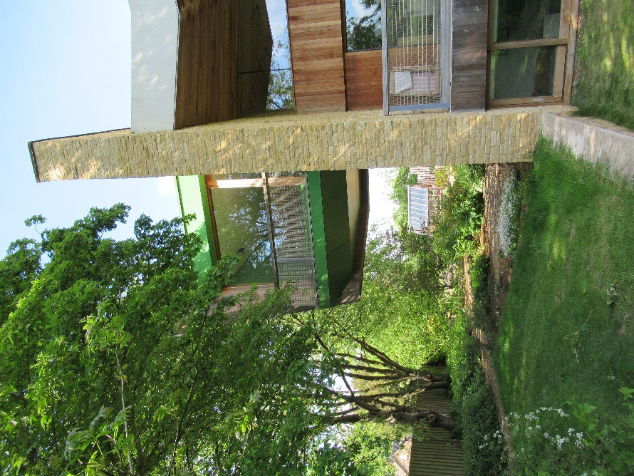
The most imposing elevation faces south and is only partially visible to the public from a public footpath. It has a sedum roof.
On the south side an overhung roof, which creates shaddow on the extensive glazing, timber cladding, and approximately half a storey embedded below ground level, key the building into the landscape without diminishing the striking nature of its unusual architecture when viewed at closer quarters.
3 Top Street
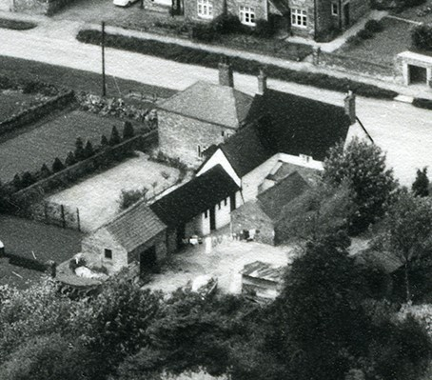
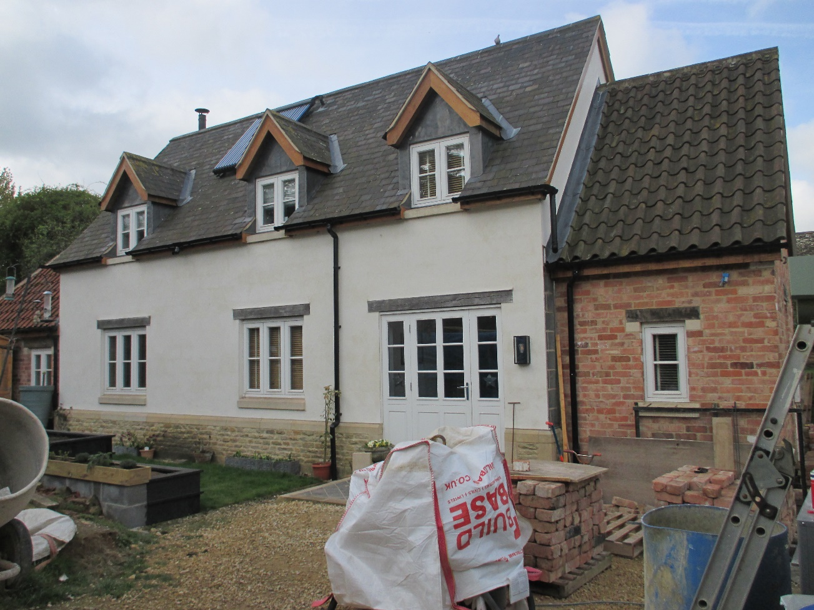
3 Top Street is located at the rear of 3A (Listed) and 3B (Listed) Top Street, is still work in progress, and concludes the transformation of the former Cuckoo Inn (see 1960’s aerial photograph above) and its site into three separate heriditaments and homes. Built on the line of former Cuckoo Inn brick outbuildings, it comprises a dwarf ‘skirting’ wall in limestone, rendered blockwork, conventional but overhung dormers with bargeboards, and a slate roof. Flanking service areas are in red brick with interlocking biscuit pantiles. The windows are reminiscent of Listed Building fenestration referred to at the entry for 3b Reeves Lane above, but also have stone cills. The overall effect is one of empathetic simplicity and yet borrows from different design sources around the village, as does the rear elevation of 3A Top Street. It sits inside the C.A.

Tithe Barn, 1a Top Street
Tithe Barn is immediately east of 3 and 3A Top Street, was once part of Churchfield (Listed) which was formerly called The Rectory and which occupied a large, complex site. The main access to the Rectory stables and barn was probably once achieved through the stone wall forming the current boundary between Tithe Barn and the former Cuckoo Inn (previously known as The Red Lion Inn and then The Noel Arms), now the 3, 3A and 3B Top Street site. At this time (see 1886 O.S. map included in ‘A History of Wing Village and Its Setting 1066 - 2018) three cottages known as Cuckoo Cottages stood between 3B and the highway and two cottages known as The Nook were located to its rear. This meant that the highway then had a different configuration. Nowadays Tithe Barn, as a separate heriditament created partly from the former Rectory barn and outbuildings, shares an access drive with Churchfield (The Rectory), the latter having also undergone transformation through substantial selective demolition around the turn of the 19th/20th Century and restoration after this 1971 aerial photograph.
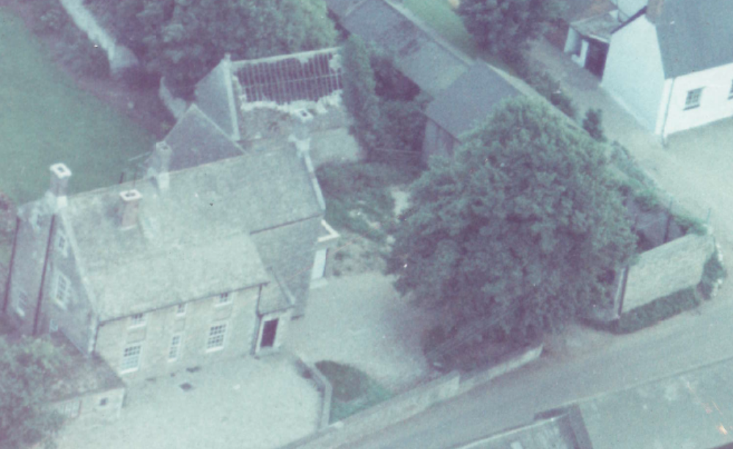
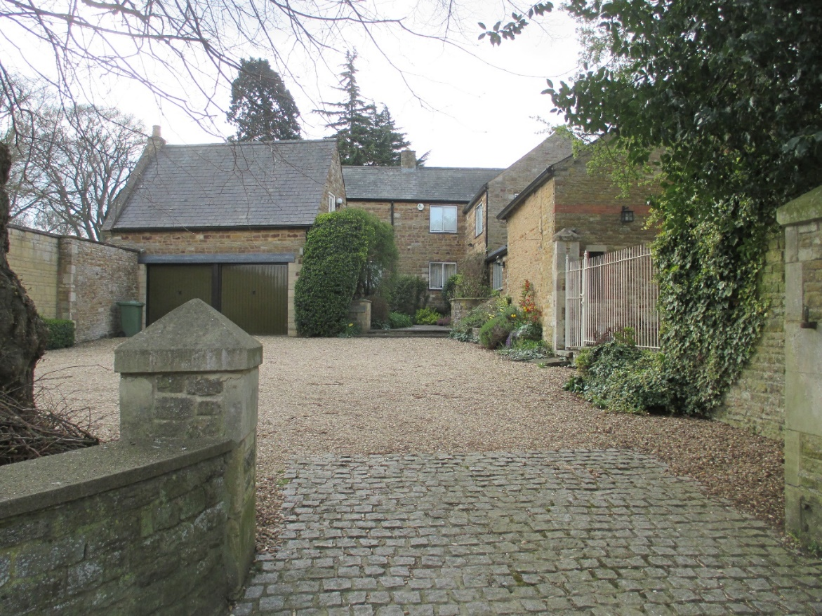
Tithe Barn sits inside the Conservation Area and is constructed from limestone (possibly relating to three eras – 17th, 19th, and 20th centuries) and sandstone coloured bricks (20th century) with slate roofing. The two oldest parts of the building are those left and right in the foreground of the contemporary picture which correspond to the building with a substantially damaged roof and the barn just beyond the tree in the aerial picture. Part of the building, the barn, also has some red-brick stringcourses and detailing most likely to date to the late 19th century.
Opposite Tithe Barn on the north side of Top Street is another farmyard redevelopment wholly within the Conservation Area.
Top Street
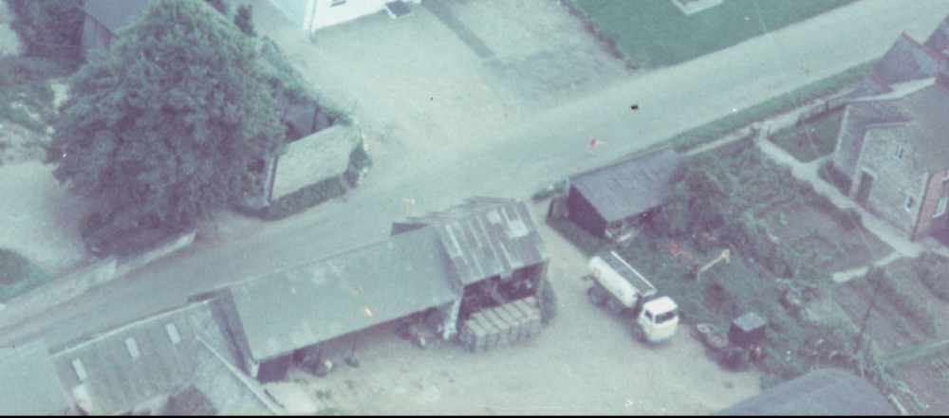
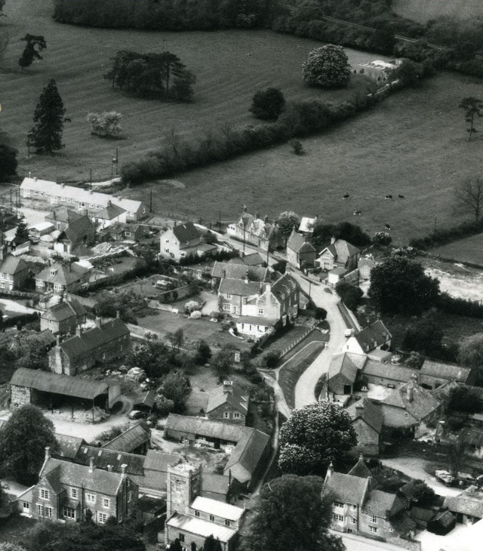
The top picture above is another extract from that 1971 aerial photograph but this time homing in on what is now Church Cottage, Sycamore House, and Holly Tree House, Top Street. The lower photograph is a section of an aerial photograph taken in the 1960’s which shows in the bottom left hand corner, just above the Rectory and the Church, the opposite side of that same Top Street farmyard prior to redevelopment. There is a Dutch barn on the left, part of which appears in the bottom right hand corner of the top photograph. The lower photograph also shows the site of yet another farmyard re-development which subsequently took place through the conversion of single storey barns at the corner of Top Street/Church Street but with a Church Street address (see below).
Sycamore House, Top Street, sits pretty-much on the line of the former Dutch barn shown above. It is constructed in red brick with a slate roof. Its dormers sit across the eaves line which mimics the other such examples within Wing, at Wingwell Farmhouse (Listed) and 9 and 7 Top Street. The fenestration simulates vernacular architecture.
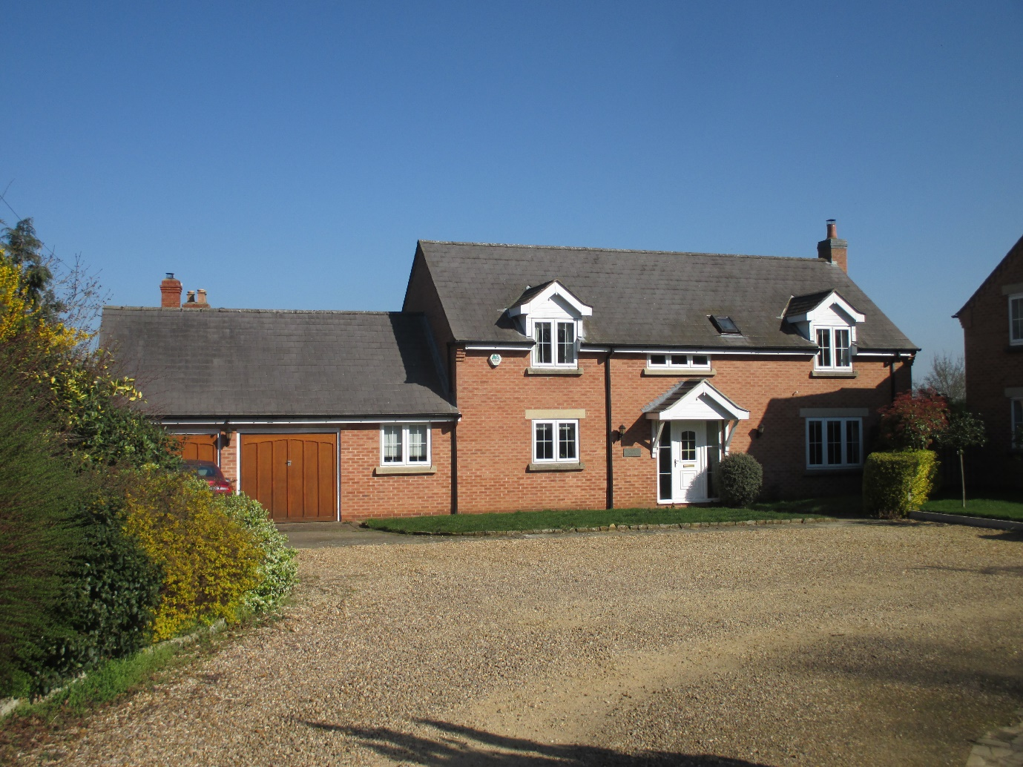
Of the three properties comprising this farmyard infill redevelopment dating to the 1990’s, two were wholly constructed from new materials following farm buildings clearance, and the third, Church Cottage, with its southern wall fronting Top Street was constructed with the re-use of two existing stone-walled farm buildings. The offset access and the stone building frontage to Top Street, with the gables in limestone coloured bricks at what is a sensitive streetscape close to the old Rectory (now called Churchfield - Listed) and the Church (Listed) dating to the 12th Century, help to harmonize the impact of this modern architecture.
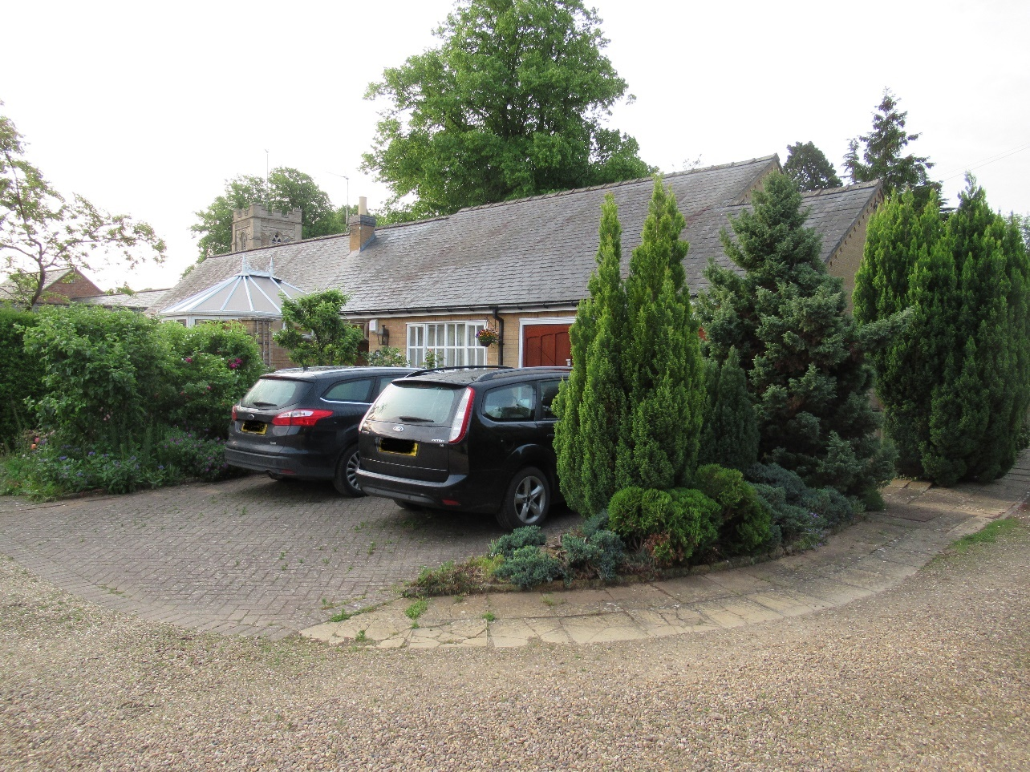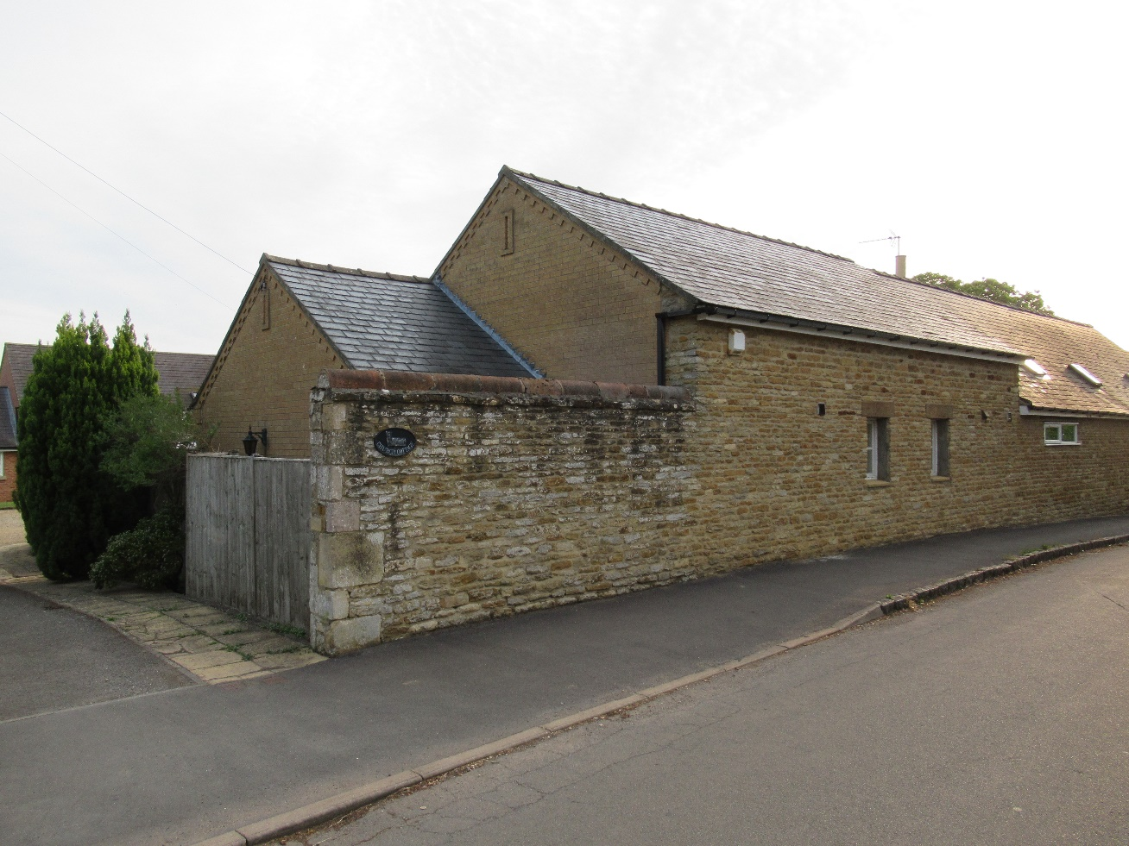
Holly Tree House, Top Street
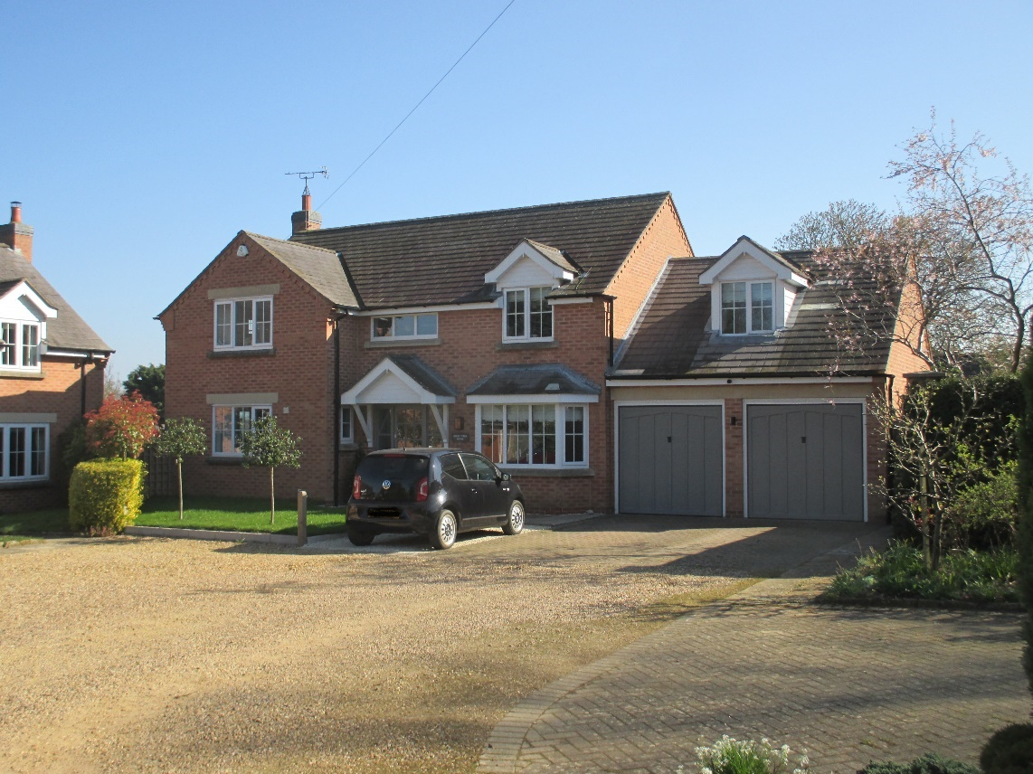
The detailed design of Holly Tree House is slightly different, but the materials and design characteristics are the same as for Sycamore House. Somewhat strangely the dormer, which is of the same design, is set lower to its eaves, as are the stair-light windows. Both properties have front-door canopies on timber brackets, whilst only Holy Tree House has both a bay window to the ground floor and a garage dormer.
Top Street, Wing Village Hall
On the south side of Top Street beyond Churchfield (Listed) and the Church (Listed), the Village Hall is the last property on Top Street before it becomes Morcott Road, and the last property within the Conservation Area. Townsend House (Listed), opposite the Village Hall on the north side of Top Street, also marks the end of the C.A.
Built in 1853 as the village Church of England School, it continued as a school until closed in the early 1970’s. It was sold in 1980 to the local community to be used as the Village Hall. Subsequently, it was remodelled and extended with the use of Millennium Grant funding and other charitable donations and was vested in a Charitable Trust which operates with the Parish Council as sole Trustee.
A field at the south side of the Church graveyard is still in Church ownership but is outside both the C.A. and the village boundary for permitted development.
An adjacent field, east of the Church owned field, and west of the Glaston Road, known as the Village Recreation Field, was gifted to the Parish Council by Dorothy Worrall and has been made the protective subject of a ‘Fields in Trust’ covenant. It too, is outside both the C.A. and the area of permitted village development.
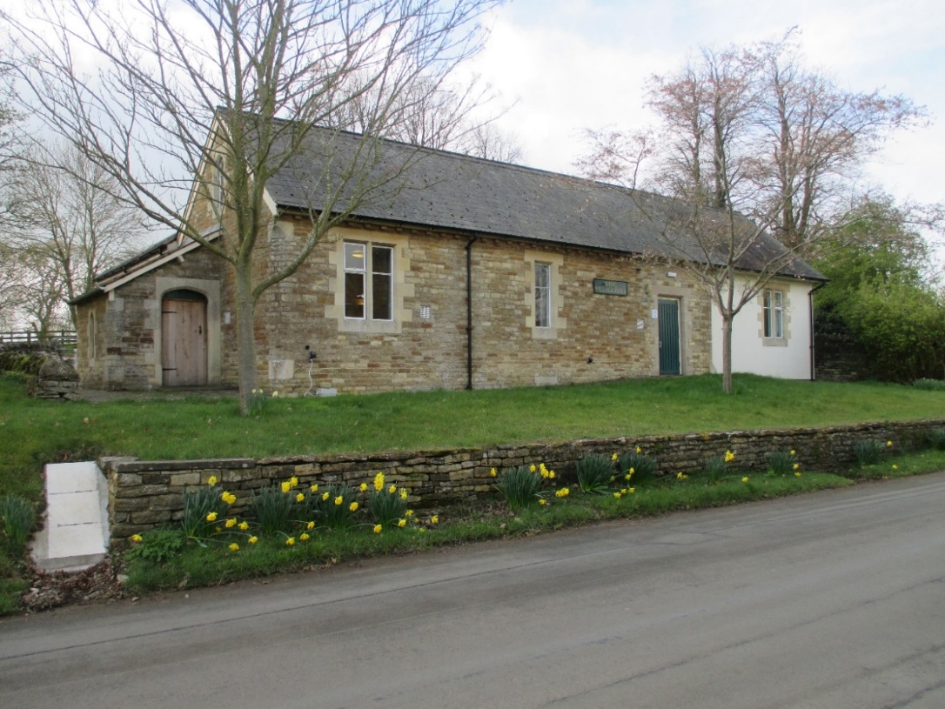
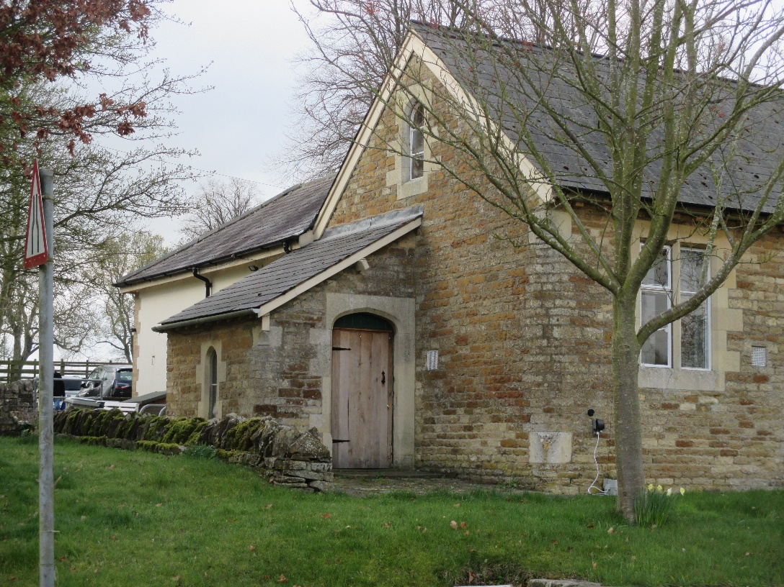
The Village Hall, as it stands today, was constructed of limestone with limestone quoins, door-header, and window reveals, and has a slate roof. The modern extensions are in rendered block with limestone detailing.
Taken together with its immediate neighbours, the Church and Churchfield, the Village Hall occupies an important part of the historic and architectural street-scene. It needs to be further protected beyond the terms of the Trust Deed and constitutes a Local Heritage Asset.
Morcott Road
Morcott Road, which is an easterly continuation of Top Street beyond the Village Hall (southern side) and from Townsend House (northern side), provides the eastern access to Wing village and this eastern end of the village is marked by the eastern boundary of permitted development and the junction between Morcott Road and Glaston Road (running south – see photograph below) and the old Hambleton Road (now an unmade ‘green lane’ running north). The Glaston/Hambleton Road historically was part of the main Medieval highway running from London/Northampton to Lincoln/York, largely unrecognizable as such today, and the Top Street/Morcott Road was historically part of the main Medieval highway running from Leicester to Stamford, again unrecognizable as such today.

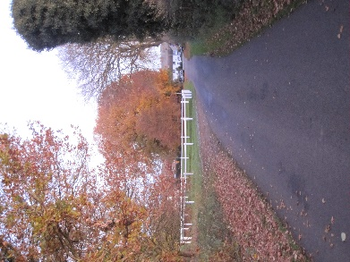

Wing’s first Council houses were built at this junction in 1930 – they appear ‘white’ in the above current photograph of Glaston Road which also features the Wing Maze (Listed Historic Monument) surrounded by its white fence.
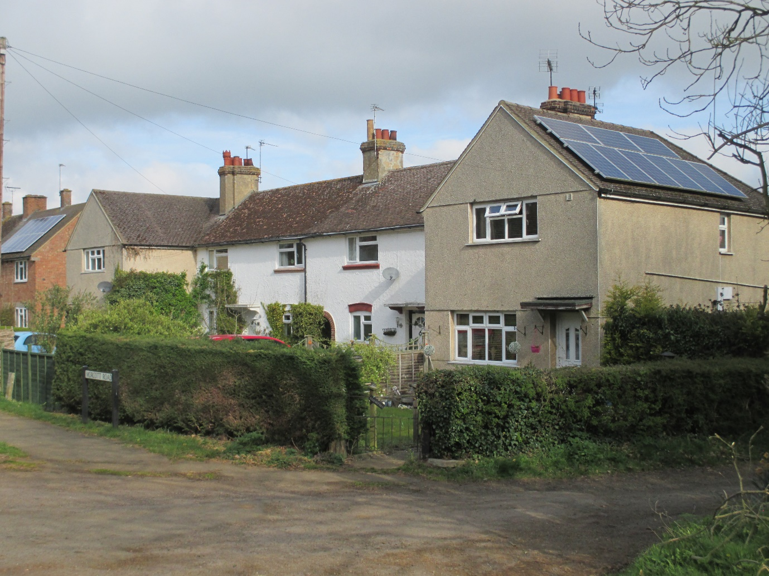
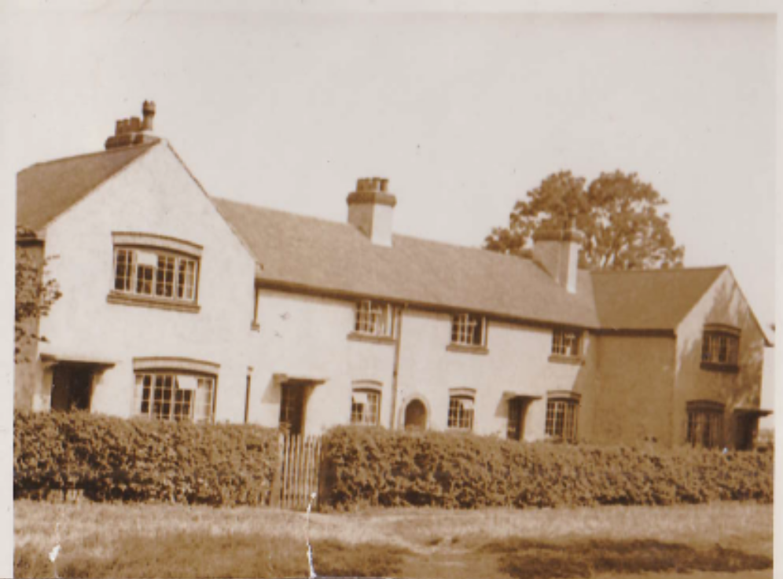
31 to 37 Morcott Road; The two photographs above show these houses (now in mixed tenure because of ‘The Right to Buy’ legislation) as they are today and how they looked shortly after their construction. They were built in common brick and pebble dash rendered and had plain brownish-red clay roof tiles. They were reputedly built for railway workers, Manton Station/Junction being a very busy mainline linking London to Liverpool and having shunting yards for freight haulage linked to local stone quarries. The design is typical of a model used by public utilities from the 1920’s to the 1940’s with front gardens and sizeable back gardens, in these cases with fine views over the Chater Valley. The original fenestration is reminiscent of the ‘Arts and Craft Movement’. Born out of Lloyd George’s “Homes fit for Heroes” 1919 legislation, these houses constitute Local Heritage Assets.
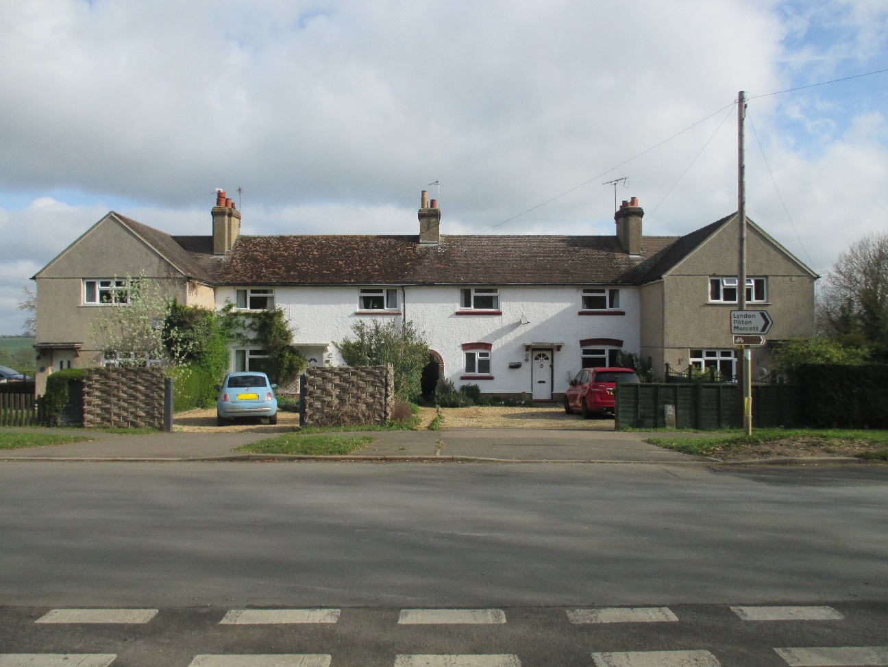
Originally sited a few hundred yards distance from the last of the other village houses at ‘Townsend House’, these first four council houses saw the intervening land and the land opposite between the Glaston Road junction and the village school/hall, successively developed for further phases of council houses and flats/apartments in 1946, 1949, 1953, and 1965. Many of these houses are also now in private ownership because of the ‘Right to Buy’ legislation.
1946, 18/20 Morcott Road; Two timber clad, prefabricated houses were built immediately west of Glaston Road and were a gift from Sweden after the end of the Second World War to assist in meeting the UK’s housing crisis. They introduced an unusual piece of architecture into the village, presumably setting the scene for other timber clad houses that followed on Glaston Road and Reeves Lane.
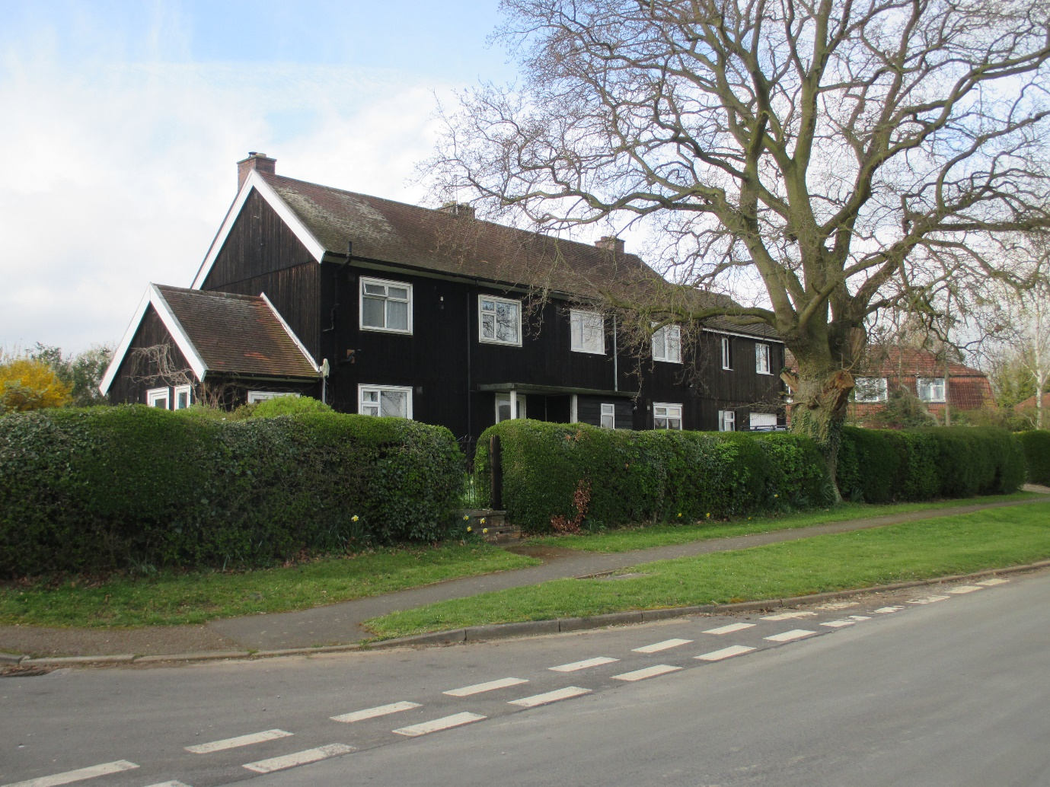
1949, 15 to 29 Morcott Road; Eight houses (4 X 2 semi-detached) constructed west of the first four, in common brick with plain clay tile roofs. Many have been remodelled concerning their precise plan arrangements because ‘Tudor Walters’ (the new 1918 utility standard for public housing) floor areas were relatively generous, but not necessarily well organised. The Chater Valley view is a real asset.
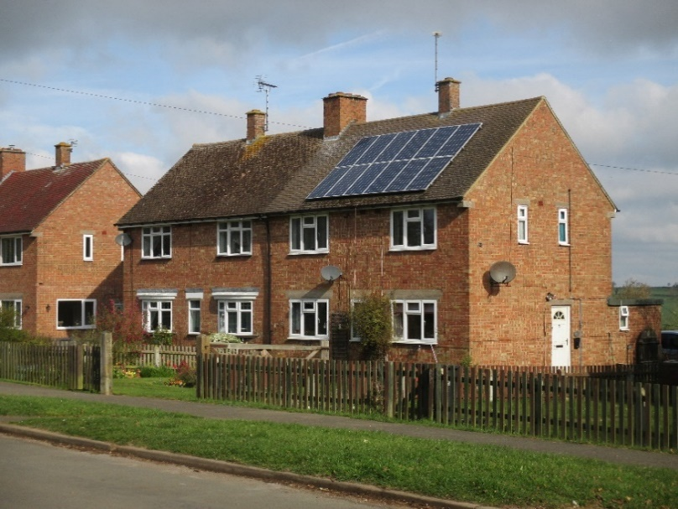
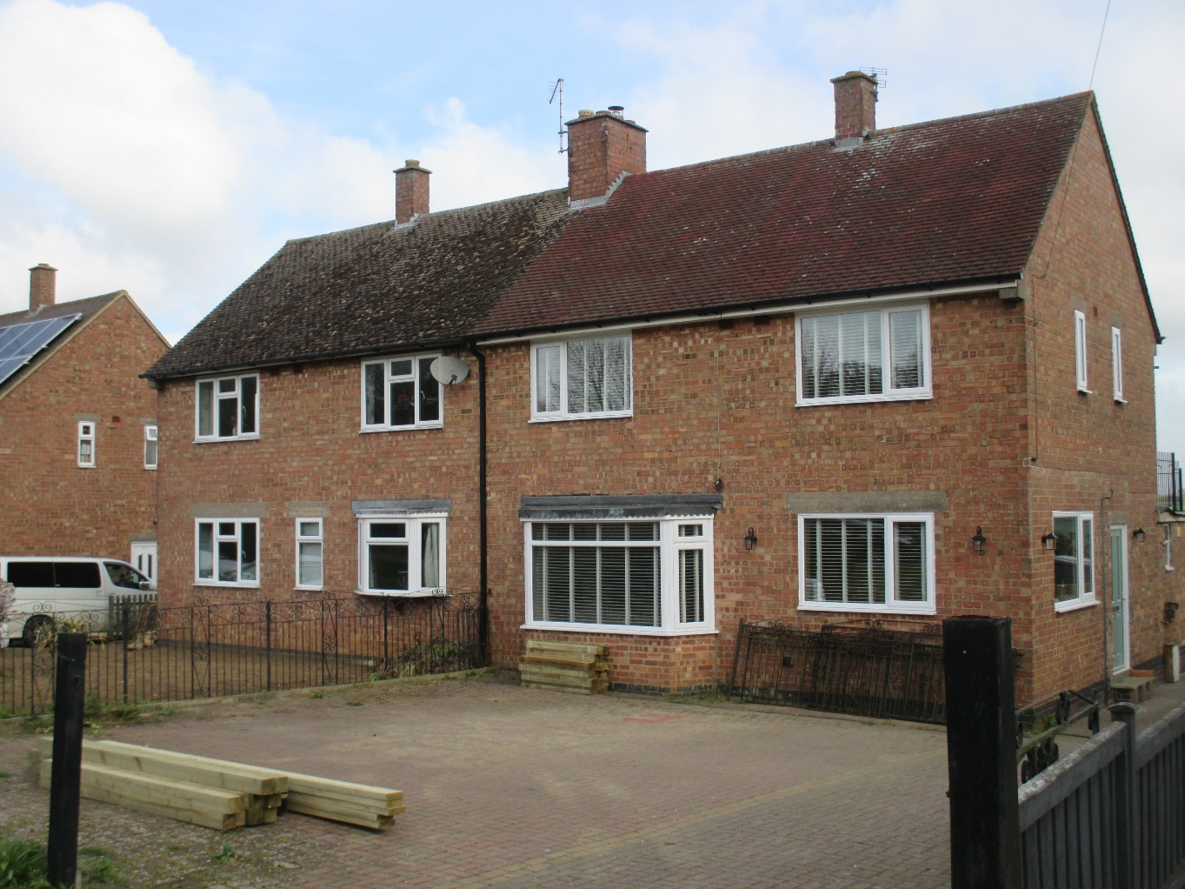
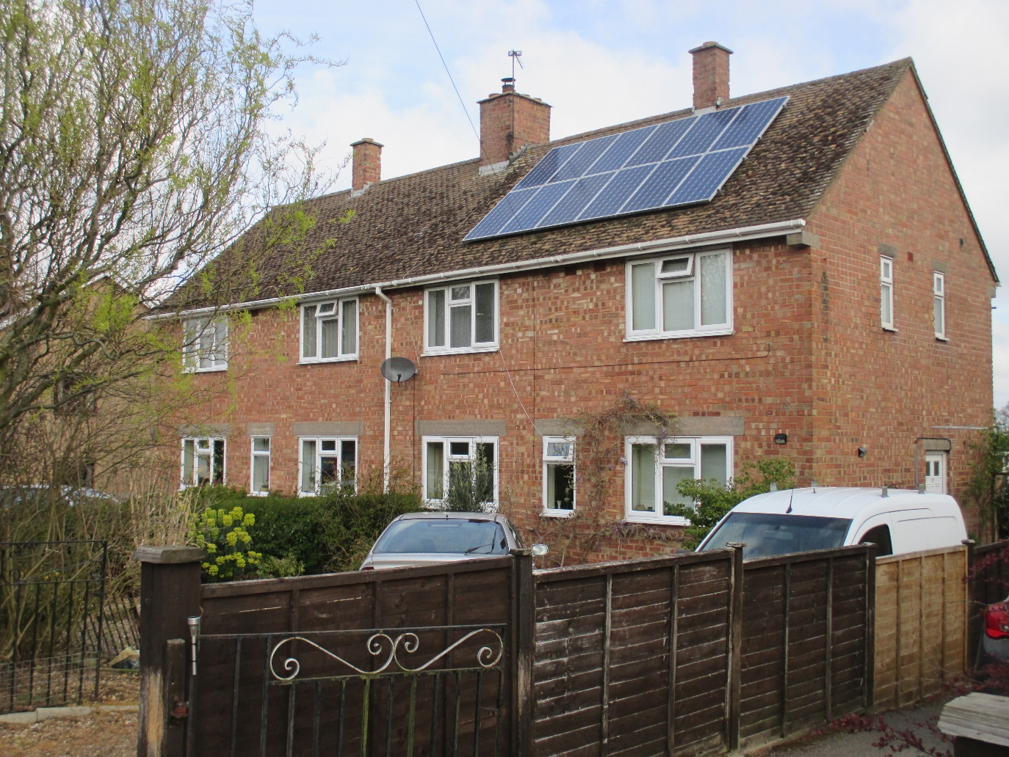
1953; 2 to 16 Morcott Road; Eight system built council flats, in a typical 1950’s ‘Cornish’ design, were next developed on the south side of Morcott Road, adjacent to the ‘Swedish Houses’. Originally these buildings had concrete wall panels and introduced another and locally alien design feature in the form of a ‘Mansard’ roof. These system built flats developed structural faults, had poor insulation, and were the subject of national remedial programmes of publicly funded work. Today they present as limestone coloured brick facades with terracotta (and the more-scarce low-arched) interlocking pantiles. These properties are also differently set at angles to the highway, neither face on nor gable end on, as was the local village tradition.
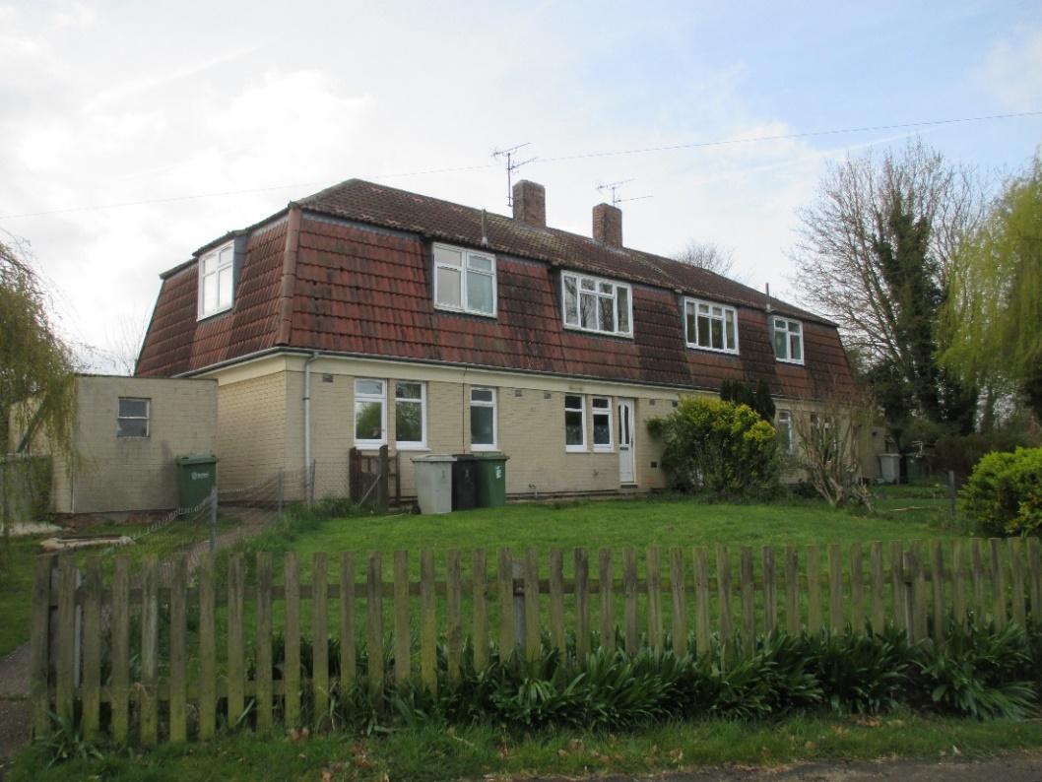
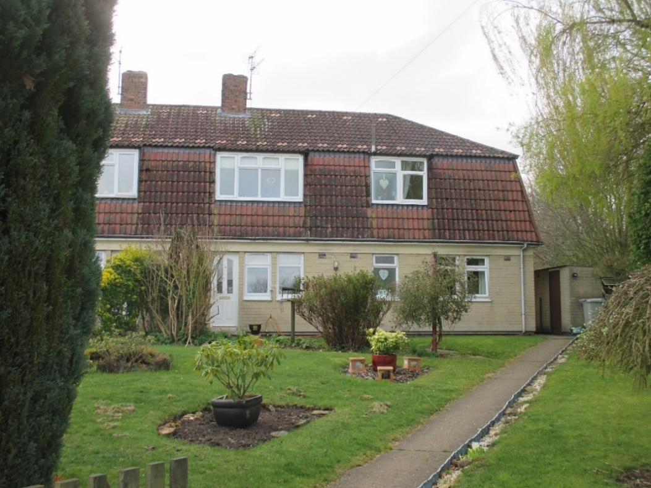
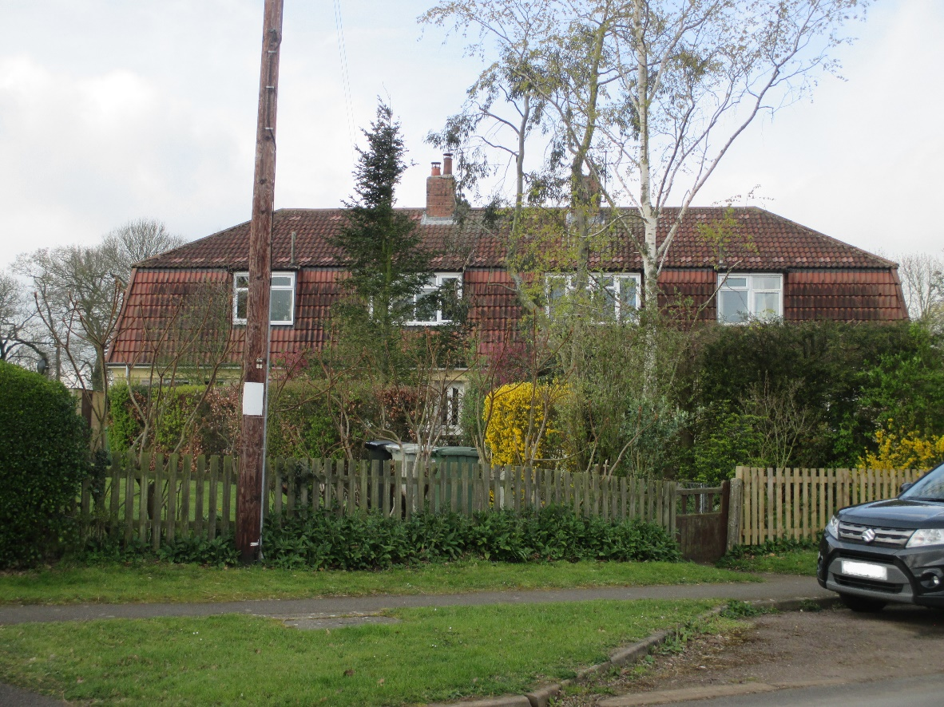
1965, 7 to 13 Morcott Road; Finally, four further council houses were built on the remaining plot between the 1949 development and Townsend House on the north side of Morcott Road. These were of a typical 1960’s local authority design (based on the new Parker Morris 1961 standards for public housing) with sand coloured bricks and a grey, ribbed, interlocking concrete roof tile. Bay windows were fitted to the living rooms and small canopies to the front doors. As with all houses on this north side of Top Street, the Chater Valley view is terrific.
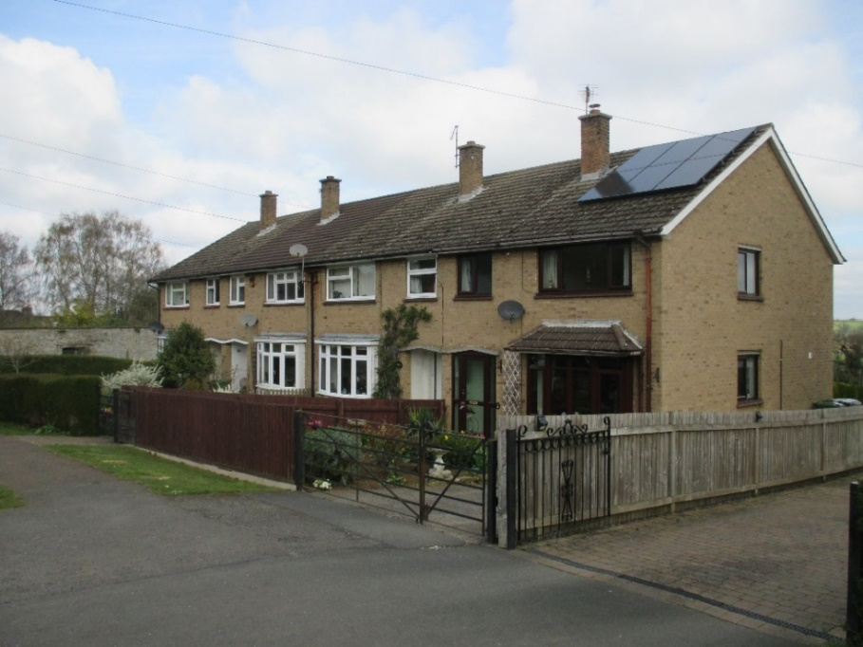
Morcott Road, Glenbervie House, sits within Wing Parish but outside the Wing Village area of permitted development and also sits outside the Conservation Area, on the eastern side of the Old Hambleton Road (Flinthams Lane) and the north side of the Morcott Road, with its main residential access perhaps a hundred yards from the Glaston Road/Morcott Road junction. The house was built in 1994/95 and is located within its own farmland again perhaps a hundred yards down its own drive off Glaston Road. Its stone came from the same old barn source as Tannachie House.
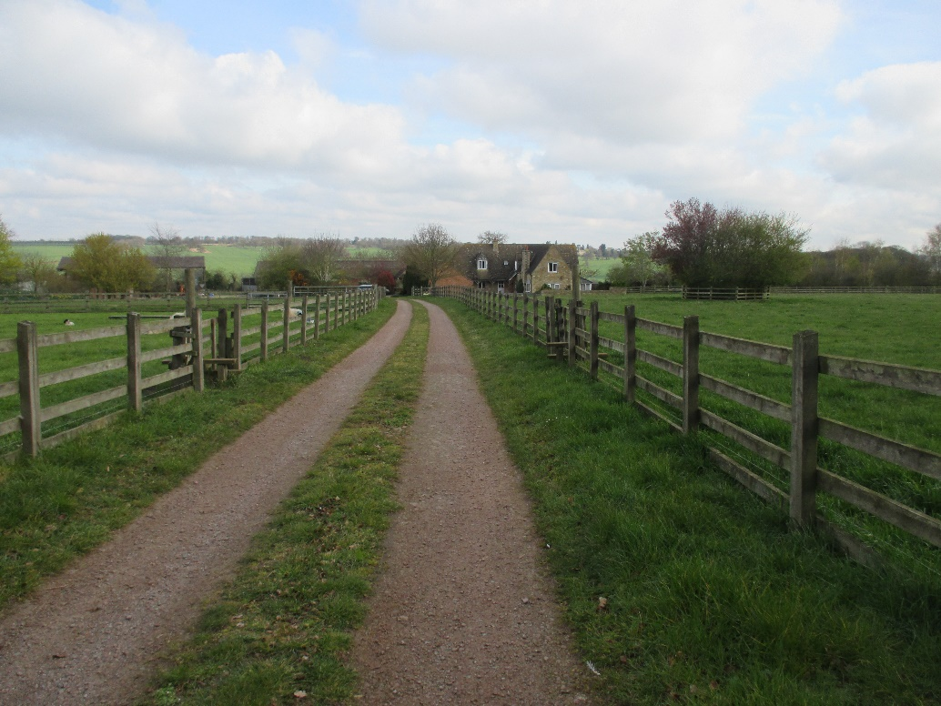

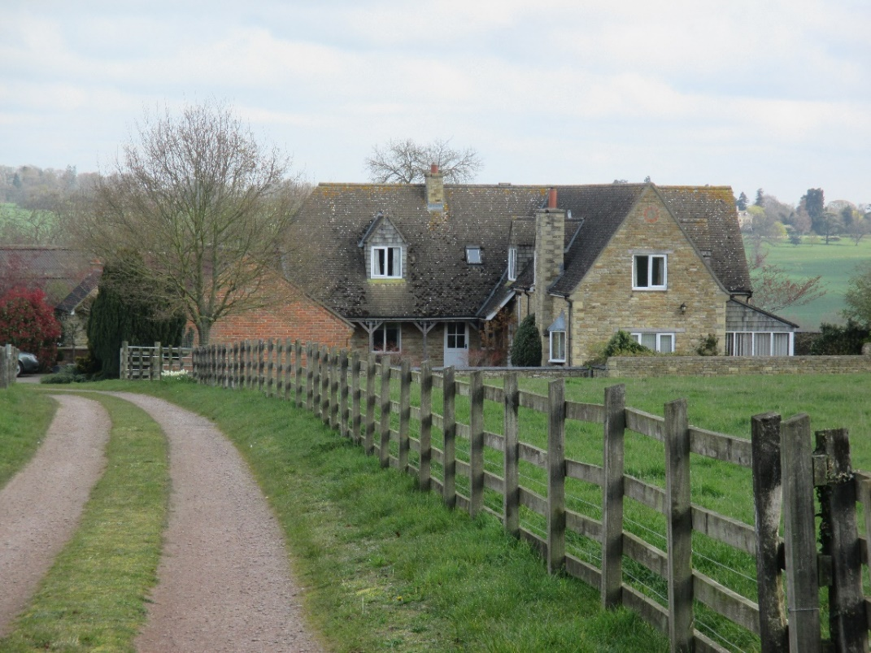
Glenbervie House is constructed in limestone with extensive limestone quoins and a plain clay tile roof. The front access is through a three-sided courtyard, the entryway being flanked by two single storey outbuildings in red brick. It has conventional dormers which are roof-tile hung on the sides and facias and these are contained wholly within the roof slope. The south-facing side of the courtyard has an extended overhung roofscape to provide a loggia, something akin to the south side of Wing Hall. The two-light modern casement timber windows are without glazing bars. There is a protruding two-light fire window with lead canopy. It embraces some of the vernacular architecture.
Glaston Road
There are two developments on the Glaston Road, both within the area of permitted development. The first comprises two detached bungalows built in the 1960’s. These sit within sizeable plots roughly equivalent to the plot sizes of the houses constructed at the western end of Top Street and Reeves Lane/Westhorpe Close in 1972/73.
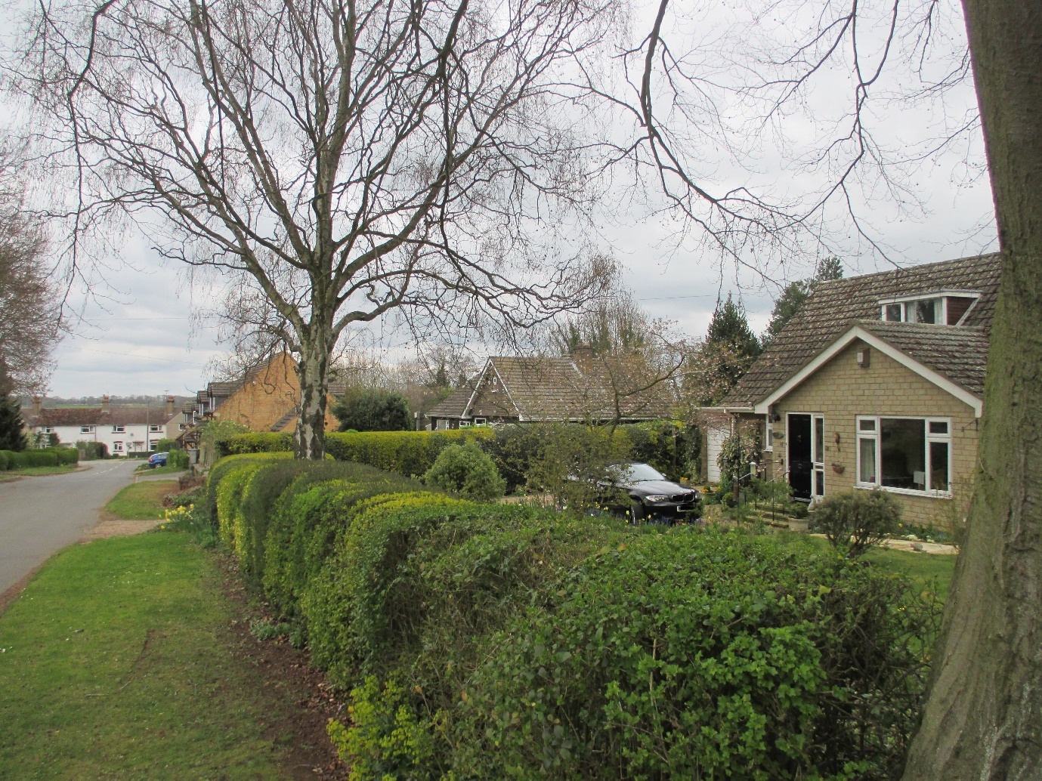
7 Glaston Road
This bungalow is constructed of grey sand coloured brick/stone with grey, ridged, interlocking concrete roof tiles. The gables are half-timber clad. It has large fixed central window lights flanked by rectangular casements and top ventilation lights, all in timber and indicative of the period. There is a similar flat roofed dormer which is lead covered. It has an attached garage.
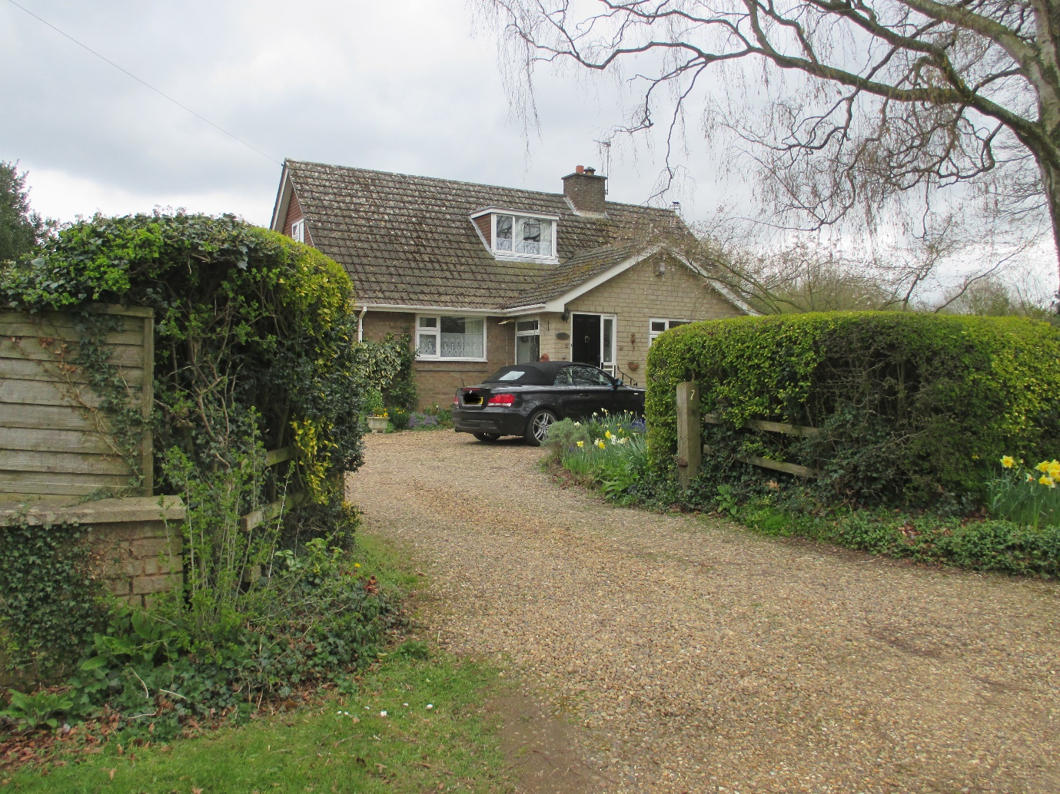
5 Glaston Road
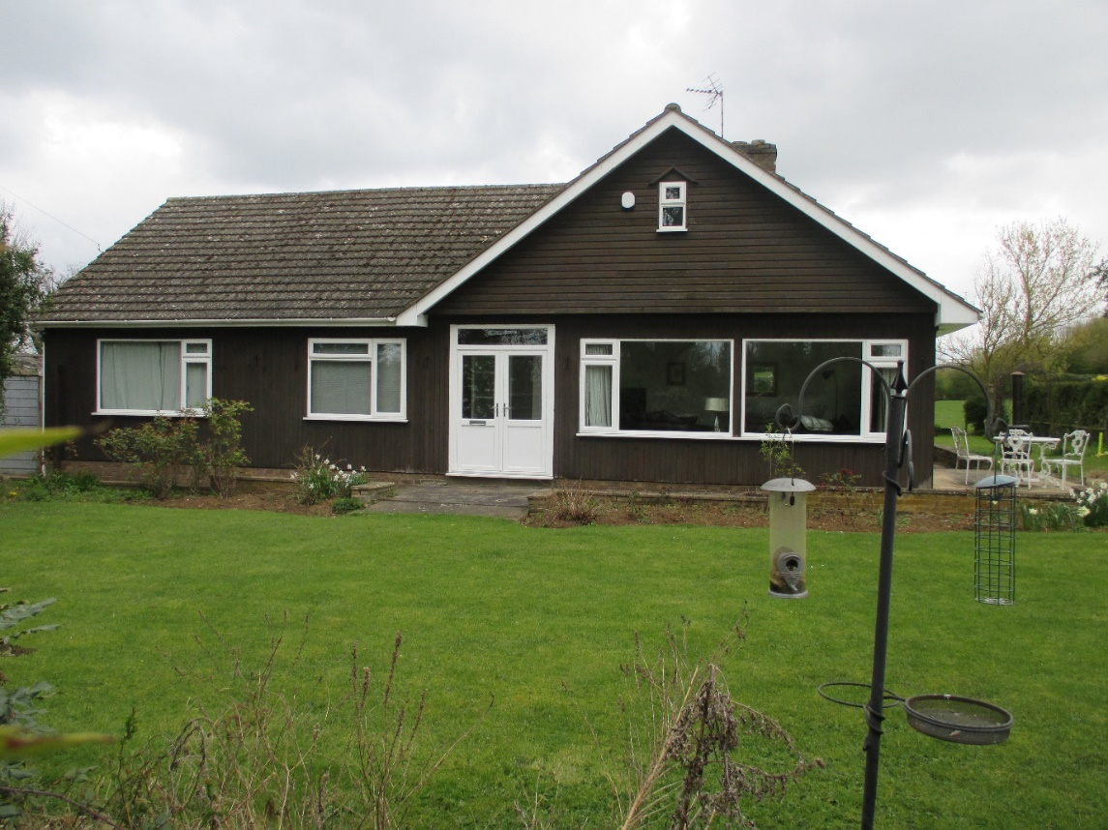
5 Glaston Road was built in the 1970’s, has the same plot characteristics as 7 Glaston Road, but is timber clad with a wider forward extension and a lower roof pitch, albeit still covered with concrete ribbed and interlocking tiles as at number 7. There is a small forward facing window in the front gable, but no dormer and the garage is a detached prefabricated structure in concrete. Until comparatively recently this property had an industrial connection to the land lying between its present residential northern boundary and the Morcott Road where an industrial unit/servicing garage together with yard/parking area stood. These were demolished in 2009 to make way for four terraced houses (see photograph below) which either share a party house wall or a party attached garage wall.
1, 2, 3, and 4, Glaston Road
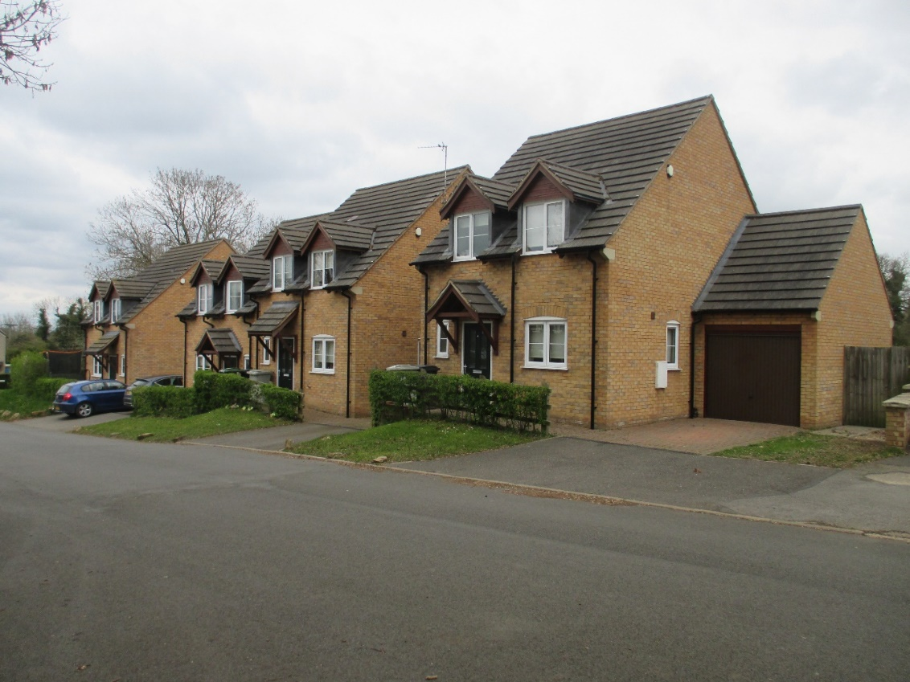
These houses built in 2011/12 are constructed of limestone coloured bricks with dark grey plain concrete roof tiles. They all have conventional dormers at the eaves line which are tiled with bargeboard facias at the gable and lead sheeted sides. The three principal windows on the frontage are square two-light opening with one side hung UPVC casement and central glazing bars. The principal ground-floor window also has boarding to a shallow brick arch. These (except for the UPVC) are consistent with the local vernacular which is itself consistent with the ‘Sub-Medieval Phase’ which lasted until the mid-18th Century. (See R.W. Brunskill ‘Vernacular Architecture: An Illustrated Handbook’ 4th Edition 2000, Faber & Faber Ltd.) All the houses have tiled porches to the front doors carried on timber wall brackets.
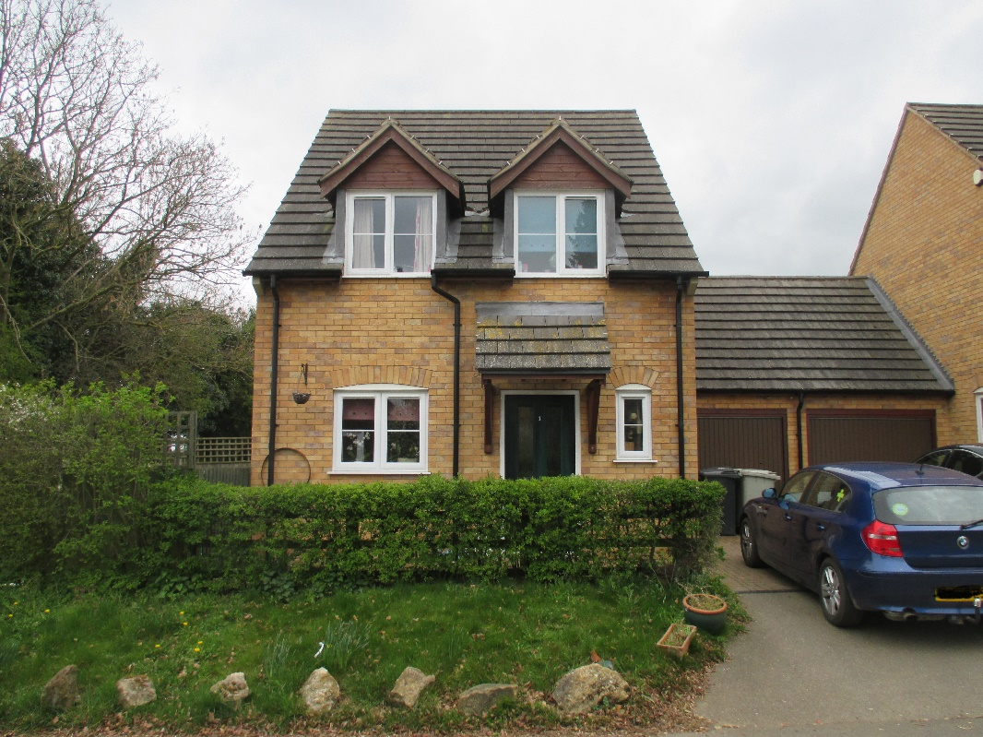

1 Mill Close is located off the Glaston Road outside the Wing Village area of permitted development and outside the Conservation Area, but inside the Wing Parish boundary, hence the six houses at Mill Close, like Glenbervie House (above) on the Morcott Road, and Wing Grange (below) on the Preston Road, and the cottages at Wing Hollow (below) on the Manton Road, are all technically outside the village – a bit of a nonsense. The Wing village road sign indicates that Mill Close sits inside the village.
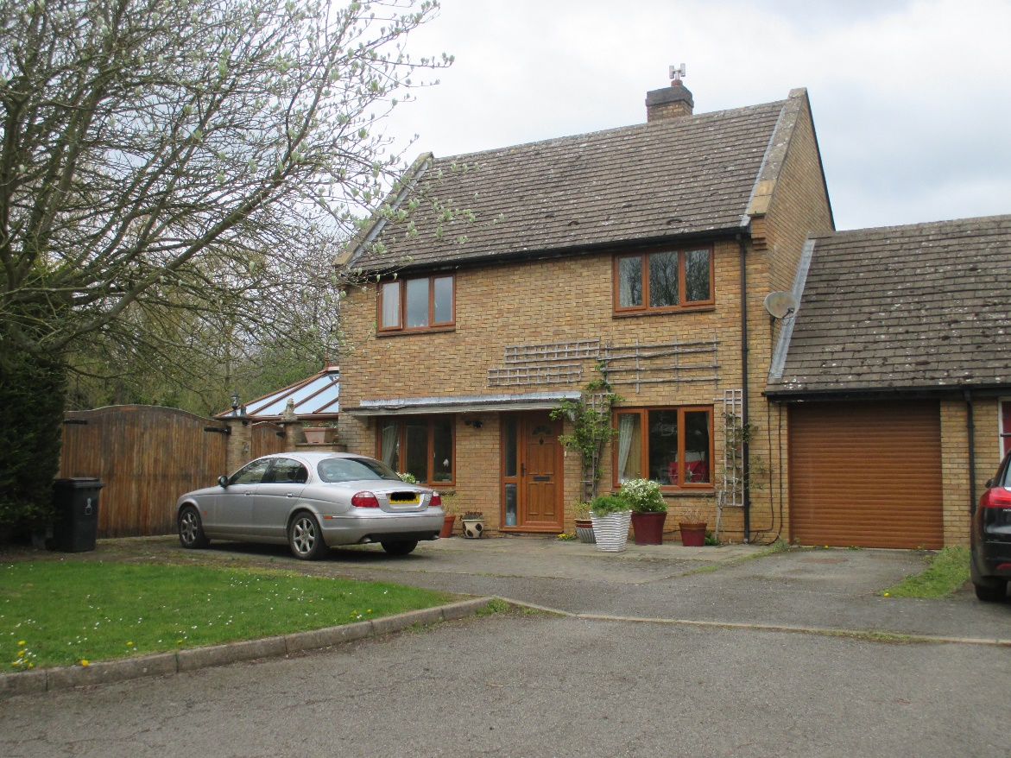
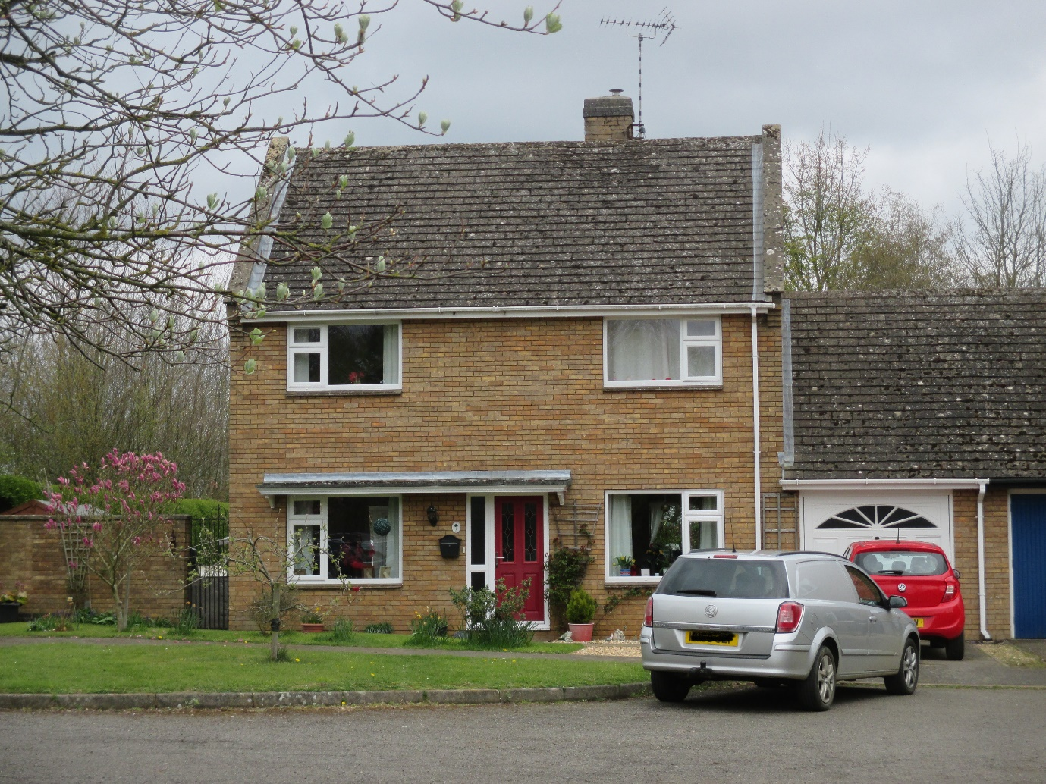
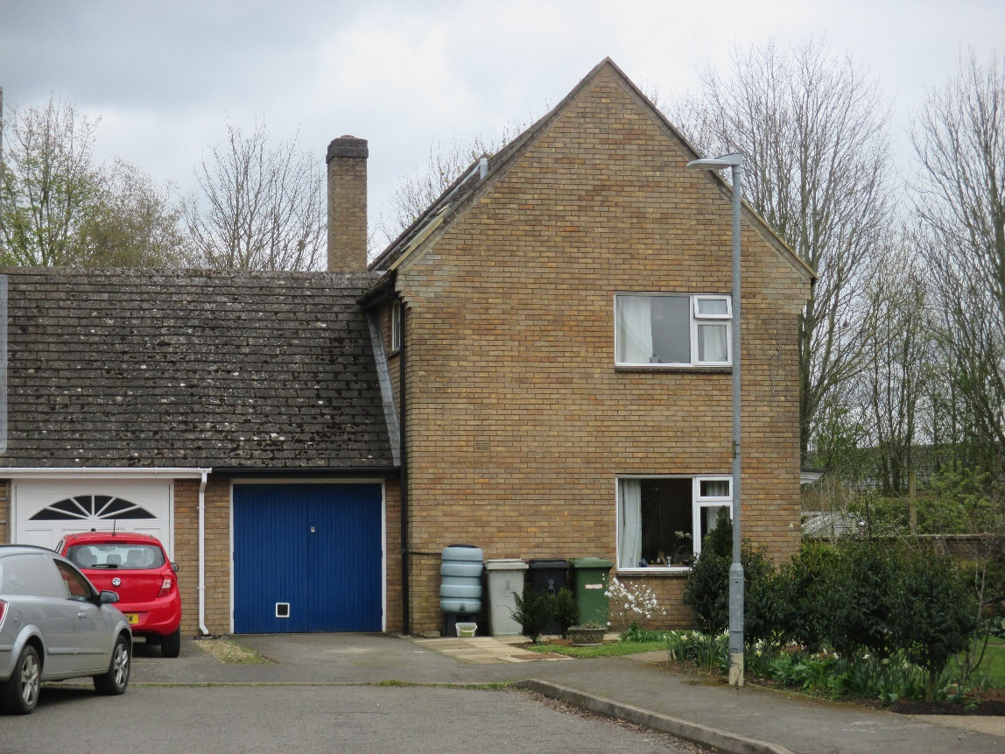
Built in the 1970’s by the Water Authority for its staff, these houses were sold off consistent with all those housing portfolios that were owned by public utilities and privatised during the 1980’s and early 1990’s. Constructed of limestone coloured bricks and plain clay tiled roofs these houses attempted to simulate some of the vernacular architecture, additionally including raised gables with concrete capping stones and brick kneelers. Unfortunately, emulating a stone predecessor in concrete and brick appears to have contributed to some design problems in terms of water ingress, leading to remedial works precisely around the eaves at the brick kneelers. Nevertheless, with that problem presumably long solved their general appearance with those characteristics conveys vernacular empathy. Unfortunately, as with a significant number of village houses built in the 1960’s, 1970’s and the early 1980’s, a commitment to including some vernacular detailing was to some extent undermined by the inclusion of fenestration wholly unsympathetic to previous historic indigenous casement and window light architecture.
This in turn highlights the need for advice through a village design guide that covers more than new construction and doesn’t necessarily imply intrusion or additional costs to residents in helping to more widely achieve the design outcomes indicated by their responses to the recent Neighbourhood Plan Questionnaire. Such advice could be deployed at times when there is fresh investment in properties, typically at changes of ownership, or as major visible components require renewal.
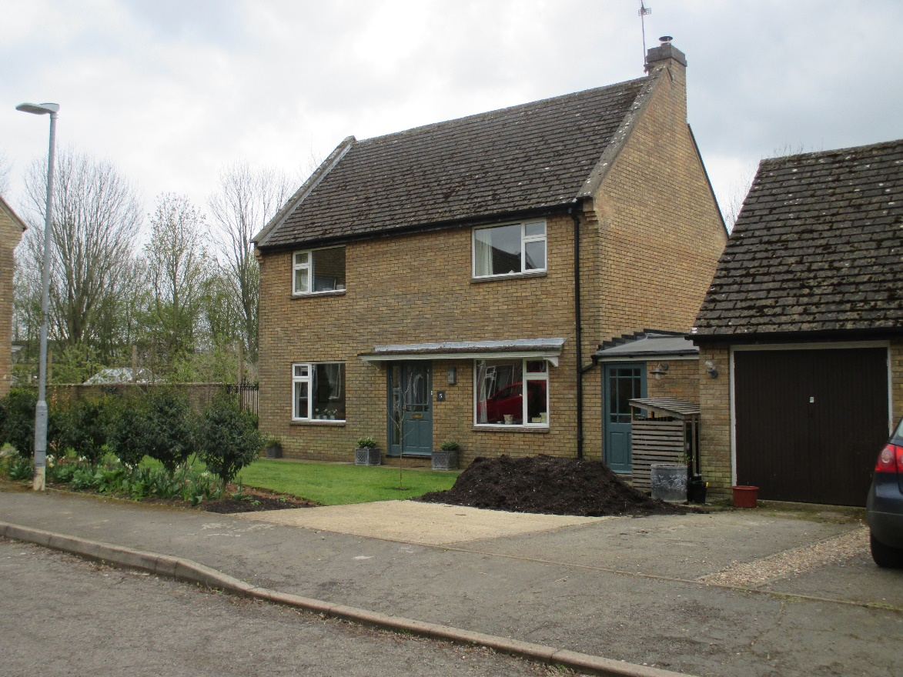
The houses at Mill Close front the street with two exceptions which are gable end on and they have linked garages with one slight variation, much the same as the approach adopted at 1 to 4 Glaston Road. Plot sizes vary but they are mainly large compared to comparatively priced new local housing where densities have been increased. The Mill Close site inherits its name from earlier times when one of two Wing Windmills was located on the sites north-western corner.
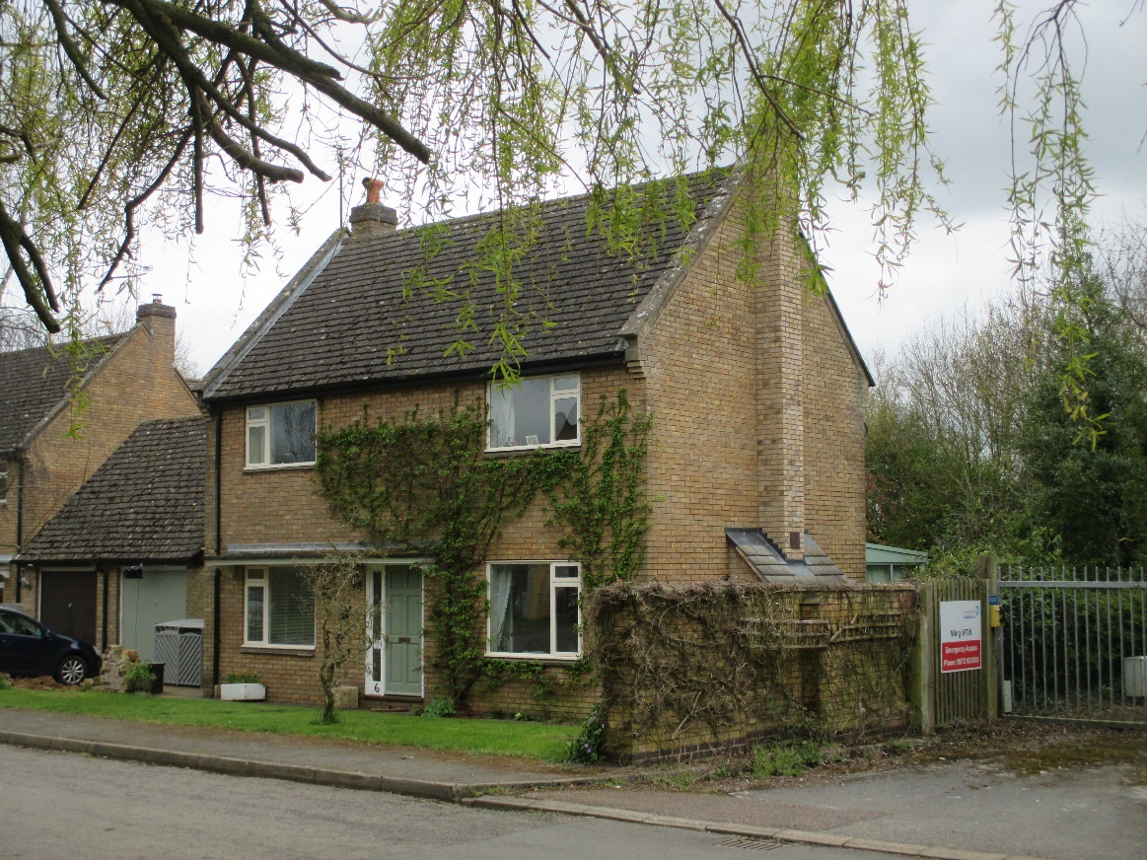

Church Street
Returning to the Wing Church of St. Peter and St. Paul (Listed) on Top Street, Church Street, opposite, runs downhill in a northerly direction. It is wholly within both the village area of permitted development and within the Conservation Area. There are seven Listed Buildings along its length with dates ranging from the early 17th Century to the late 19th Century. There are protected walls immediately on the right hand side, looking north, and the tennis court adjacent to Inglewood Cottage at number 8 (which is Listed) but owned by Wing House (Listed) opposite, has a Listed boundary wall and is also a protected green space, preserving a far-reaching view from the heart of the village down into the Chater valley. (See Wing Village: A Directory of Listed Buildings 12/12/18.) Immediately on the left-hand side, looking north in Church Street, there is the access to The Byre House and Church Farm Cottage, both buildings having been created in the 1990’s from the farm outbuildings as shown in the 1960’s aerial photograph (2nd photograph below).
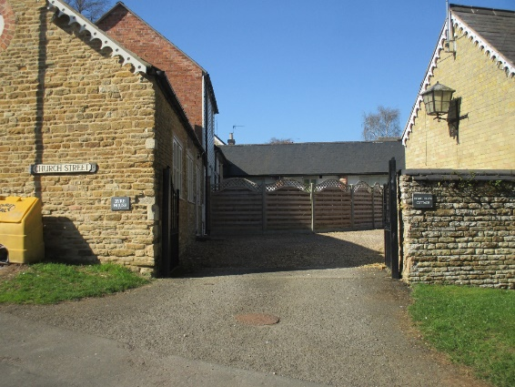
The various walls flanking the access gates and parts of the homes themselves date to different periods as suggested by the current photograph above. The front retaining wall on the right likely dates to the early 18th Century, the walls of the building behind it, now forming part of Manor Farm Cottage, to the late 19th Century, whilst the wall on the left, now forming part of The Byre House, probably dates to late 18th Century/early 19th Century and the two storey brick building to the 19th Century.
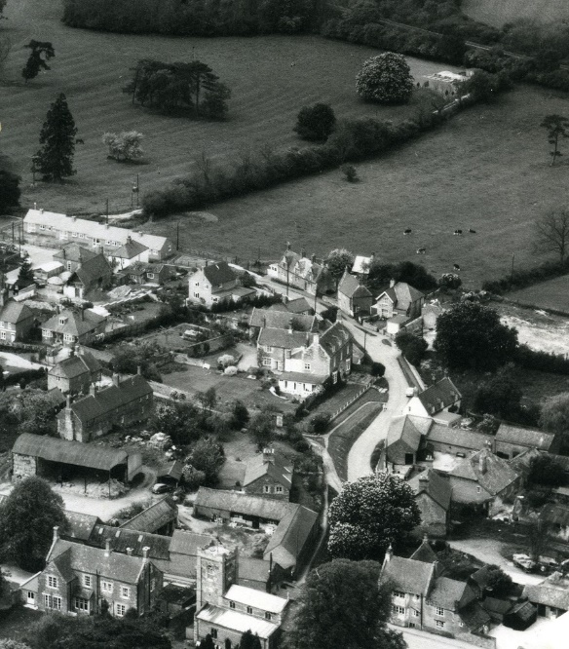
The aerial photograph, dating to the 1960’s also indicates that the tennis court, half-way down on the right, was a later addition but the nature of the front wall to that area and its access gate (Listed) suggest that the purpose of this piece of land was important and may well have been a recreational garden for Wing House in addition to ensuring that the view from Wing House down into the Chater Valley wasn’t compromised by other construction.
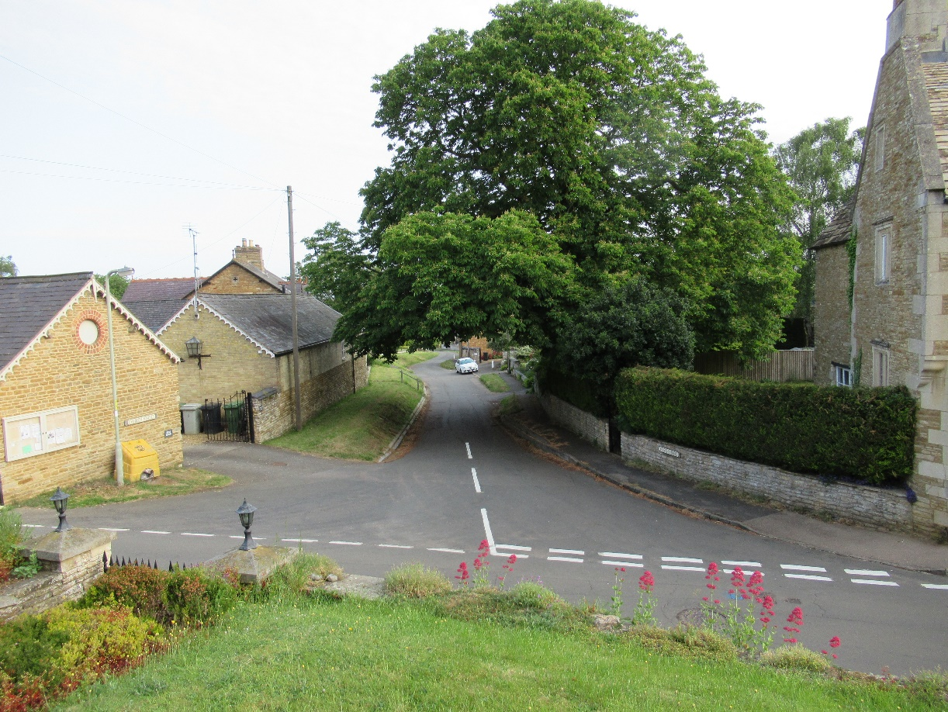

The materials used at The Byre House and Home Farm Cottage are the original stone and brick buildings, but they probably had block work to close the open sides of the original outbuildings to which was added timber cladding. They had/have slate roofs.

1 Church Street, ‘Home Farm House’
Walking south, downhill from the Church of St. Peter and St. Paul, beyond the courtyard development of Byre House and Home Farm Cottage, sits Home Farm House.
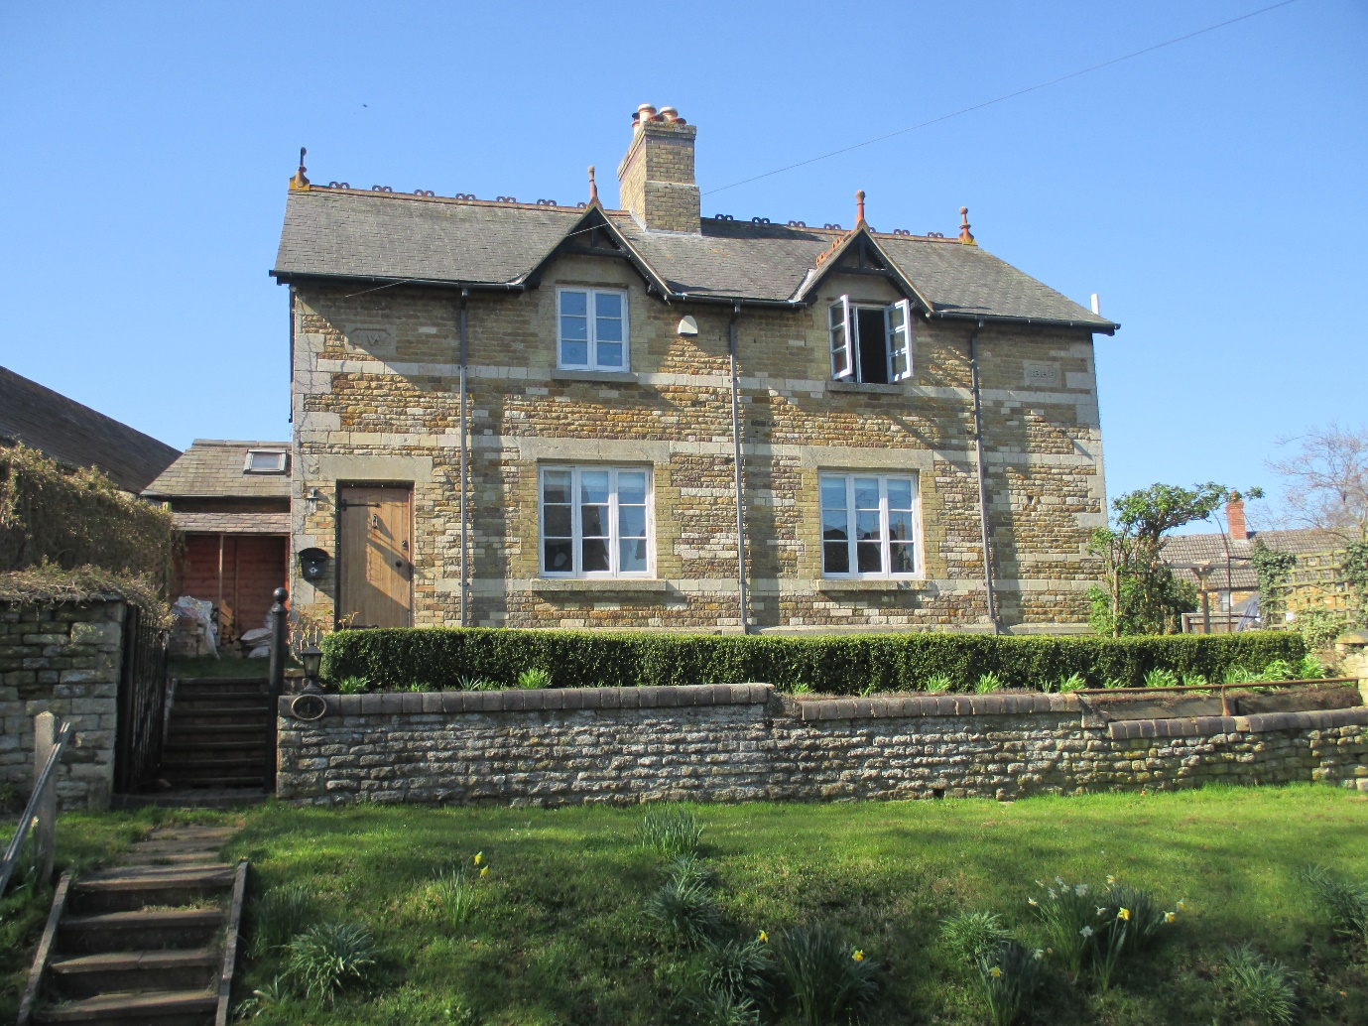
‘Home Farm House’ was built in 1886 by James Worrall, who acquired a significant part of the Sheild family estate in 1885 as settlement of loan debts. (See ‘3,3a and 3b, Top Street, Wing, formerly and chronologically; ‘The Red Lion Inn’, ‘The Noel Arms’ and ‘The Cuckoo Inn’: Summary of the property transactional history’ David Seviour 1/1/2019).
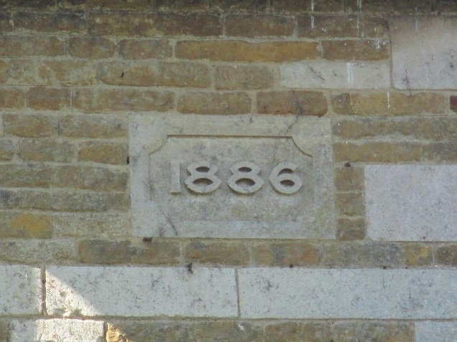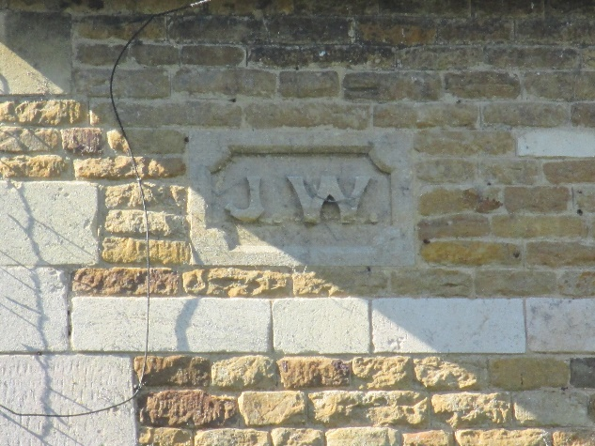
The house was built of limestone and ironstone in shaped blocks rather than ‘coursed rubble’, and it included ashlar quoins, string-courses, window and door headers, a stone capped parapet skirting wall, datestone, initials stone, and door and window detailing in limestone coloured bricks. It has hooded dormers with terracotta finials, and a slate roof with terracotta finials and decorative terracotta ridge tiles. The front garden retaining wall appears to use an older limestone than used on the house. The three light, three pane, nearly square windows simulate the historic vernacular.
It is a house of both historic and street-scene importance and constitutes a Local Heritage Asset.
2 Church Street
Opposite Manor Farm Cottage and north of Corner House (Listed), 2 Church Street was built in limestone blocks. It is an imposing modern house and has limestone quoins, windowsills, window and door detailing. There is a rectangular bay to the first floor built off a shallow front door portico. The two light, four pane fenestration organised in casements of four with a central plain mullion, effectively simulates the vernacular style of some of the nearby Listed buildings but with a crisp modern feel. The roof has thick grey slates which may have been reclaimed. The front building line is well set back compared to the Listed Buildings at Corner House, 6, and 8 Church Street which tends to ‘lose’ the building, particularly when the significant adjacent trees are in leaf.
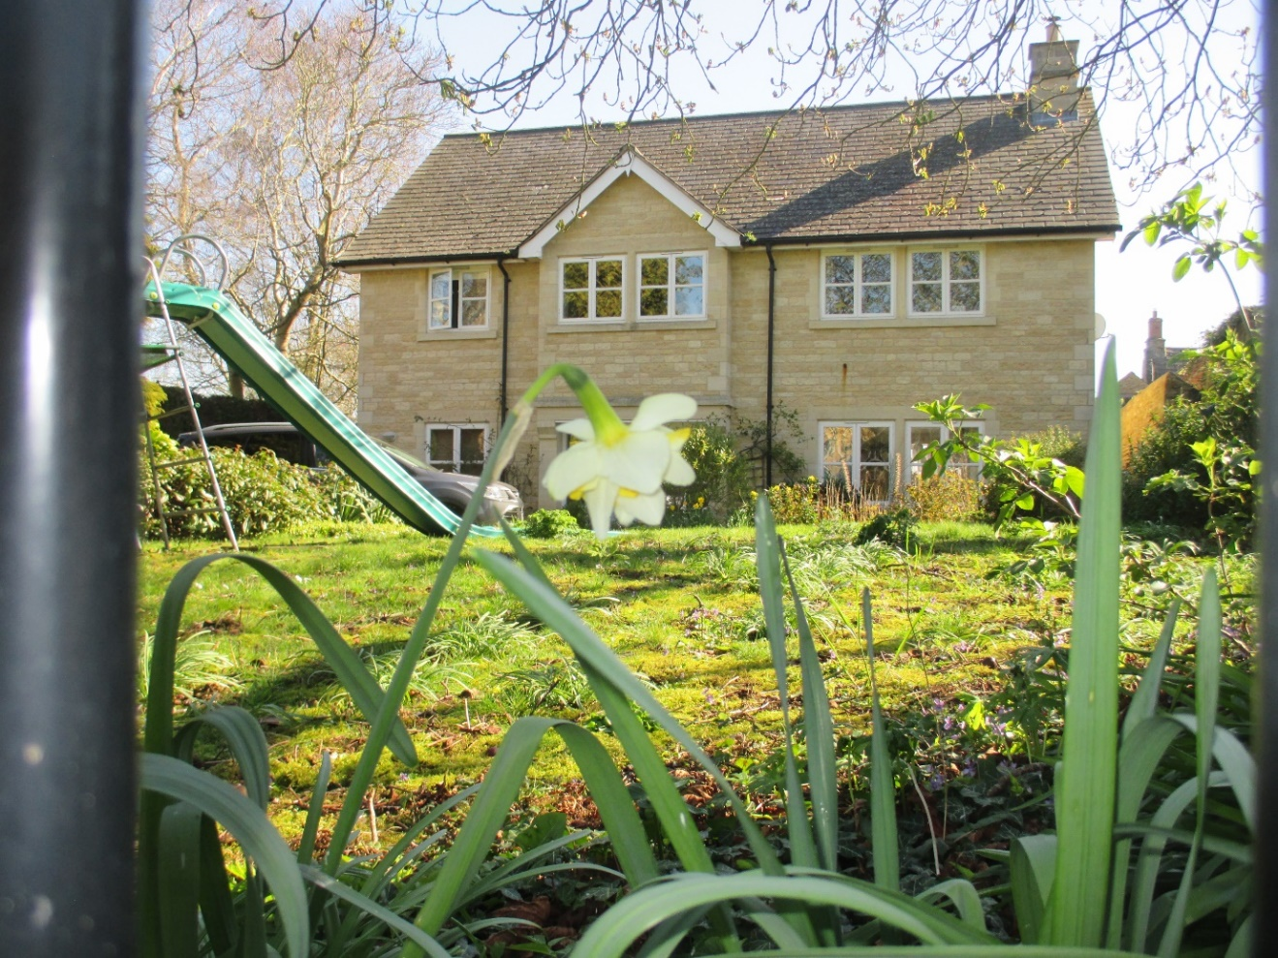

4 Church Street
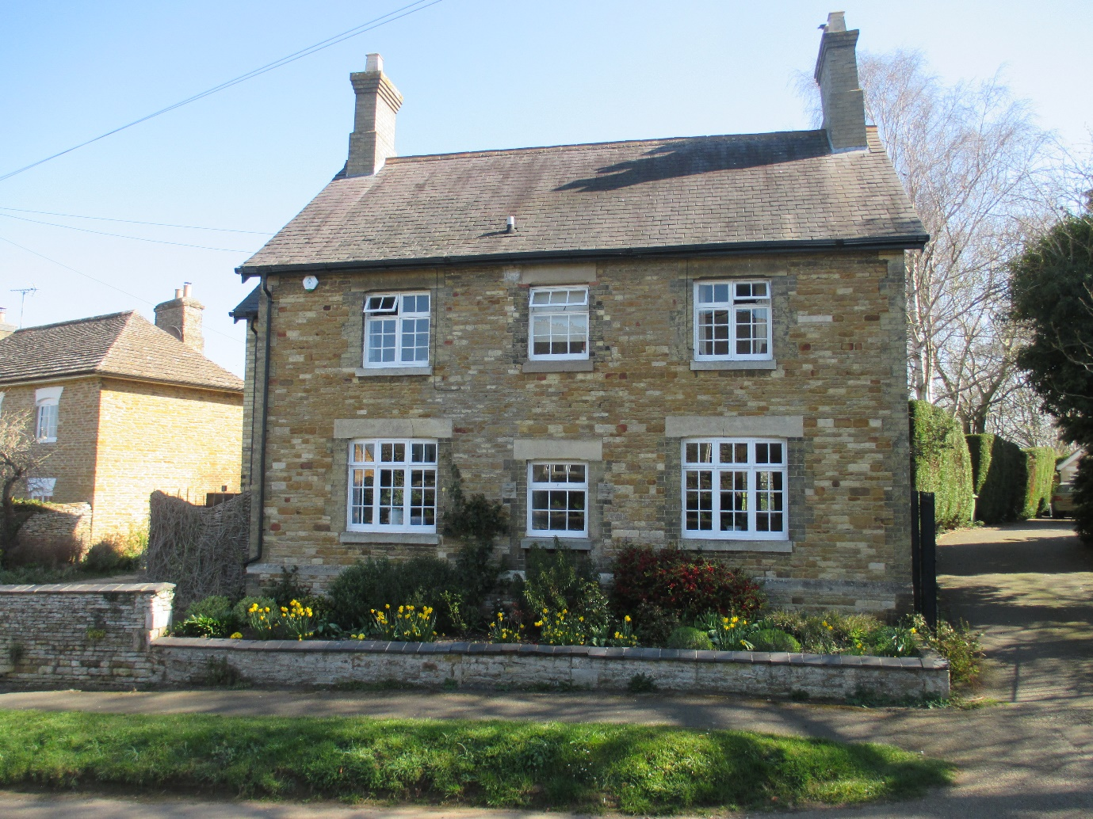
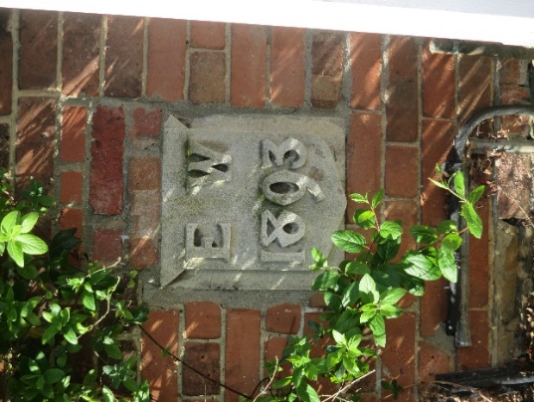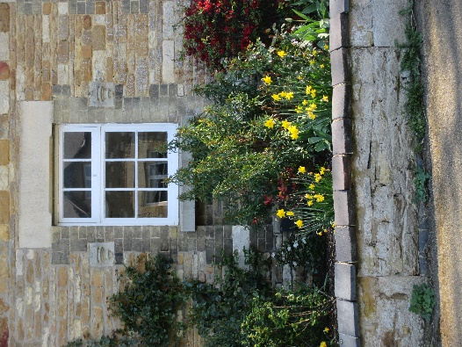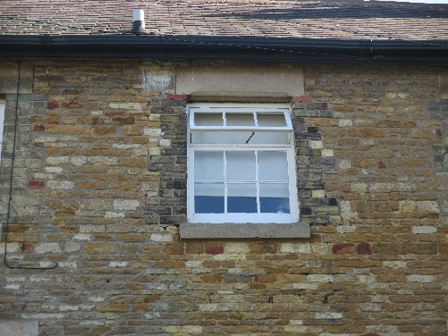
4 Church Street was built in 1893 by Edward Worrall, the frontage being constructed of limestone blocks with some ironstone, limestone quoins, limestone-coloured brick detailing around the windows and the original and central front door opening, very much like Home Farm House. The roof is also of slate. Similar elements of the fenestration - three-light casements - can be discerned too but they have been changed to a later style of panes numbering six in each section with two-pane top opening lights. Clearly two of the ground-floor window headers have been changed with the removal of the brick headers, presumably to facilitate the changed frame. In addition, the front-door framing has been half-closed to become a window and the access re-made at a left-hand side extension which may have been facilitating a relocated staircase? The central first floor window, despite an attempt to simulate the other brick window-detailing, looks to have been a later creation and once was probably an area that only contained the stone initials and date plaque detailing which, once removed, was remounted at ground level on the red brick façade of part of the rear of the house. It is now only notable because it is located adjacent to a pedestrian gate to the garden from the drive of number 2 Church Street.
Like Home Farm House, there is a stone capped parapet skirting wall along the frontage.
Nevertheless, notwithstanding the changes to the original structure, this house remains a fine building and warrants the status of a Local Heritage Asset.
3 Church Street
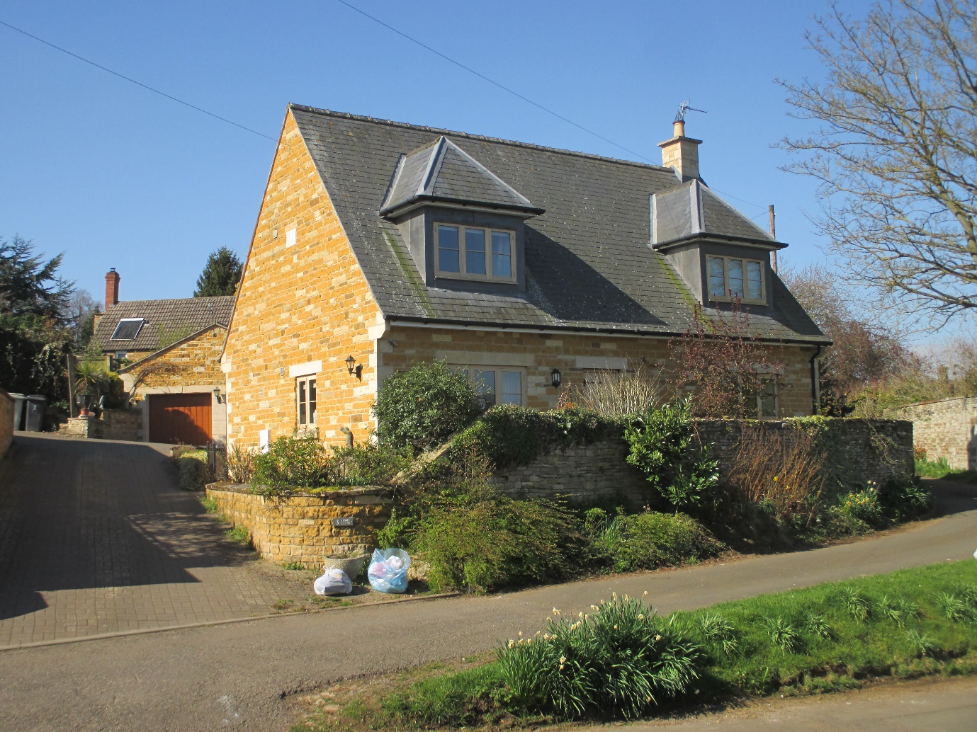
3 Church Street constitutes 21st Century (2008) village infill development on land formerly part of the Home Farm House holding, for which there is a shared drive. The house is constructed from coursed limestone blocks of changing sizes and with some random ironstone and white limestone. The gables have interchanging sizes of blocks to create strings and there are quoin-stones, gable-end eaves kneelers, and door and window header blocks in ashlar. There is a date/initial stone. The roof is in slate and it has hipped lantern dormers. The fenestration is modelled on a square opening of three lights in wooden frames, a fine horizontal glazing bar, and two side hung casements, meeting the vernacular sub-Medieval phase of village Listed buildings.
There is a detached garage which has used the same materials with a strong use of ashlar on an important sightline from the road. Similarly, the new front retaining walls have been brought into curved conjunction with a much older curved boundary wall to the public footpath through The Jetty. This is a sensitive Conservation Area site given its prominence in Church Street and proximity to six Grade II Listed buildings and structures. The use of Listed Building/Conservation Area materials sets a good example for village infill developments as do Lantern Cottage and Tannachie House referred to above.
Church Street
In terms of Conservation Area setting, the photographs below show Church Street looking south from the corner of The Manor Farm Barns (Listed), and east across the tennis court into the Chater Valley.
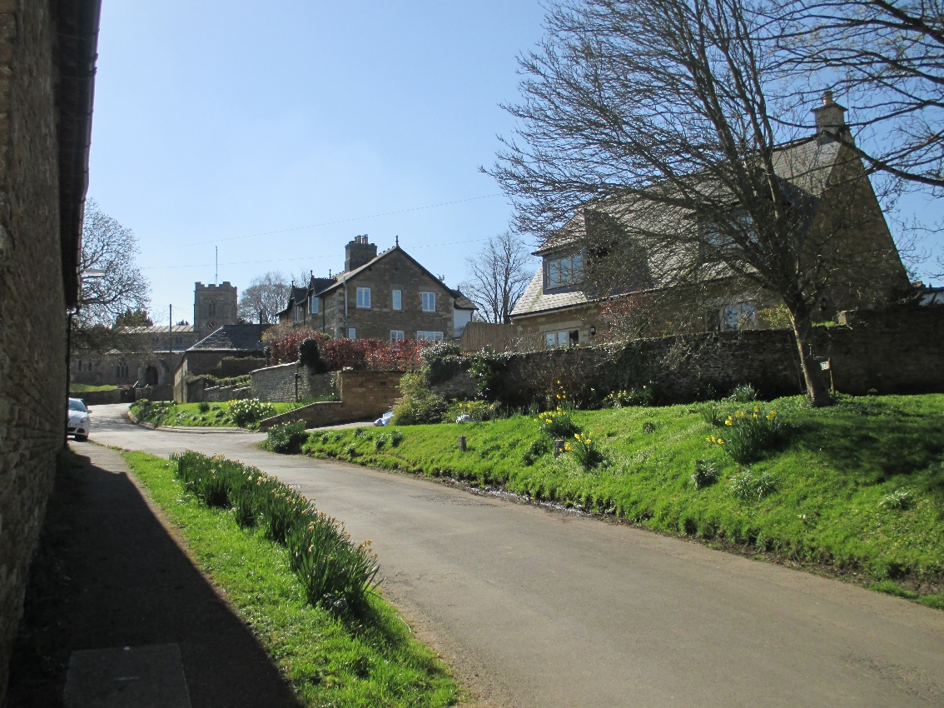
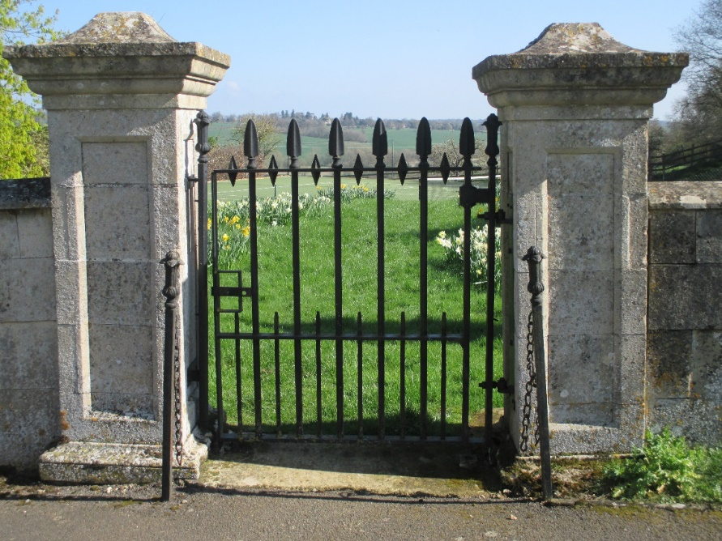
This third (below) photograph shows Church Street looking north from just above Manor Farm Barns (Listed), and Manor Farm (Listed), both just below on the right, 3 Church Street with its lantern dormers just below on the left, and Wing House (Listed) after that, just beyond ‘The Jetty’- a small lane and then footpath running off Church Street on the left to connect with Middle Street and containing another Listed Building.
There has been some controversy about Rutland County Council using double height plain concrete curb-stones in such a sensitive Conservation Area setting that contains six Listed Buildings within sight; Corner House, Church, Manor Farm, Manor Farm Barns, Wing House, and 7 The Jetty.
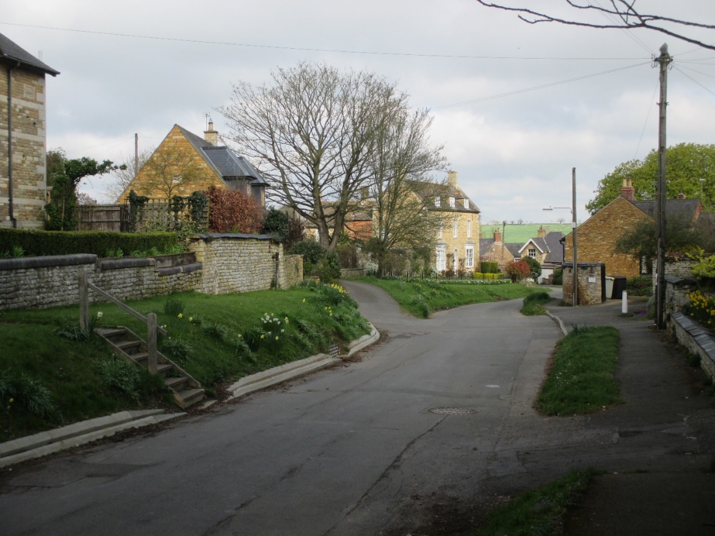
The photograph below shows the tennis court (protected green space and Listed wall) from its northern machinery entrance with 10 Church Street, part of a modern two house infill development just visible in the bottom left of the picture. Further photographs of the Listed wall and the importance of the tennis court’s preservation of scenic views from the village core into the Chater Valley can be seen on pages 43 and 44 of ‘Wing Village: A Directory of Listed Buildings’ First Edition, 12/12/2018.
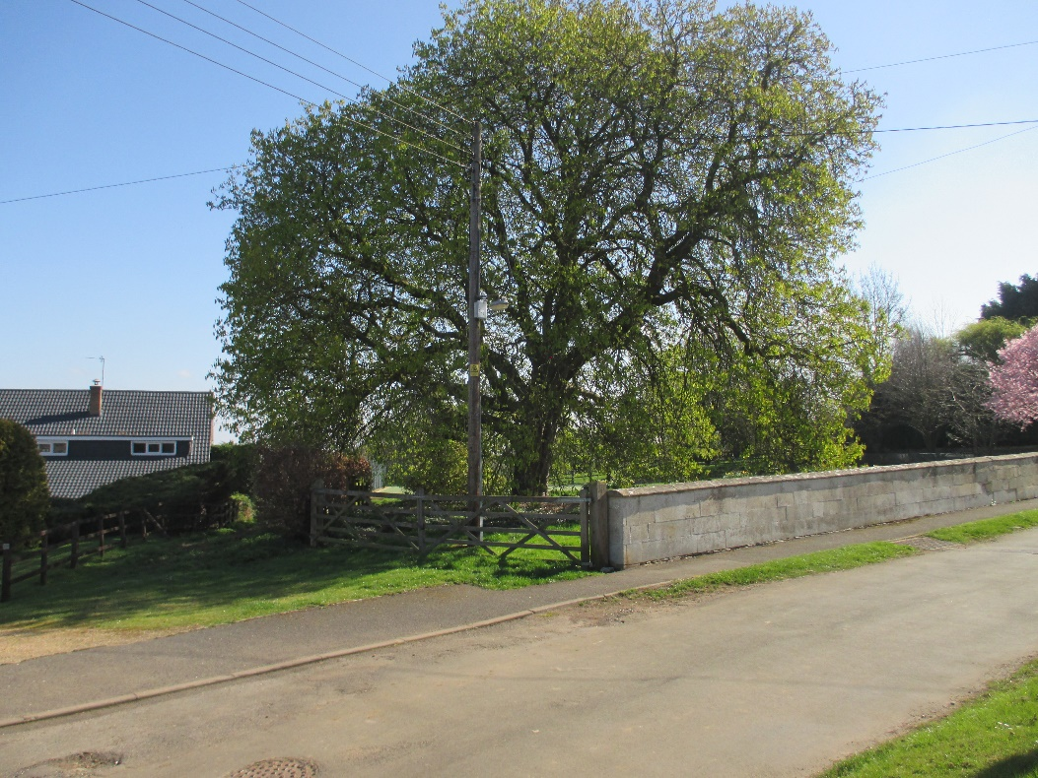
10 Church Street
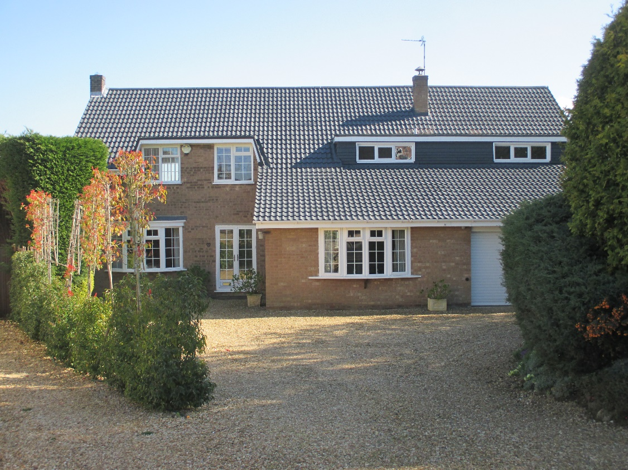
10 Church Street is very much a product of 1970’s design with flat roofed dormers, large unremitted roofscapes at eye level associated with integral garages, bay windows on wooden kneelers, ridged interlocking concrete tiles and fenestration comprising four-light windows with small panes and central upper opening lights. It is constructed in sand coloured brick which is the main ‘nod’ in the direction of vernacular architecture, albeit that the window pane sizes are suggestive of some of the ‘Sub-Medieval’ phase casement fenestrations, but slightly larger, whilst the local reference point might have been the ‘Renaissance Phase’ of Wing House (Listed) bay windows but these are (and in their time were) sash windows.

14 Church Street
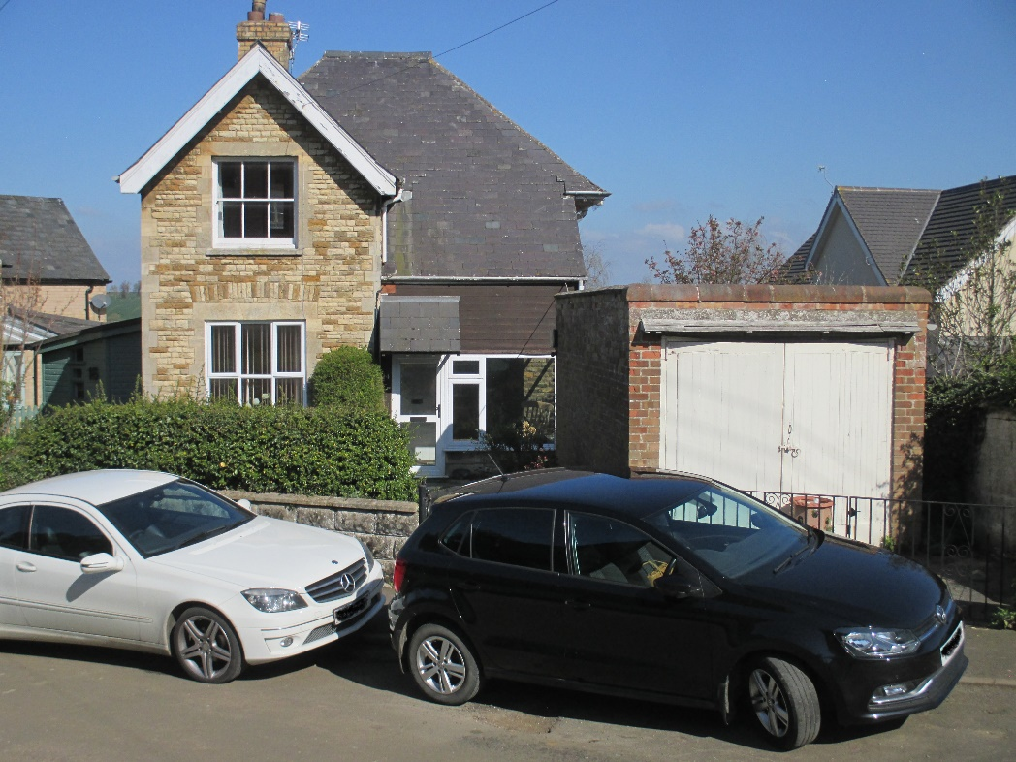
‘The Haven’, 14 Church Street, presents as an ordinary house, of mixed dates and mixed extensions, together with a much later and prominent garage. It does, however, possess an interesting documented history going back to 1837 which also suggests that part of the building together with its historically associated adjacent land (now numbers 10 and 12 Church Street) were once part of a larger complex of buildings which included cottages and stables.
Leaving aside the garage, porch and small front conservatory, the main frontage is constructed of limestone blocks with some ironstone and there are ashlar quoin-stones, window headers and detailing, all suggestive of the late Sheild/early Edward Worrall period. In fact, the stone block shallow arched window headers show the same changes through the introduction of ashlar lintels as obtained in relation to the once Edward Worrall owned estate cottages at 7 and 9 Top Street. There is also documentary evidence dated 26th April 1913, (see ‘A History of Wing Village and Its setting 1066 – 2018’ David Seviour 29/5/2018, page 46) that the property left the Worrall’s ownership when it was bequeathed by George Wyatt Worrall to his “man-servant”, John Gillespie MacGregor. The property has overhung barge-board eaves, a slate roof and in the upper front window a balanced sash window within deep reveals of the ‘Renaissance’ vernacular design/configuration that likely dates to that same Edward Worrall period.
‘The Haven’ core building frontage, leaving aside the later additions, constitutes a Local Heritage Asset.

16 Church Street

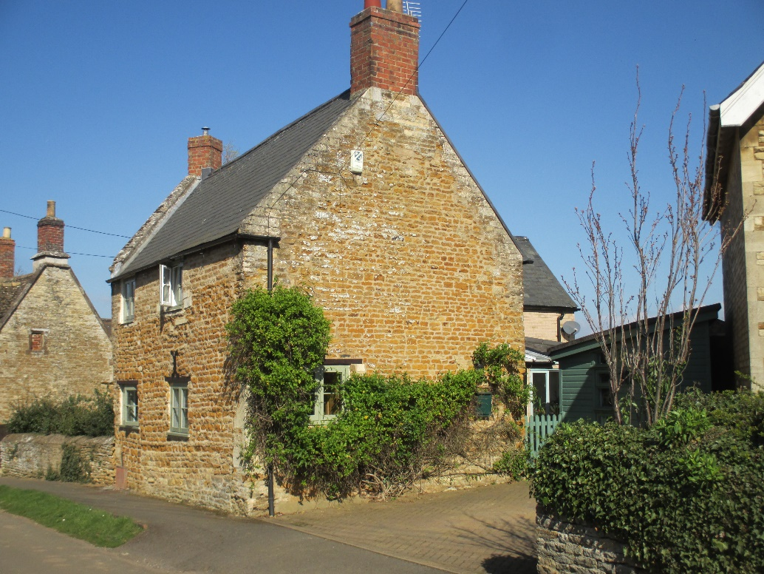
16 Church Street, above as it is today and below, as it looked in the 1930’s with the Almshouses, (early 17th Century, Listed) now called ‘Sundial House’ in the background. 16 Church Street is constructed from coursed rubble limestone, seemingly repaired later with some ironstone, and having later brick chimneys and a slate roof. The raised gables indicate that it was once thatched and there is evidence of early measures – inserted quoin-stones, tie bars and differing stone repairs, to suggest that some instability occurred at an early date – possibly with the removal of an adjoining wall or building given the relative widths and angles of the gable walls. The closed-up front doors and some of the window sizes suggest an early date of construction, perhaps early 18th Century.

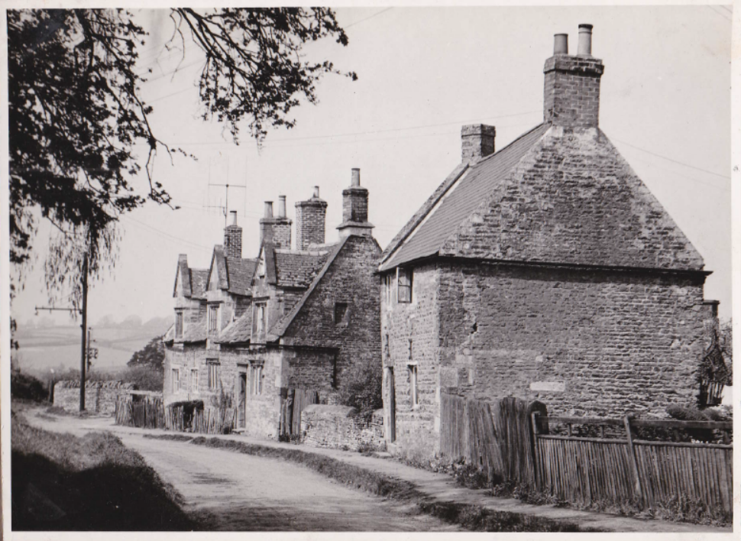
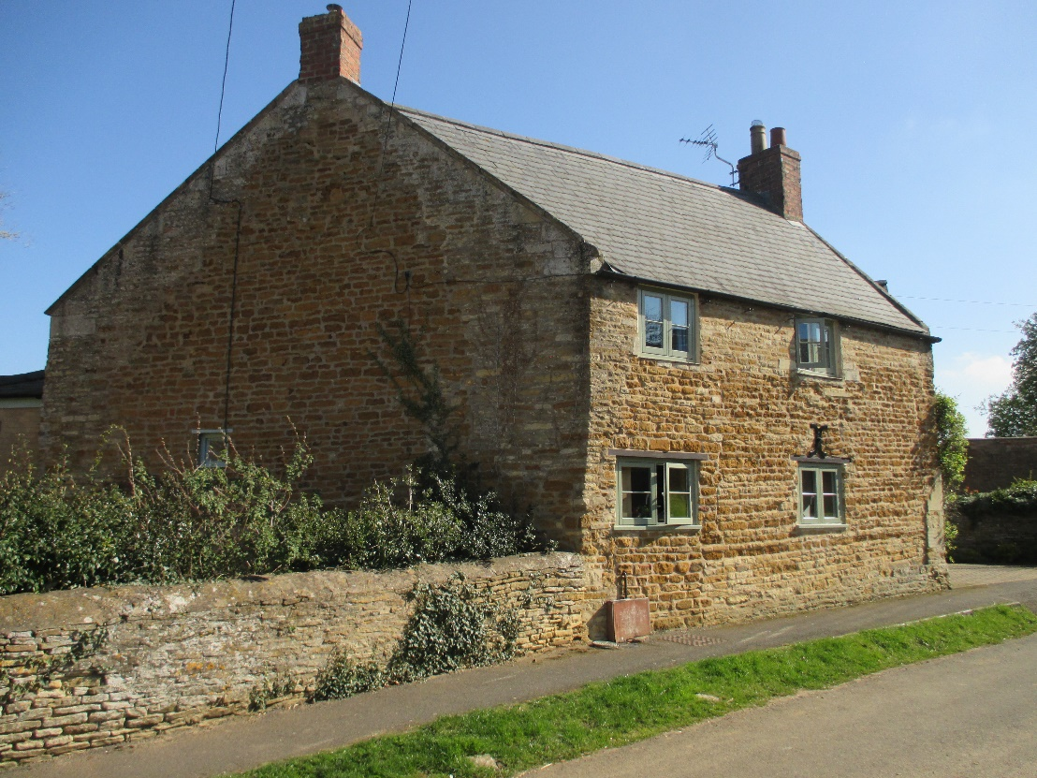
The fenestration is an excellent example of modern window replacements replicating the architectural vernacular of its period (Sub-Medieval phase); square two-light opening, side-hung wooden casement, single horizontal wooden glazing bar. It’s predecessor perhaps having been a flush profiled side-sash. In terms of the future integrity of the Listed Buildings’ street-scene, 16 Church Street is a Local Heritage Asset.

7 Church Street, Pear Tree Cottage

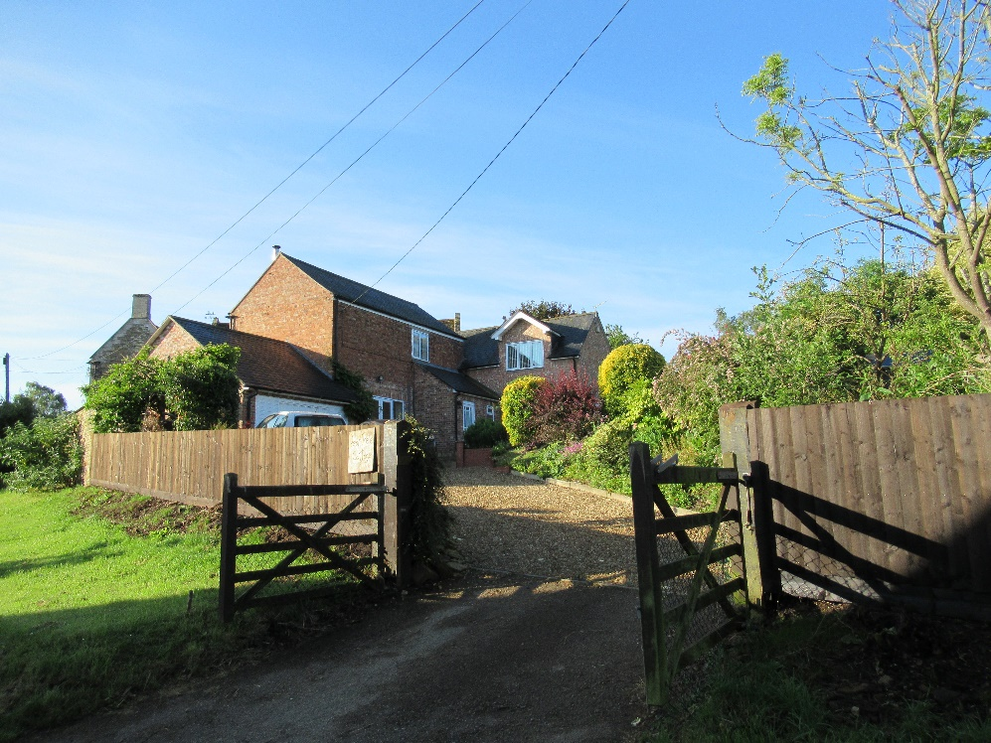

Pear Tree Cottage comprises a core brick barn of earlier date, with red bricks and a slate roof consistent with the other few brick barns around the village. It is sited very close to the Listed stone barn at Wing House, suggesting it both pre-dates the 1984 Listed Buildings’ ‘sweep’ of the village and likely dates to the 1930’s/1950’s. It was once part of the Wing House landholding which in turn dates to both Sheild and Worrall manor holdings – the Worralls’ if it does indeed date to the 1930’s/50’s.
The stone wall along its Church Street boundary, shown in the second photograph below, dates to the early Sheild period of the Mid-18th Century and is another section of the same wall which virtually encircles the village on the inside of Church Street, Bottom Street, Reeves Lane to Westhorpe Close, and Top Street. Only sections of this wall are explicitly protected; those associated with Old Wing Hall (Listed), Garden Cottage (Listed), and the eastern side of Church Street at Corner House (Listed). Other sections, like the one above, and that along Bottom Street, are Local Heritage Assets and should be explicitly protected.

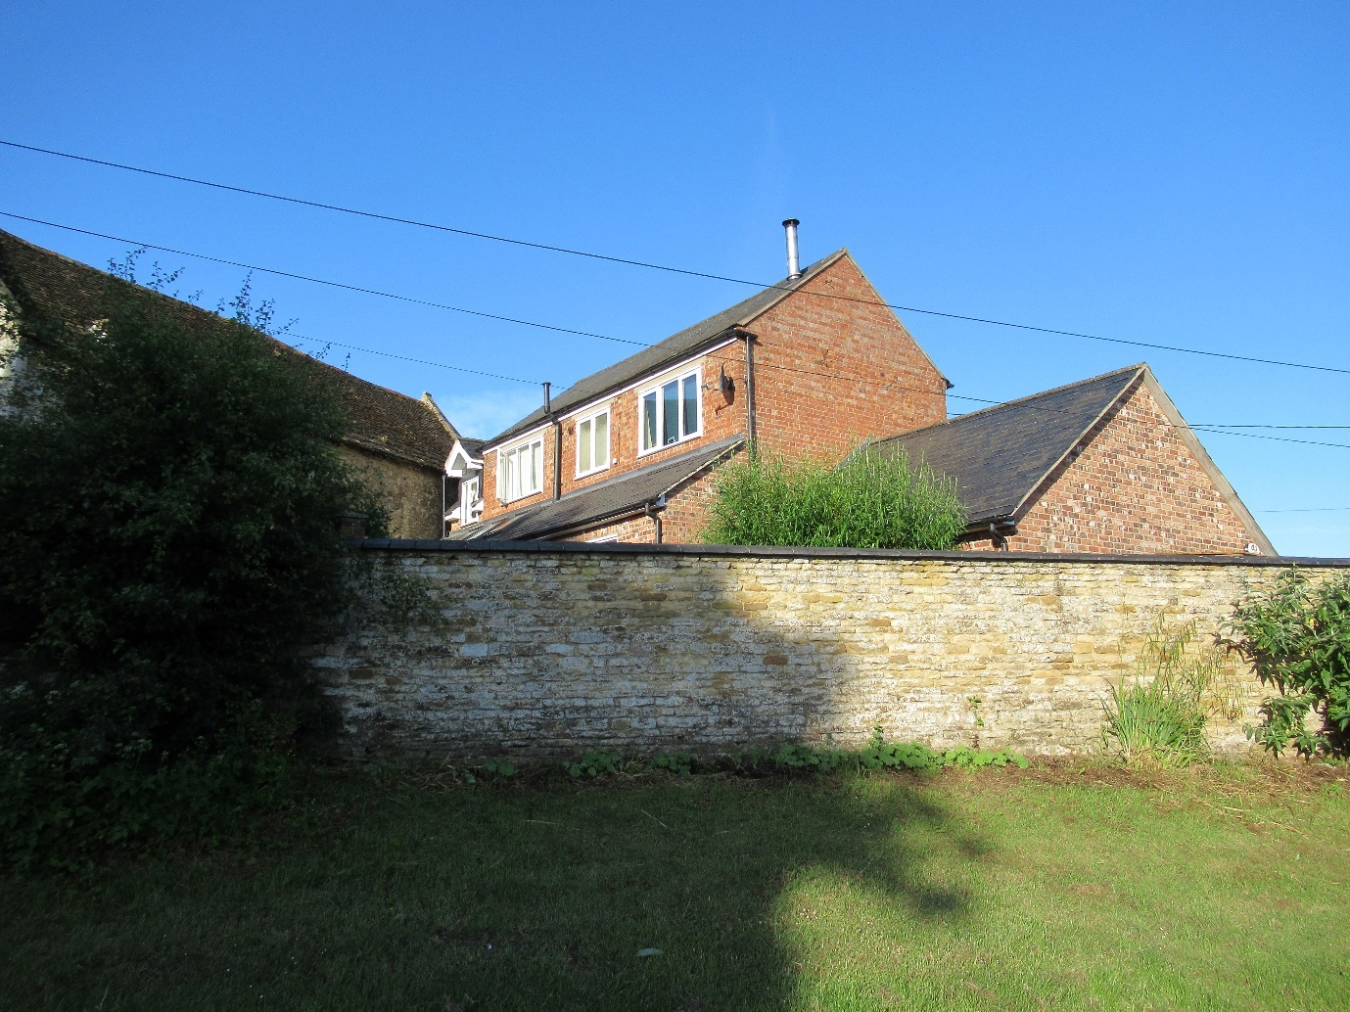

The brick barn was subsequently converted and extended in the 1980’s (?) with a two storey leg along and off its southern gable end (placing it even closer to the Listed stone barn at Wing House), front and rear single storey extensions, and a single storey extension off its northern gable. These extensions have used a different brick, more akin to that used in the earlier construction of number 9 Church Street and there are slate roofs throughout.
The two and three light casement fenestration is modern UPVC without glazing bars, but the two dormers are set below the main eves, are gabled with their own eves overhung with barge-boards, and like Sycamore House and Holly Tree House on Top street, reminiscent of Wingwell Farmhouse dormers with regard to their eaves positioning.

Southern End of Church Street

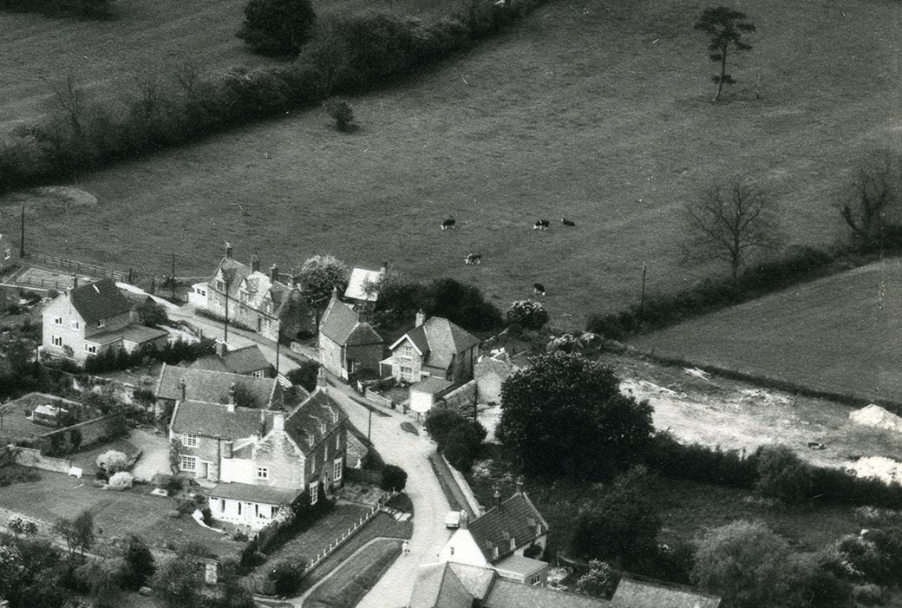

The above aerial photograph shows the southern end of Church Street in the 1960’s. Wing House (Listed) is shown in the bottom left with its ‘L’ shaped configuration, followed down the hill by its staggered Barn (Listed and still unconverted), followed by the roof and window of 7 Church Street and then by 9 Church Street.
On the right-hand side of Church Street; the roofs of Manor Farm Barns (Listed and now three holiday lettings) are at the bottom right, followed by the white painted Inglewood Cottage (Listed) with its roof already changed to take dormers and what looks like a then new flat-roofed extension at the rear, next the tennis court wall (Listed) which then gave access to a rough agricultural plot, after that there is the rough plot undergoing some clearance (?) which became 10 and 12 Church Street, next ‘The Haven’ clearly revealing a larger property than might be imagined from its frontage, then the cottage at 16 Church Street, and finally ‘The Almshouses’ (three cottages) which became ‘Sundial House’ (Listed).
The run of aerial photographs are interesting because they demonstrate that much of the Conservation Area has already been infilled with development both prior to the photograph and afterwards and that there is scant opportunity to carry out further infill within the Rutland County Council defined limits of village development without the potential to seriously undermine the Conservation Area and its constituent Listed Buildings’ “settings”, which would also thereby counter the protective wishes of local residents as expressed in the Questionnaire results of 2019, pursuant to a Neighbourhood Plan.

Eastern end of Bottom Street
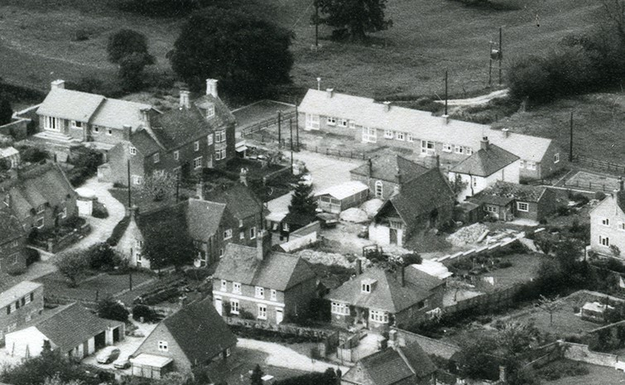
This section of the 1960’s aerial photograph focuses on the western end of Church Street where it becomes the eastern end of Bottom Street (originally called ‘Far Lane’) and at the junction with the northern end of Middle Street. The top right-hand side features the four newly constructed Local Authority bungalows for the elderly shown in the first two photographs below.
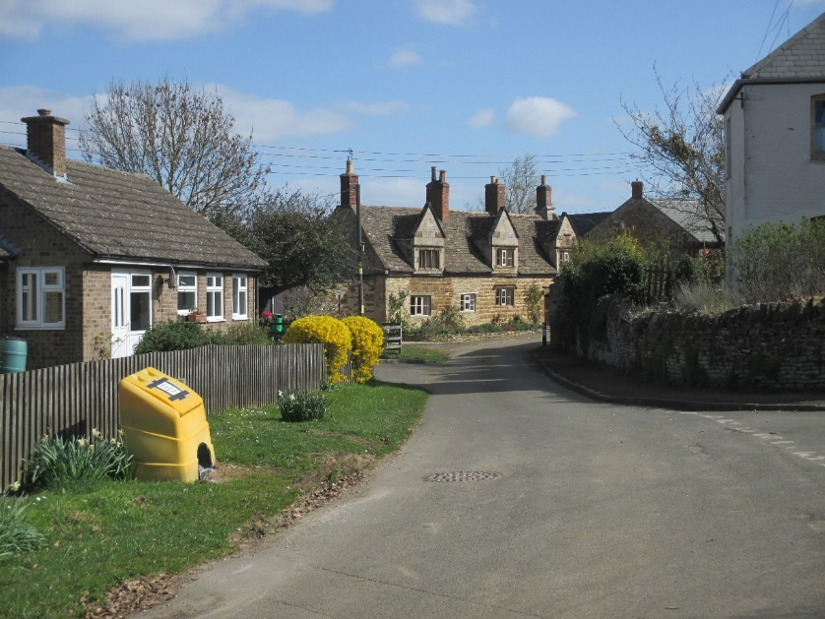
The former Local Authority bungalows are constructed of grey sand coloured bricks and grey ribbed interlocking tiles. The fenestration style is typical of the 1960’s and 1970’s with top opening lights, albeit that they almost certainly will have been replaced with UPVC double glazed units. Whilst neutral in design, nothing reflects the local vernacular architecture.
They are now in the ownership of Spire Housing Association following the Government’s LSVT (Large Scale Voluntary Transfer) initiatives which were geared to enabling the achievement of the Government’s Decent Homes Standard through new investment without resort to increased Public Sector borrowing. The capital receipts were used to commute public debt. The 8 former Local Authority apartments on Top Street and 5 of the houses on Top Street remain in Spire ownership, 11 of the latter having been sold under the terms of Right to Buy legislation.
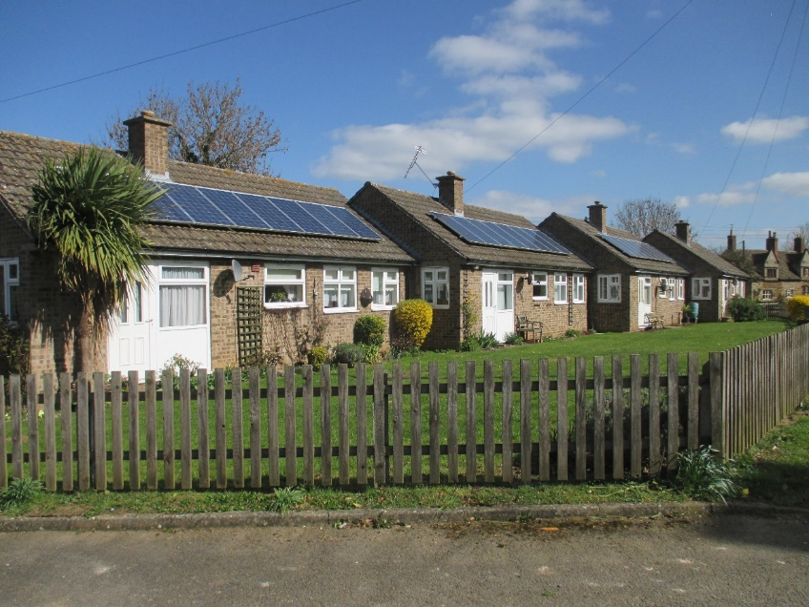
The top left-hand side of the 1960’s aerial photograph shows the private bungalow newly constructed, and is shown in the current photograph below.
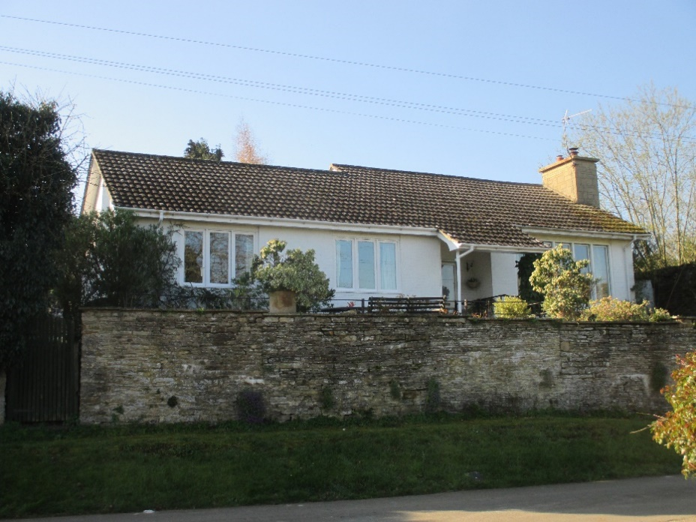
Built of brick, clearly at the same time as the other bungalows, with completion dated 1971, it has been painted and has different roof tiles – low curve pantiles. The fenestration is a three light rectangular casement of modern design, (installed in 2000) although the four light window has deep reveals suggesting a different opening method or fixed frames and glass. The front limestone wall runs the entire length of Bottom Street and likely formed the boundary to the Sheild manor house at Cedar House (Listed) on Bottom Street, with its kitchen garden west of this bungalow, and its stone dovecote and separate stone laundry south of the bungalow (see below at ‘Middle Street’). See also the view from Bottom Street across the Chater Valley below.
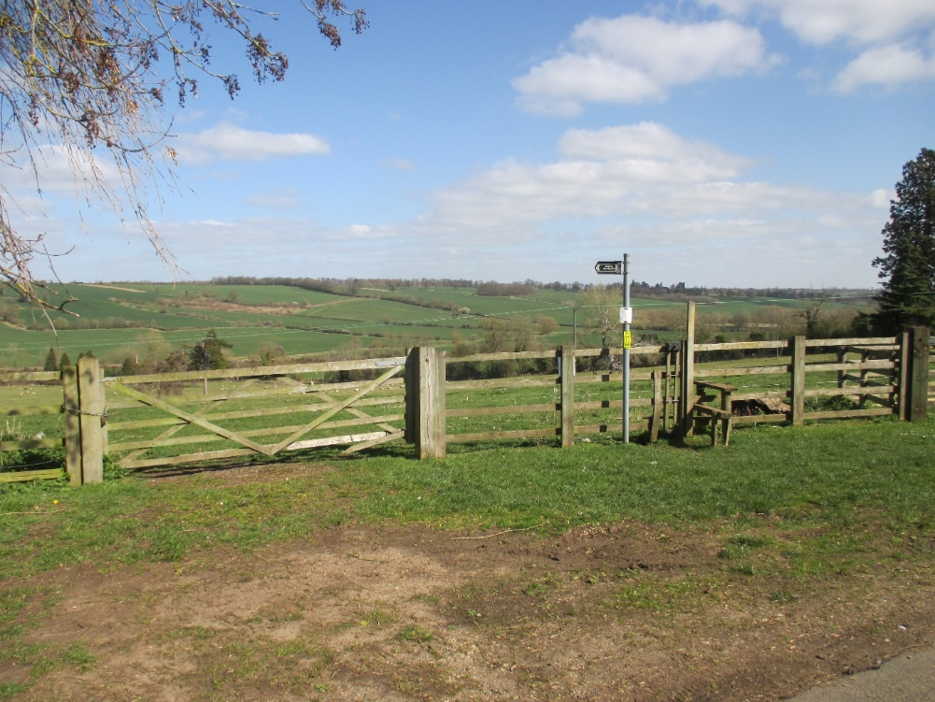
At the junction of Middle Street, Bottom Street and Church Street in the 1960’s aerial photograph at page 78 above, 15 and 17 Middle Street (both Listed) sit on the left, whilst the Chapel (Listed and lately converted into a holiday letting) sits on the right next to its un-listed proprietor’s house (white) at 16 Middle Street. The land and a house between the Chapel and numbers 10 and 8 Middle Street (number 8, ‘Tom Cottage’, being Listed and lately used as a holiday letting) was clearly in transition/demolition at the time of the photograph and led to the construction of 12 Middle Street.
This photograph on page 78 again demonstrates previous infill development, demolition and transformation of usage, prior to the declaration of the Conservation Area and after it, in a sensitive locality where there are six more Listed Buildings within the scope of this single extracted 1960’s view of the bottom of Middle Street. Boundary changes also seem to have taken place.

13 Middle Street, Dove Cottage
Looking up Middle Street in a southerly direction from its junction with Bottom Street/Church Street, the first properties on the right-hand, western side, are 17 and 15, both Listed. The next property, Dove Cottage at 13, is set back at the end of a long private drive.
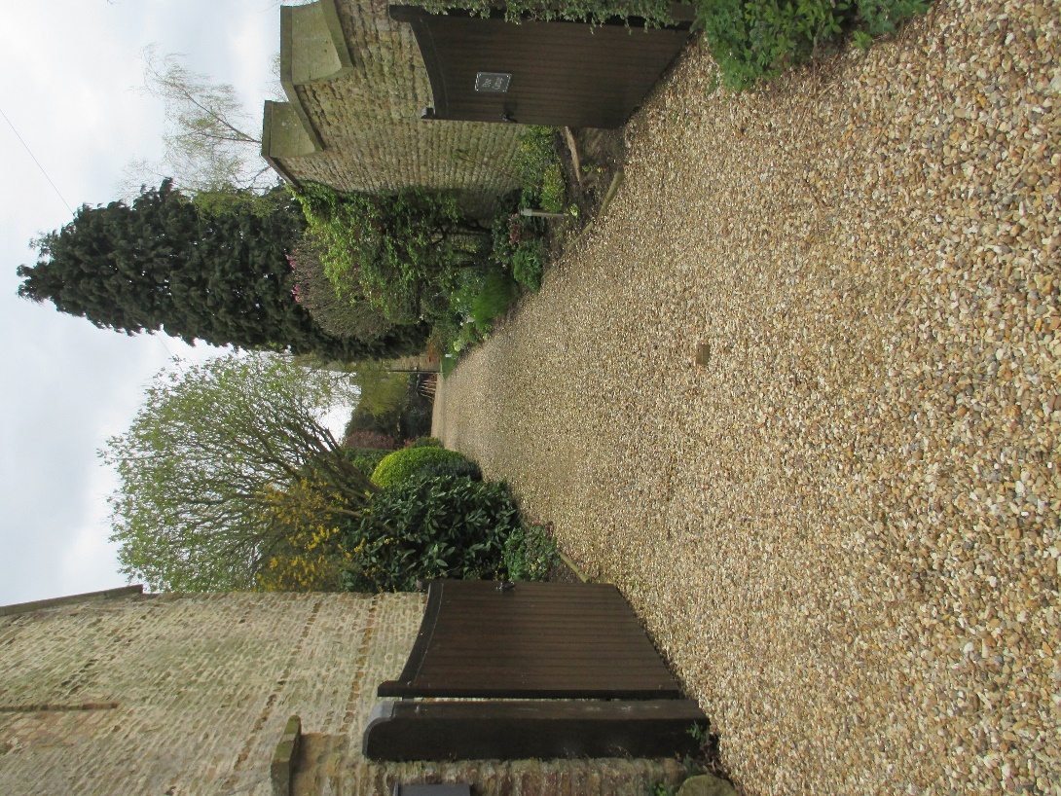
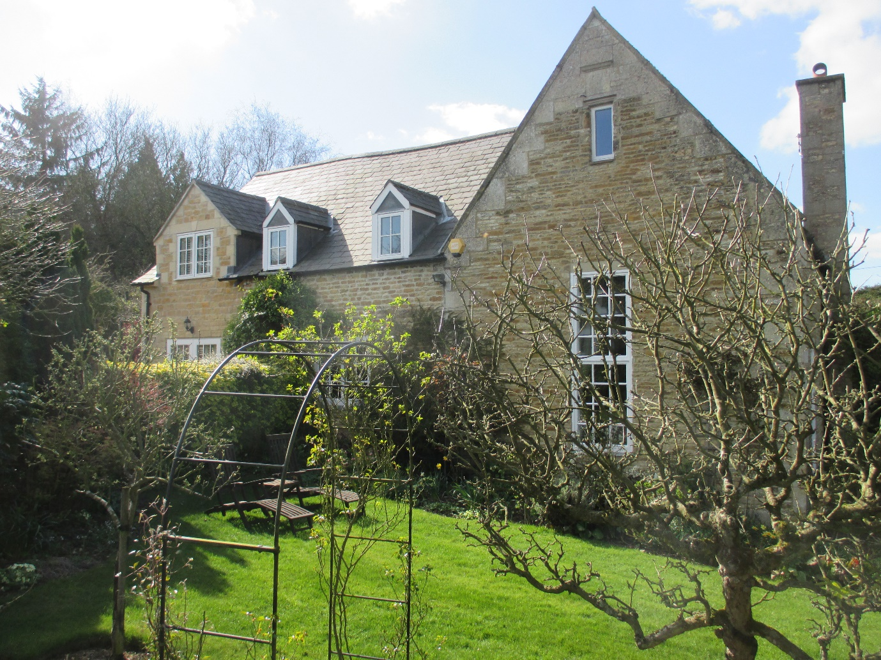
Built in 1759, the northern section on the right in the current photograph above was the manor house dovecote, that is the dovecote for Cedar House, (Listed) and its farmyard was once accessed off this drive with the dovecote on the left and the manor house laundry on the right of the drive. The laundry later became a coach-house, then a garage with studio residential accommodation above as part of the Dove Cottage holding.
The former dovecote is built of coursed limestone with ashlar quoin-stones and gable headers together with raised limestone coping stones from when it was thatched. There is a date-stone and Sheild family initials. The middle section dates to around the late 1800’s and is constructed of limestone blocks, the same as the former laundry. The southern section and its western wing date to the late 20th and 21st Centuries, again in limestone blocks but they have rear (western) walls in sand coloured brick. The roofs are predominantly slate but with a dark pantile on the northern side of the dovecote section where it was historically fire-damaged from a thatch fire. There are four dormers, two in vernacular style with led and slate, two gabled one in stone and one tile hung in slate. The fenestration is mixed, some on the eastern side of the vernacular ‘Renaissance Phase’ and some on the south side modern.
Dove Cottage is tucked away in the middle of the village and must have been missed by the Local Authority ‘Listings sweep’ in 1984 and hence must be the only unlisted intact dovecote of this large type in Rutland and possibly in England. It clearly is a Wing Local Heritage Asset. See archive photographs of the dovecote and laundry below.
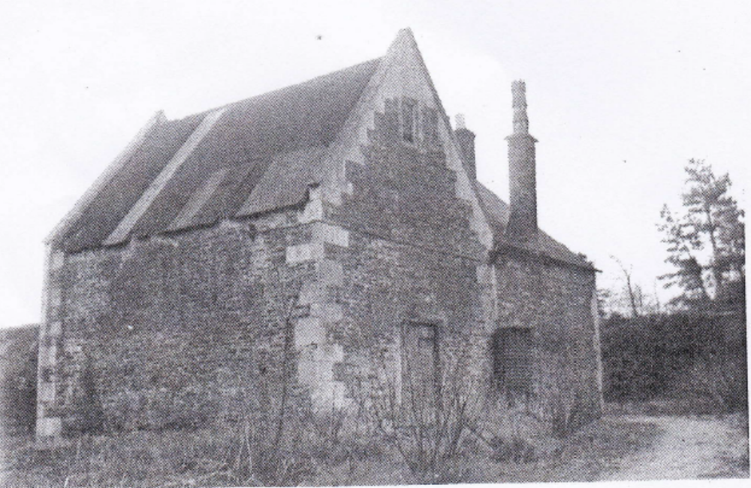
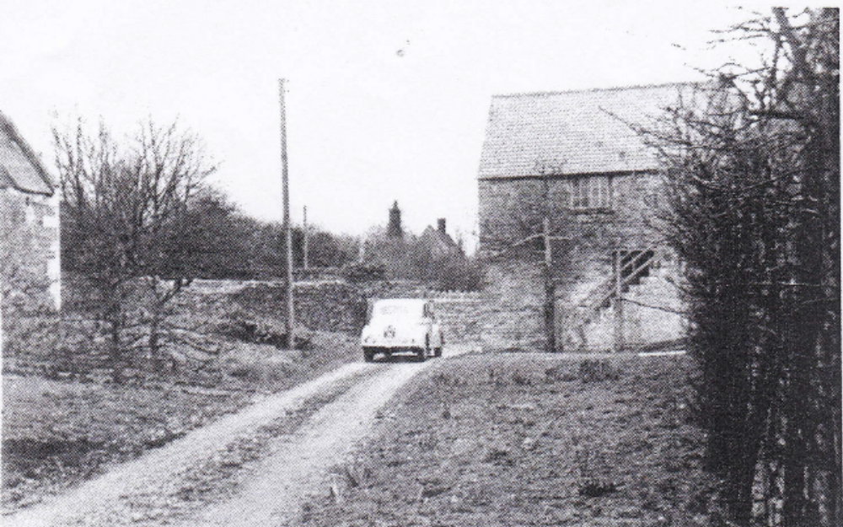

After Dove Cottage on the right hand side of Middle Street there is 11 Middle Street.
The Old Post Office, 11 Middle Street.
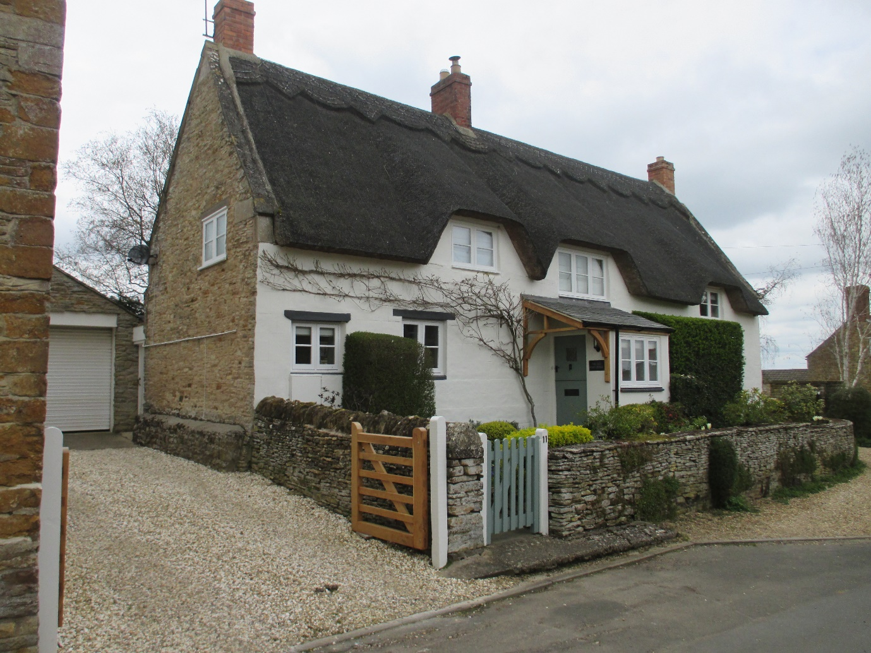

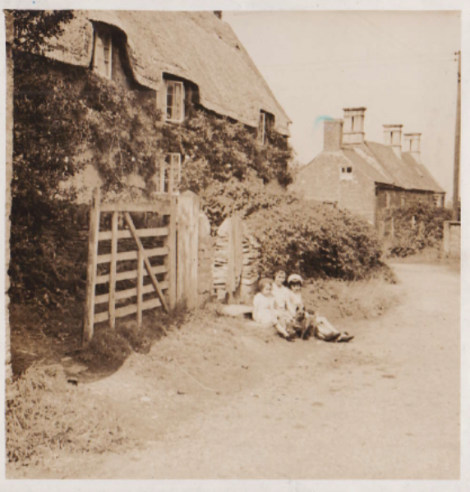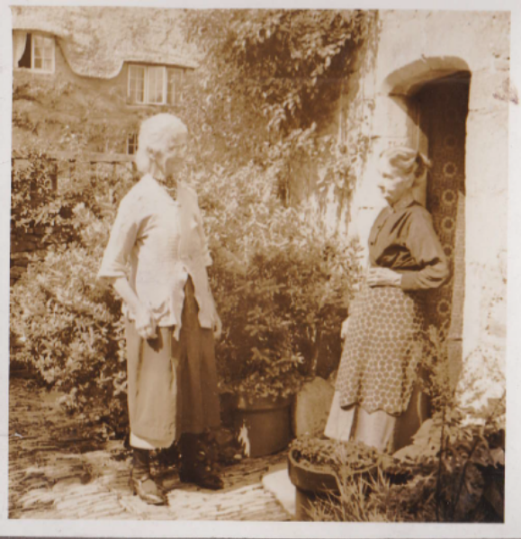
The Old Post Office sits between Rose Cottage, 7 Middle Street (Listed), which was once two very small cottages and hence the odd address sequence, and the houses at 15 and 17 (both Listed) and is more or less on the same building line – slightly back from 7 and slightly forward of 15/17. 13 is set well back down the drive between 11 and 15.
The frontage of the Old Post Office has been rendered and painted white but the south and north facing gables reveal the stone construction, which is coursed rubble limestone, with some ironstone string courses on the north gable, together with some eave quoins, and limestone gable coping stones. It predates the Worrall family period of construction and probably relates to the mid to late 18th Century which fits with the dating of 7, 15 and 17 Middle Street and falls within the Sheild family period. Number 7 carries a Sheild family datestone W and H S, 1771.
The two archive photographs from Parish Records are set between 1935 and 1945 and show a remarkable similarity in both the gate design and the ‘eyebrow’ dormer shapes as compared to the current photograph and 21st Century re-thatching and new gate. The second archive photograph is taken from just outside the old gable end front door at Tom Cottage (Listed), directly opposite across Middle Street.
The fenestration is now modern, but whilst not matching the multiple pane glazing of the 1930’s/1940’s it does replicate the vernacular style of the original period and the casement sizes appear not to have changed.
The Old Post Office is a Local Heritage Asset in terms of age, sensitive street-scene, and surrounding Listed Buildings’ setting.
Wing Lodge
Beyond the Old Post Office on the right-hand (western) side of Middle Street, there are two Listed buildings, Rose Cottage at number 7 referred to above, and then Stable Cottage, which comprises a Barn dating to the 1700’s (the Sheild period) and its cottage dating to the late 1800’s/early 1900’s (the Worrall period). See Wing Listed Buildings Directory for details. After Stable Cottage there is Wing Lodge.
Wing Lodge dates to the late 1800’s/ early 1900’s, the Worrall period when cottages dating to the 1700’s at the top western side of Middle Street were incorporated into a new Hall by the Worrall family, now referred to as Old Wing Hall although just ten years older than the New Hall built by the Worrall family at Wing Hill. Wing Lodge was built to service the original ‘Old’ Hall (Listed) which is just next door – with grooms, horses and coaches, but had a substantial first floor addition made to part of the stables and coach house in order to form larger residential accommodation in the late 1960’s when it became part of a separate landholding and property. Wing Lodge fronts Middle Street, but in addition to its large rear garden it possesses an enclosed field of more than an acre. This land, together with the land inside the Top Street Old Wing Hall curtilage, and the land at Stable Cottage and Dove Cottage, around five acres in total, provide an important ‘green lung’ at the centre of both the village and Conservation Area.
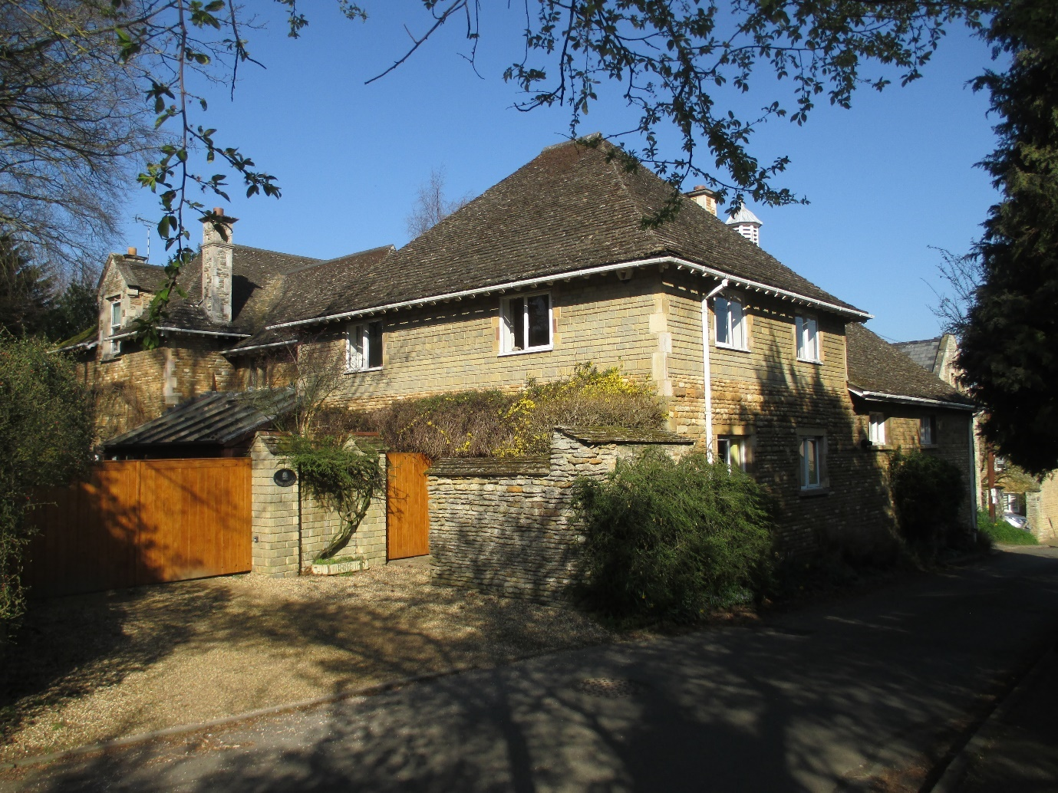
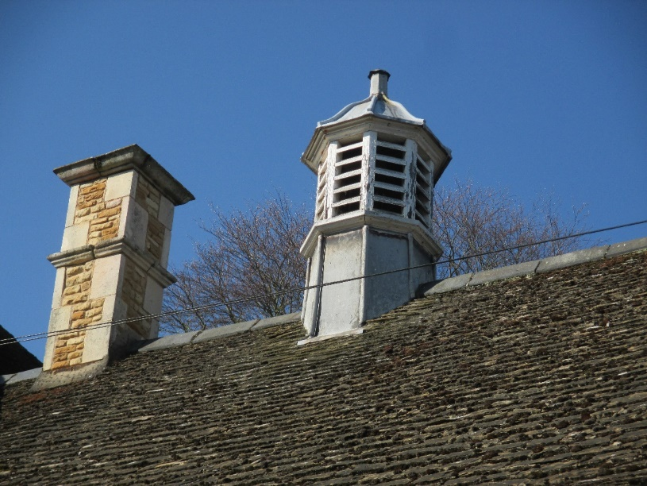
Wing Lodge is constructed from rough-hewn limestone blocks with a great deal of ironstone, ashlar quoin stones to the buildings and chimneys, ashlar dormer headers, and gabled dormers with limestone reveals to the fenestration. Some of the fenestration is vernacular of the balanced sash Renaissance Phase, whilst some on the raised height 1960’s section are of modern two-light casements. Despite the ashlar quoin stones and the use of stone walls along this upper section, the walls are not a good match. On the other hand, the chimneys and ventilation cupola are vernacular, as is the extensive stone tiled (Collywestern) roof which is hipped.
The next building on the western side of Middle Street is Old Wing Hall (Listed) with its front entrance driveway off Top Street but its ‘traders’ access off Middle Street.
Given the setting and environmental importance of Wing Lodge, it must constitute a Local Heritage Asset.

16 Middle Street, Chapel Cottage
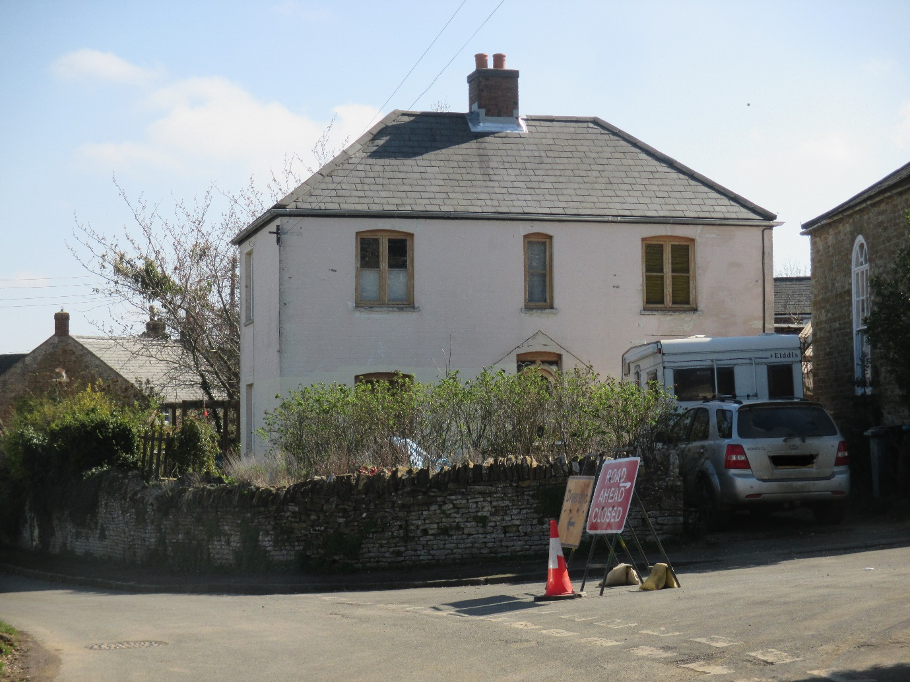
16 Middle Street sits inside the C.A., on the eastern side of Middle Street, and was built in 1924 and is constructed in brick which has been painted but based on the chimney stack, the brick is the same or a similar type as used to build 9 Church Street, albeit that 16 Middle Street appears to be older than the present façade of 9 Church Street. Its configuration is very reminiscent of the pattern adopted by institutional builders for service personnel – the Church, the Police and the Fire Service during that first half of the 20th Century.
The fenestration and door are comparatively modern/new oak replacements to existing arched brick openings, but using vernacular two light, rectangular timber casements with a central glazing bar. It has a slate roof which is hipped. The other hipped roofs within Wing village are the Chapel, The Haven, Manor Farm, the bungalow in the Jetty, Wing Lodge, Millstones, Tannachie House and 3b Top Street. The name and proximity of the property to the Chapel (built in 1840, Listed) and current common ownership of the two suggest a link, but that isn’t historically documented and appears to be current happenstance.
The front (Middle Street) and side (Church Street) boundary wall is constructed from limestone blocks (but with rough-hewn limestone vertical capping as adopted at 6B Reeves Lane) and is part of the same intermittent wall initiated at 1 Church Street.
12 Middle Street
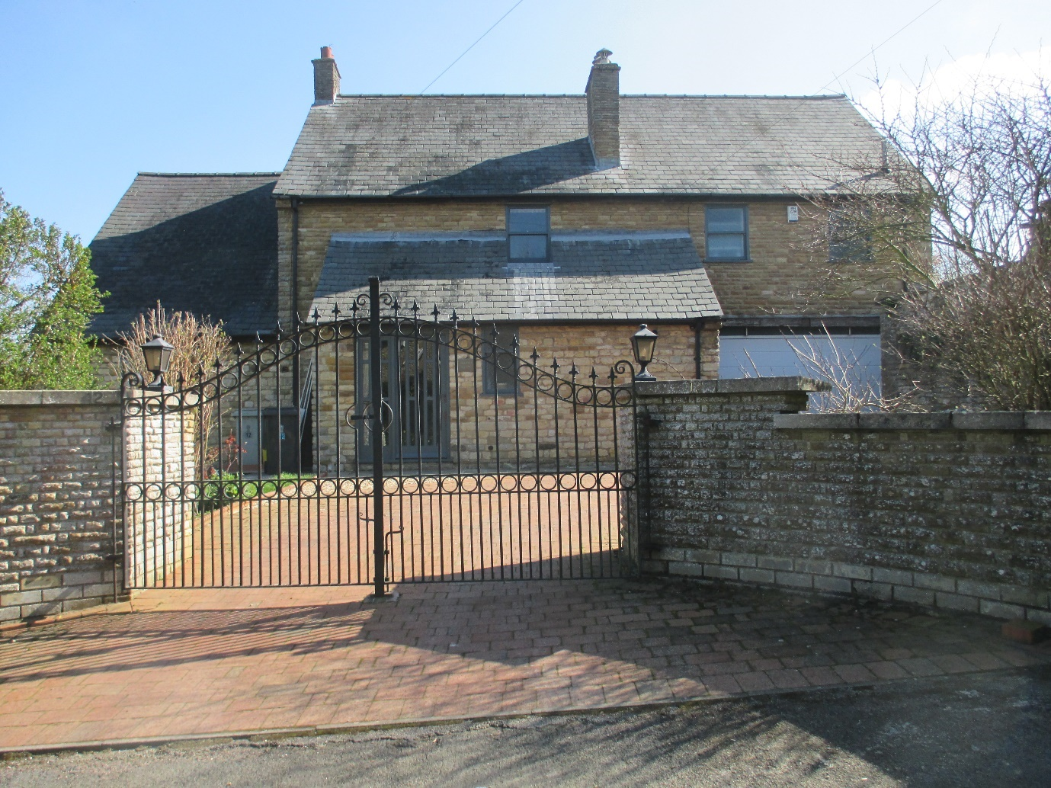
12 Middle Street was built in the late 1960’s and is constructed of limestone and ironstone blocks with a good deal more ironstone than is characteristic of those coursed limestone rubble properties from the Sheild family period and more akin to those constructed from limestone/ironstone blocks during the Worrall family period.
It has a slate roof and the fenestration is modern. The front boundary walls may have been reconstructed from the existing limestone block walls running from I Church Street and set on a modern foundation.
The house sits inside the C.A. and shares a boundary with the Chapel (Listed). It’s front building line is set behind the building line for all other properties on the eastern side of Middle Street.

10 Middle Street
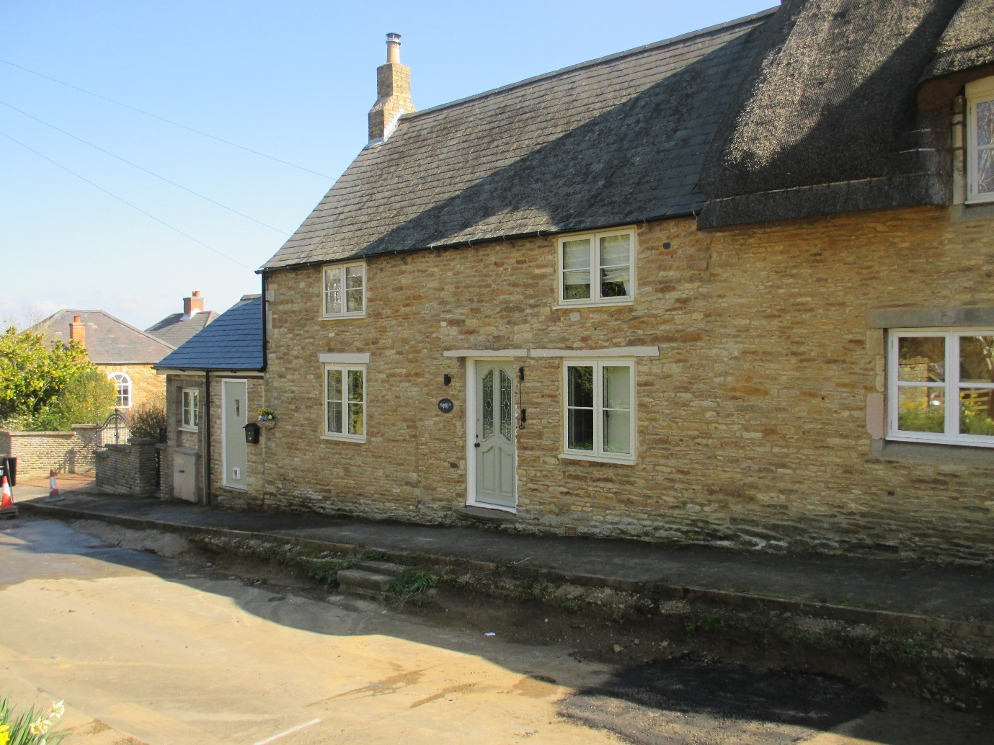
10 Middle Street presents a mixed and interesting frontage to the pavement. It is constructed partly from traditional coursed limestone rubble which in its lower right-hand section has continuous ‘string course’ elements of thinner stone running right into the next door property, Tom Cottage (Listed) at 8 Middle Street. This suggests that 10 also relates to the early 17th Century and may have been part of number 8 or perhaps a related usage at two thirds of the height of number 8.
Later, but probably not much later, the building was extended both upwards and down the street, as evidenced by both an upper vertical joint line between the two buildings and a vertical joint line just to the north of the present front door. At this point the limestone materials used also change to lose the string courses at the lower level and to incorporate more ironstone at the upper level.
Much later there is a further addition built at its northern end.
The roof is constructed of slate and the modern fenestration has followed an accurate vernacular period style.
10 Middle Street, given its integral physical connection to 8 Middle Street and given its importance to the setting must constitute a Local Heritage Asset.

6 Middle Street, Millstones

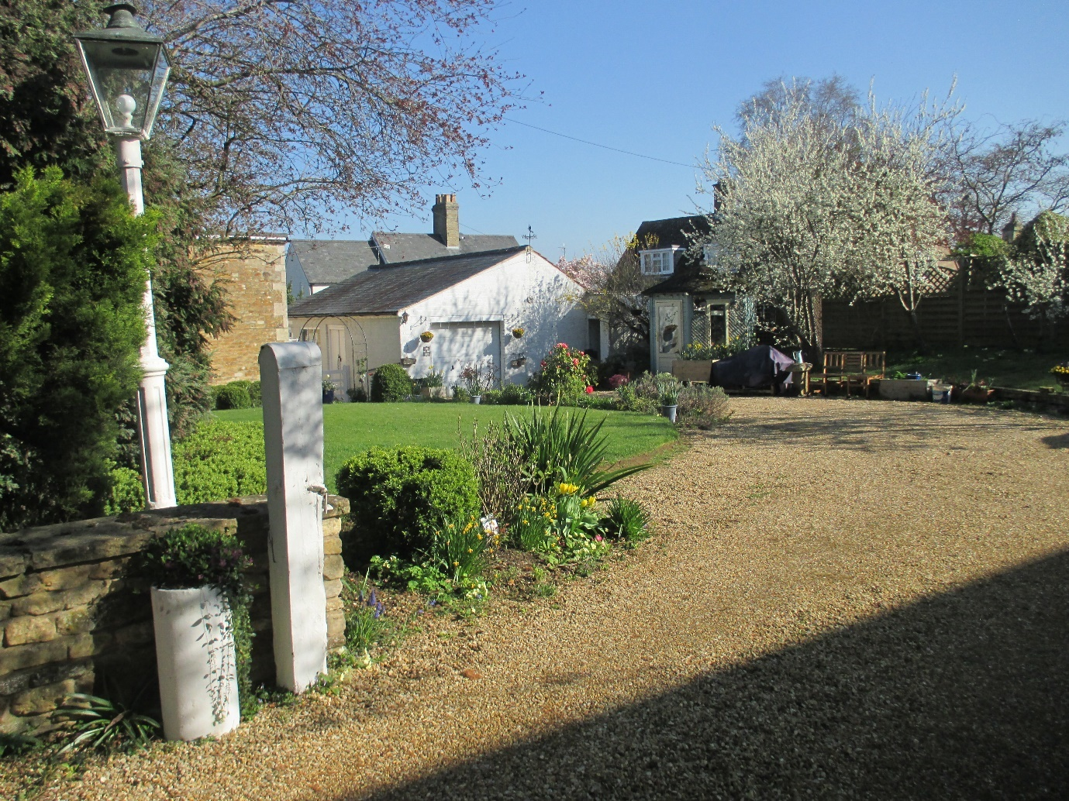

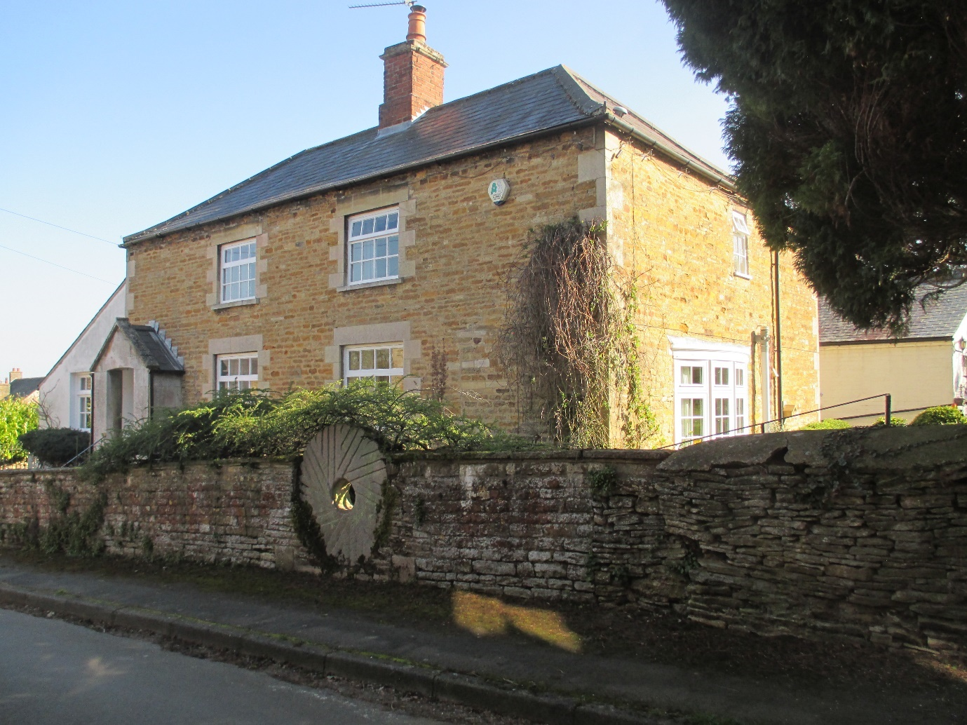
Millstones, 6 Middle Street has immediate front door access onto the street through the wall that virtually encircles Church Street, Bottom Street, Middle Street, and Top Street, and which, as mentioned earlier, is only partially protected in three sections. It all needs protecting as an historical and vital feature of the Conservation Area setting, and the eighteen Listed Buildings that are crucially related to it.
Millstones is also accessed off a driveway, as shown in the above photograph which has a right hand boundary with Garden Cottage (Listed).
Millstones (named after the two millstones located in its garden) is constructed of rough-hewn limestone and ironstone blocks with ashlar quoin stones, ashlar window reveal detailing and a hipped slate roof. There is a later lean-to extension constructed along its northern gable wall.
It was likely two cottages related to the Worrall period, with a second matching front door porch on the far right hand front wall. The bay window on its southern gable wall is a much newer addition. The rest of the fenestration appears to relate to the original openings, albeit that the current window lights look comparatively modern with top opening lights. Otherwise the windows are probably close to the original vernacular design of square lights with twelve panes, thin glazing bars and either a single opening pane, or the lights divided into two with one fixed and one casement hung and side opening. As with similar properties on the south side of Top Street, it constitutes a Local Heritage Asset.
The Jetty
On the northern, left-hand side of Millstones the Jetty, a public footpath, connects Middle Street to Church Street, ‘The Jetty’ having vehicular access only from its eastern, Church Street end to just past its mid-point, as shown in the photograph below. The Jetty is located within the C.A.
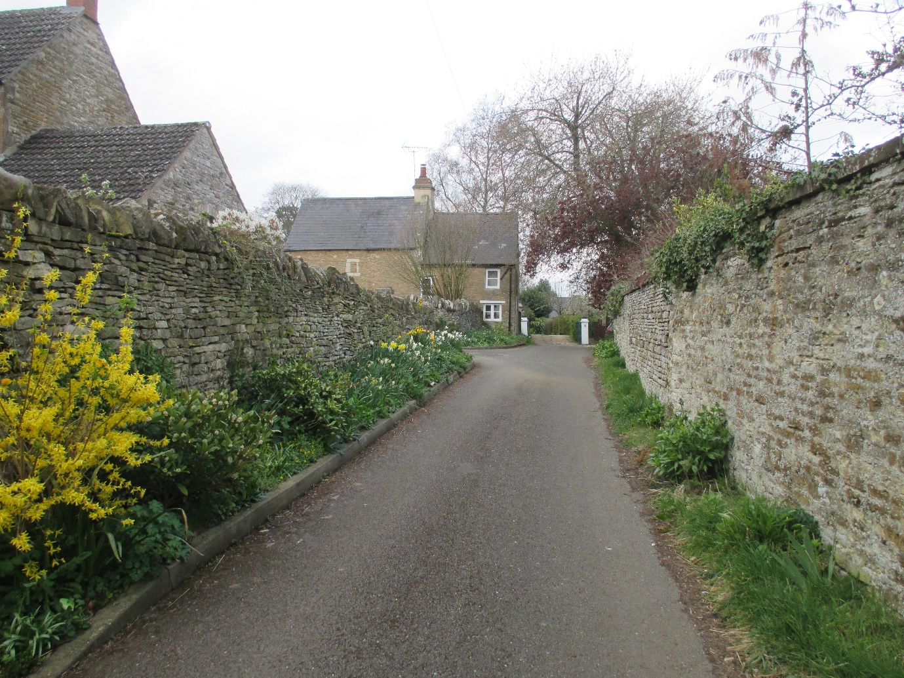
Both of the above walls are significant, the limestone wall on the right marking the boundary of Wing House (Listed) and its Barn (Listed) both in Church Street, dating to the Mid-18th Century and the Sheild period, and the limestone wall on the left, with vertical rough limestone caps, running from 1 Church Street virtually in an unbroken line to 7 The Jetty (Listed) as shown.
The two photographs, below, show the footpath from 9 The Jetty to Middle Street, with first the ‘industrial period’ former red brick cottages on the right, followed by a protected ‘green space’ associated with the Listed Tom Cottage, at 8 Middle Street, and on the left, the boundary of 9 The Jetty, followed by that of Millstones, at 6 Middle Street, on the left.

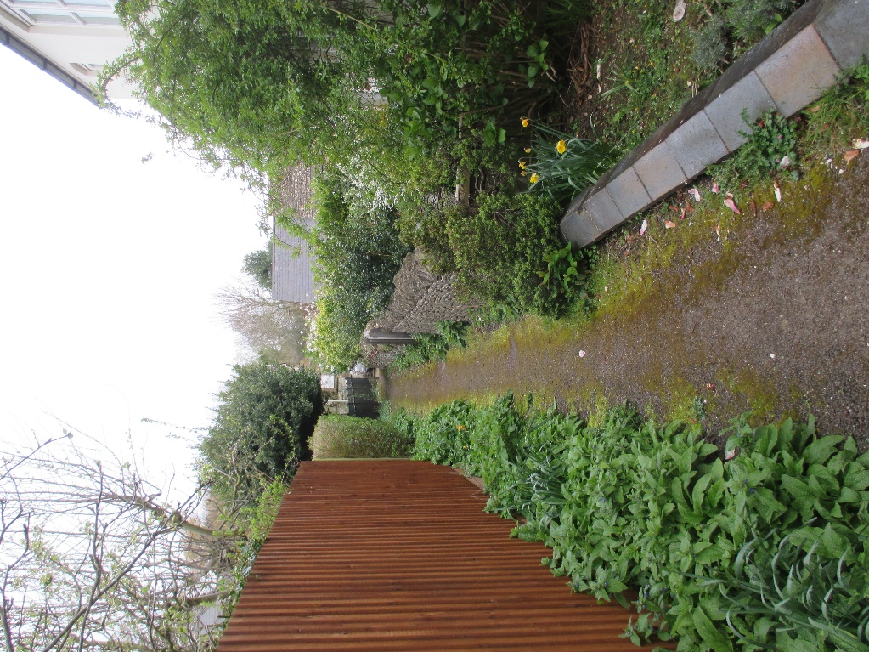

9 The Jetty
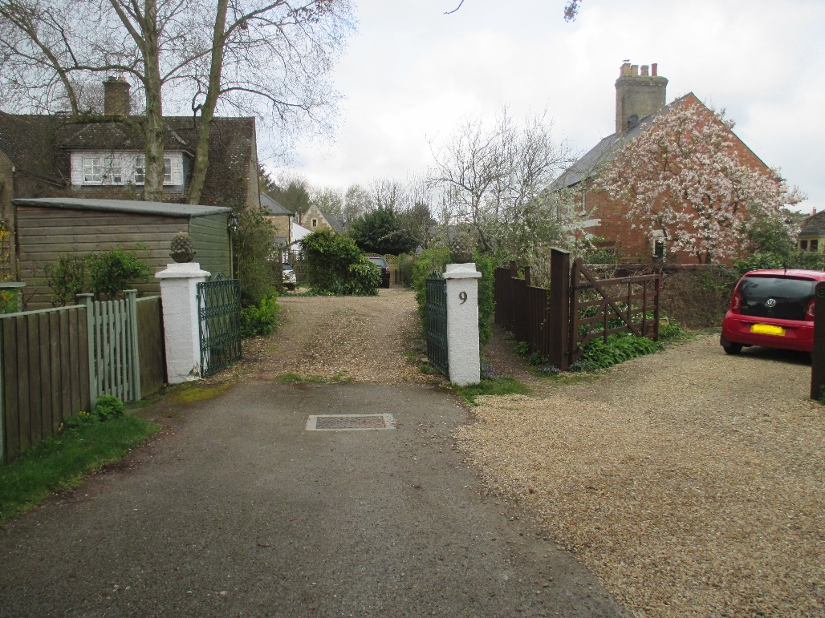
The Jetty footpath runs west from immediately to the right of the number 9 white post.
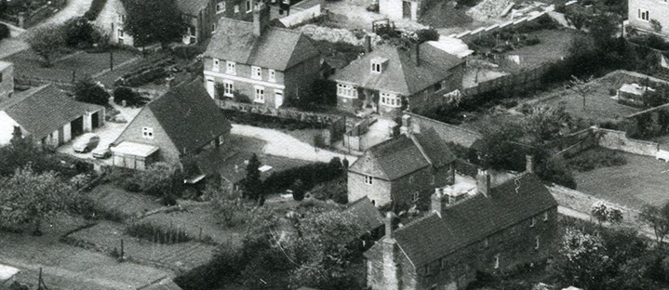
The above section of a 1960’s aerial photograph illustrates the size of number 9 (middle left) as at that date. It also illustrates the two redbrick 1920’s ‘Industrial cottages’ immediately above it, together with the 1930’s bungalow, 7 The Jetty (17th C and Listed) middle right, and right below that, the three ‘workers cottages’ of around the 1880’s.
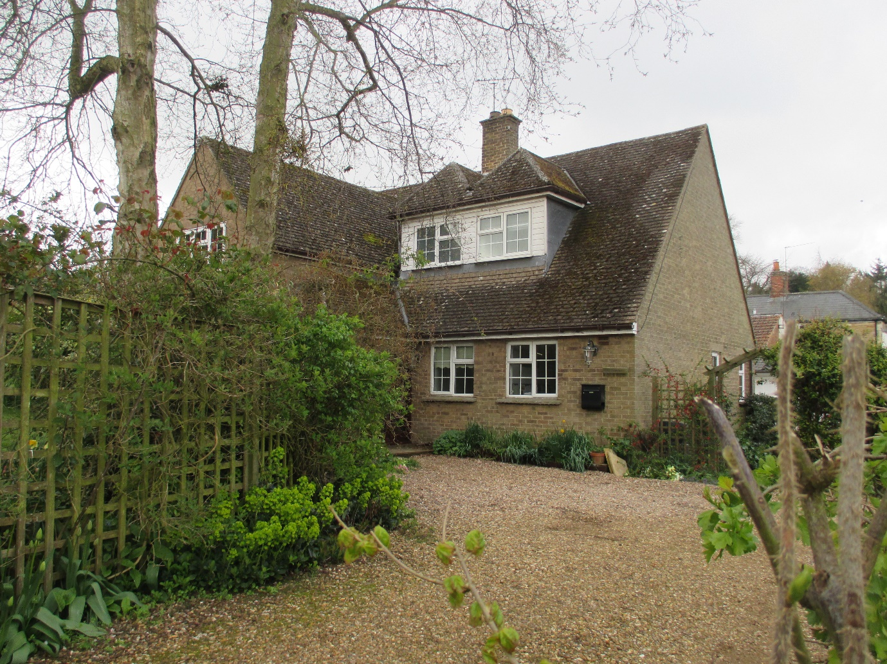
Number 9 The Jetty is a large infill property, that began life as a smaller property dating to the 1930’s/1950’s and has been extensively remodelled and extended some time ago. It is constructed in grey/sand coloured bricks with a plain tiled roof which approximates in colour to the Collyweston stone on Wing House. There are two large and unusual coexisting/tandem dormers with hipped roofs, and partly wooden panelled facias. The dormers are wholly within the roof space, and similar in design to dormers deployed at Wing House in smaller scale and the large lantern dormers used at 3 Church Street.
The fenestration is modern with a rectangular two light six pane configuration and thin glazing bars, but the top-hung quarter opening lights slightly undermine the vernacular emulation.

4 The Jetty
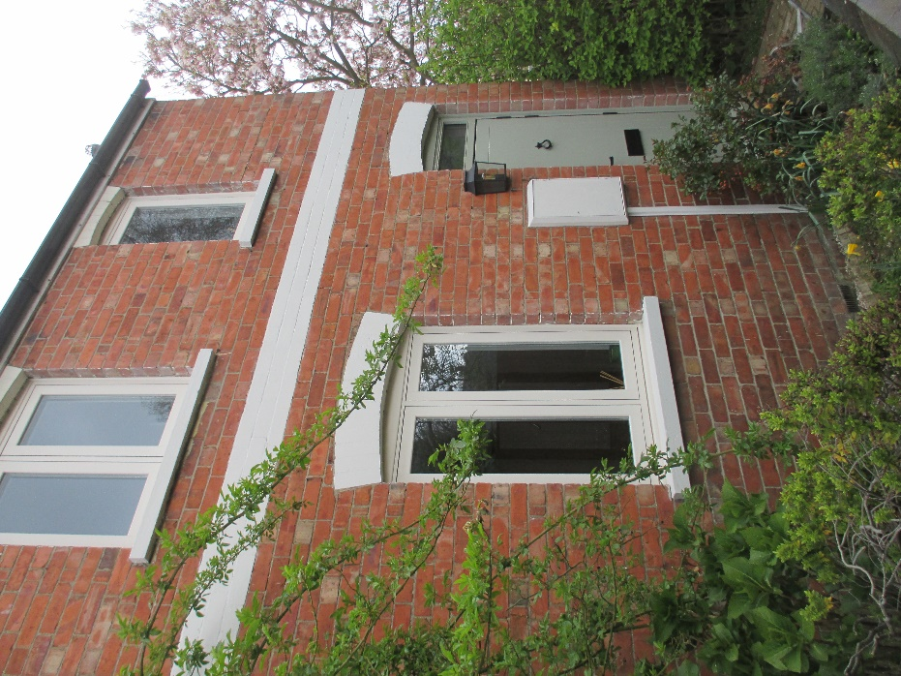
4 The Jetty retains its red brick, slate roof, early 20th Century identity but has been modernised and extended at rear ground floor level in the last year or so. The fenestration choice is modern, two light casement pattern.
2 The Jetty, Greystones

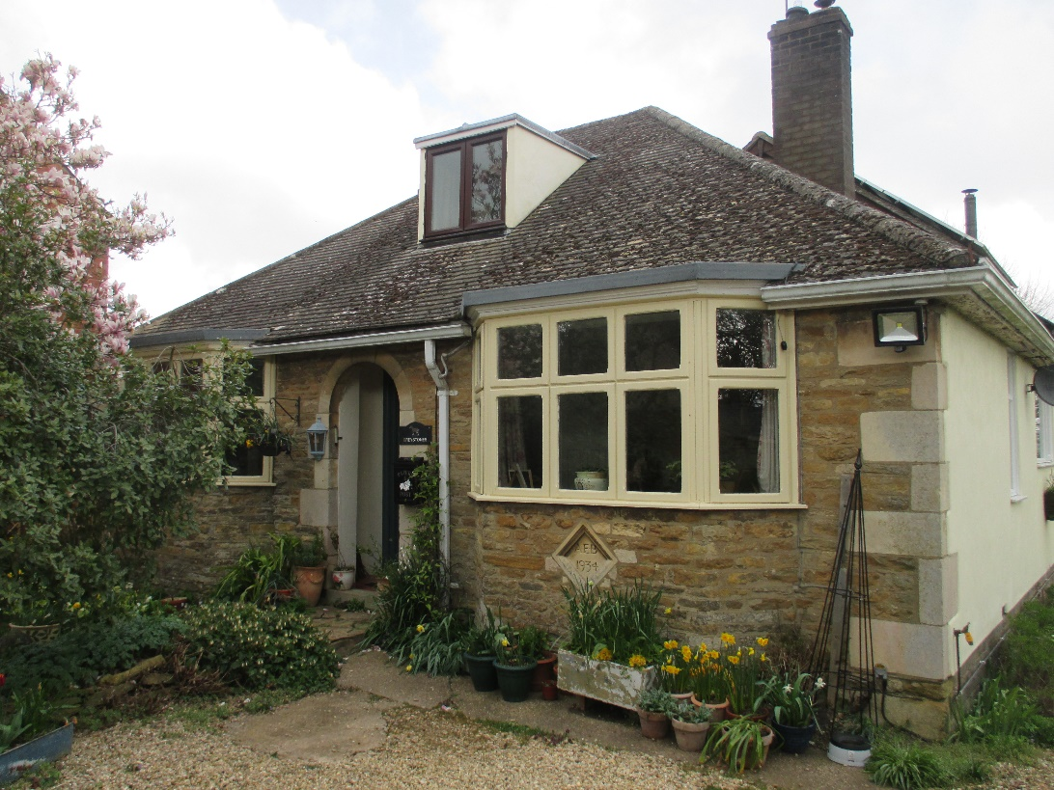

Greystones was built in 1934 in brick but may have subsequently been faced in limestone blocks, possibly in the 60’s, with ashlar quoin stones and ashlar detailing around the front porch.
It has a datestone ‘1934 AEB’ for Amos Baines, modelled on another for ‘1694 AW’, the latter reputedly from a previous building on the site which might have been the house shown as being demolished in the 1960’s aerial photograph on page 78 above.
The bungalow roof is constructed of plain tiles and there are two projected flat-roofed bays extending beyond the eaves, possibly because of the stone facing related extension to the front wall and there is a flat-roofed dormer. The chamfered fenestration is of the 60’s era.
The property in recent years has been considerably remodelled and extended at the rear, taking advantage of its large garden plot and northerly aspect towards the Chater Valley.
1, 3 and 5 The Jetty
It is difficult to decode 1, 3 and 5 The Jetty.
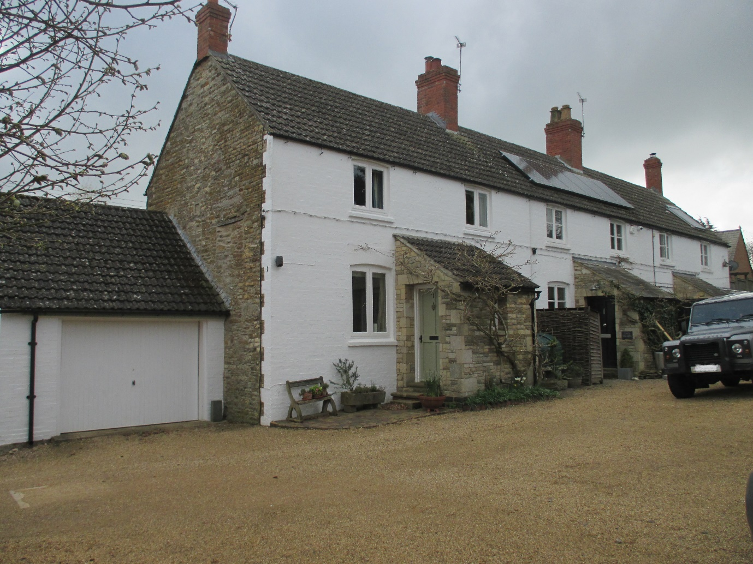
The northern gable end is constructed of rough-hewn limestone blocks with some ironstone and looks as if it once had a window at an earlier stage and some form of smaller attached building at another stage. There is a rough date stone in this gable, indecipherable from the ground. The stone type/formation looks like Mid-19th Century, dating it to the Sheild period of house building around the village and they were once three cottages. The gable end garage is later as are the three stone front porches. All the roofs are low arched interlocking pantiles of much later date, possibly the late 1940’s.
The most puzzling elements are the rear wall, facing east, and the cottage building frontages, which are on the western side. The rear wall is built of very regular limestone and ironstone blocks, which almost certainly date to the late 19th Century and the Worrall period of cottage building around the village. This wall has ironstone quoins. The front wall, on the other hand, is constructed of painted bricks, particularly evident on the painted quoins. The pattern of brick quoins into the stonework front corner is often associated with tying one wall into another. So, it may be that there was an existing stone gable wall that the newer ironstone (back wall) and brick cottages (front wall) were built off, suggesting late 19th/early 20th Centuries.
The chimneys are in red brick, suggesting the 1930’s.
The fenestration is modern with number 1 having a modern rectangular two light casement pattern, with low arched brick headers, and numbers 3/5 having a glazing bar to produce four square panes within a two light rectangular casement with low arched brick headers more consistent with the local vernacular.

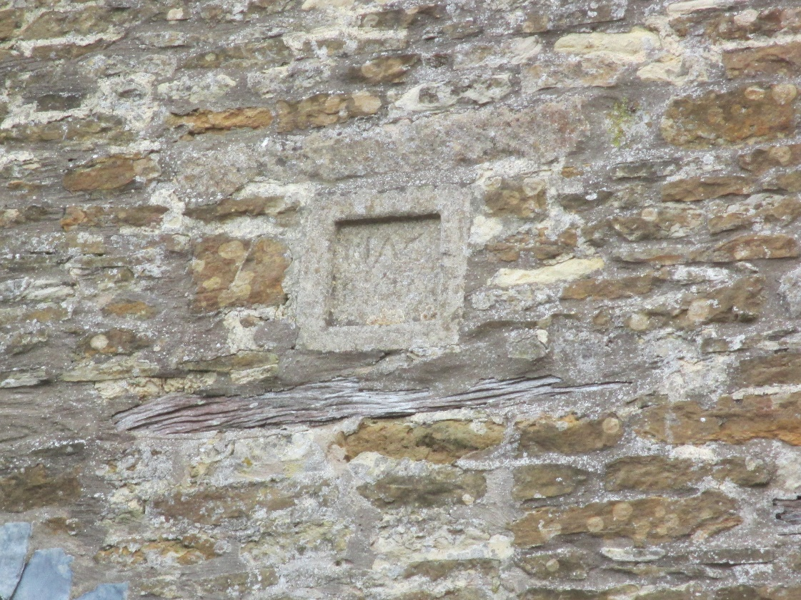
There is a limestone and glass extension to the back of number 1 which is 21st Century and a good example of blending new extensions with older buildings.
From the standpoint of the ‘setting’ the cottages constitute Local Heritage Assets and it may well be that their age and history dictate that too.

Outlying Residential Properties in the Parish West of the Village
There are two outlying residential clusters on the western side of the village, within the Wing Parish boundaries but outside the Conservation Area and outside of the village Area of Permitted Development. The first is at Preston Road from Wing Hill, and the second at Wing Hollow, Station Road at this point, on the Manton Road from Wing Hill.
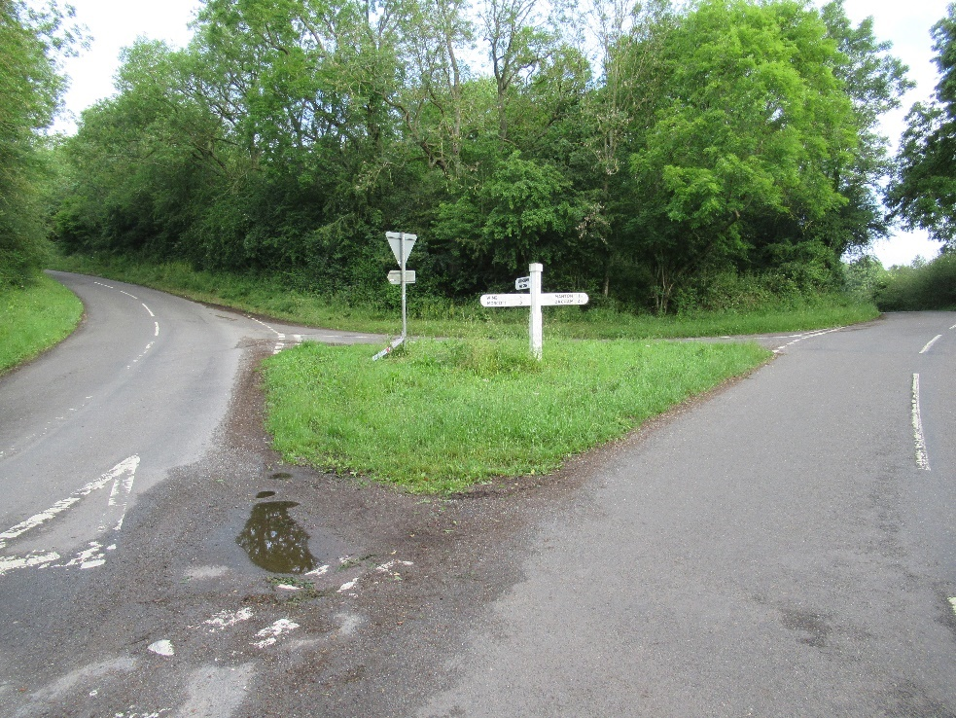

Preston Road
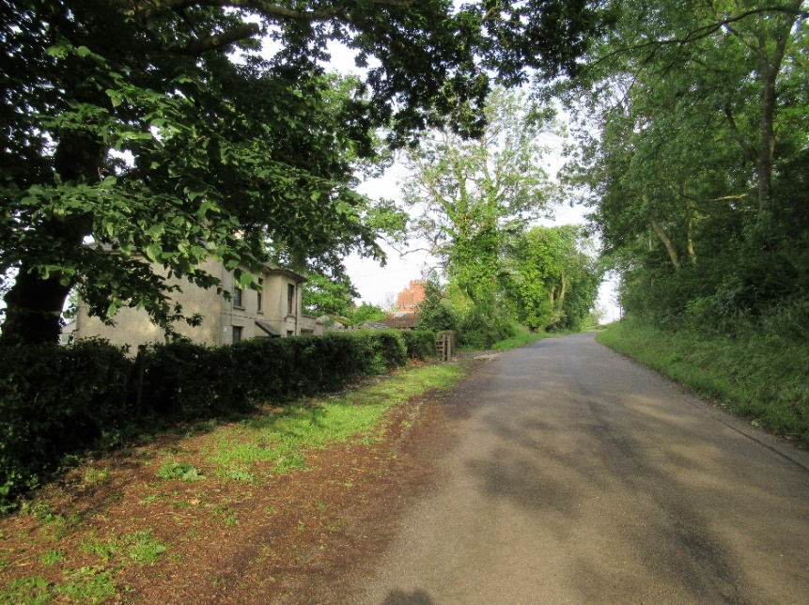
The Cottage, Preston Road, Wing Parish

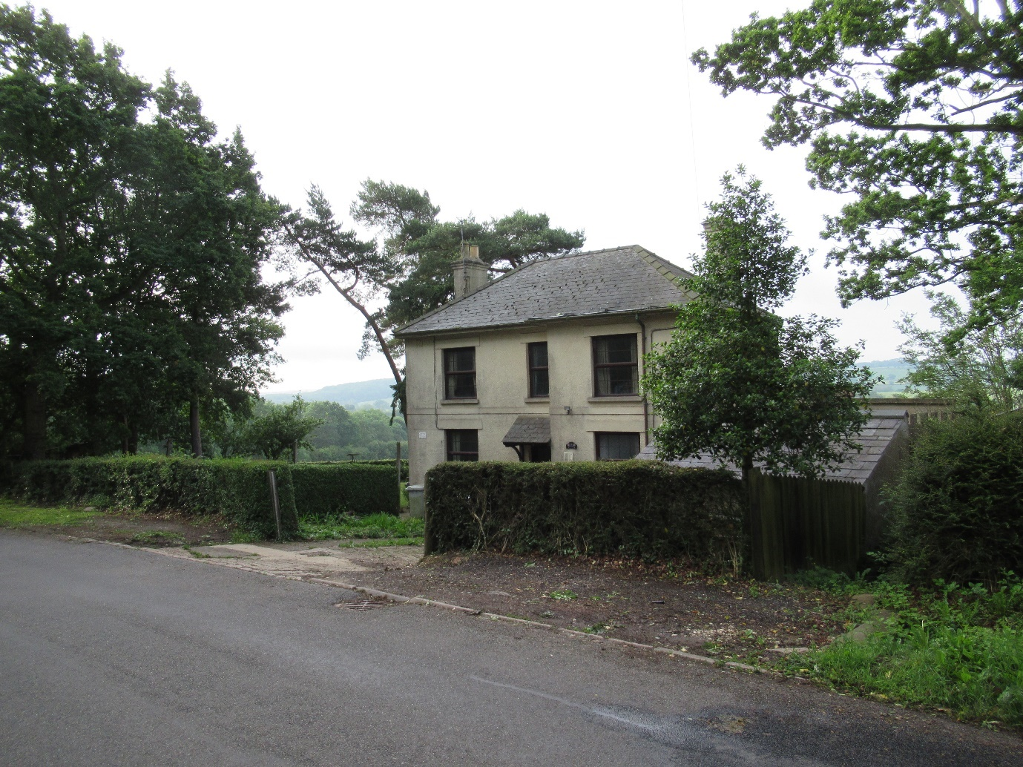
This house in its rather ‘camouflaging’ grey rough render, grey slate tiles and brown fenestration, gives little away concerning its origins. Wing Grange, (see below), next door to The Cottage, was a unique exploration in brick for Wing, built in 1888 by Robert Neil, the building contractor son of Sir William Henry Neil, who was a business man and a Director of the Midland Railway Company which built St. Pancras Railway Station, the son using some of the same decorated brickwork on Wing Grange.
This history and its name, which begs another identity, might suggest that The Cottage, Preston Road, was built at the same time and in brick. Its restricted landholding doesn’t suggest that it once stood as an independent farm. The middle banding, running around the house, might be a plainer but decorative brick string course as obtains at The Grange. The Cottage window openings and reveals are consistent with the shape and depth of the square, multi-paned, balanced sash windows of that period. The present fenestration looks like a modern simulation of that glazing bar style and the window lights are either sashes or large top hung opening lights to simulate sashes when closed. A similar hipped roof, outside Wing Village, obtains at Cromwell Farm House (Listed). There is a list of those obtaining inside the village boundary at the entry for 16 Middle Street above.
The Cottage enjoys a tremendous view across Wing’s southern valley and the rising woodland up to the Glaston ridge.

Preston Road, Dove House

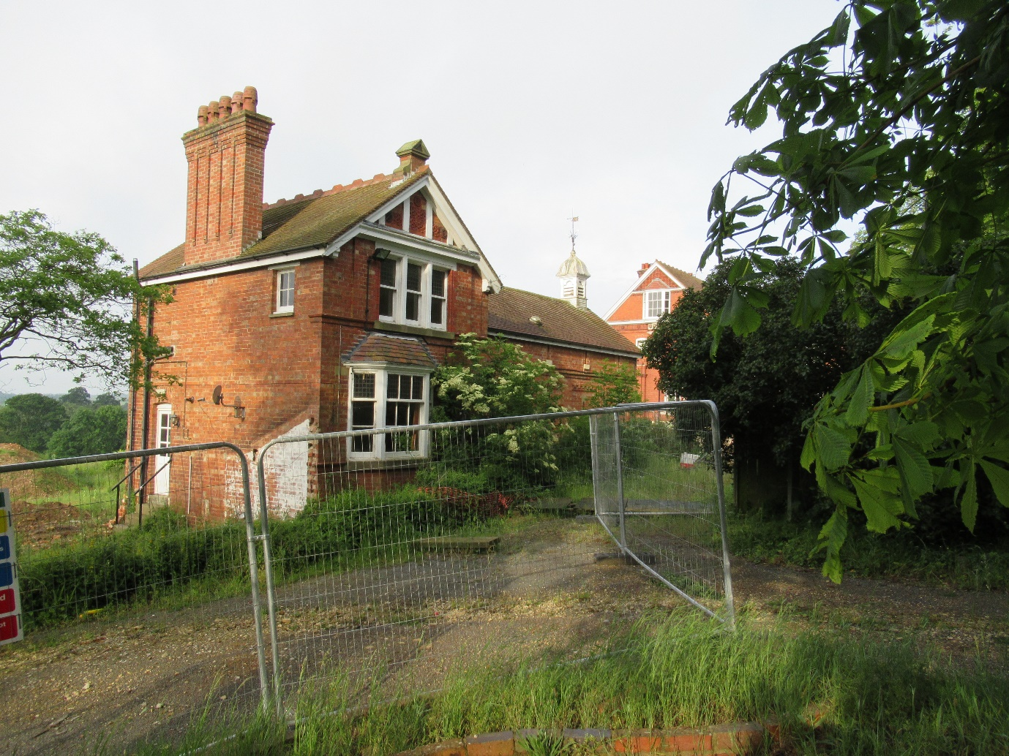
Dove House, Preston Road was historically part of Wing Grange (see below), and the once single ownership has been divided. The surrounding buildings, mainly subsequent farm buildings, have been demolished, but there is a new planning approval that will see Dove House retained as the gymnasium and swimming pool for the new house, yet to be constructed. The new house is intended to use brick along its single storey Preston Road frontage in empathy with the remaining brick structures of Dove House and to be two storeys high on the south side with a great deal of glass.
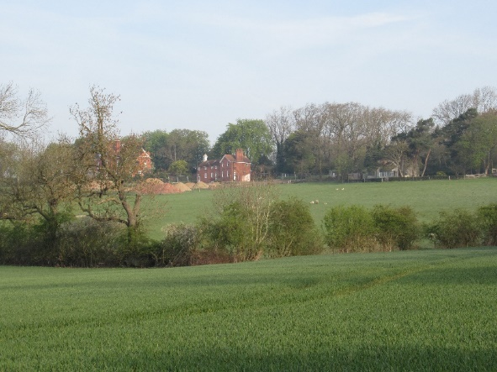
The photograph, left, shows the view of Dove House, centre, and The Cottage in the trees, right, from the nearest road in the south without using a telephoto lens. Wing Grange is behind the tree on the left

Wing Grange, Preston Road
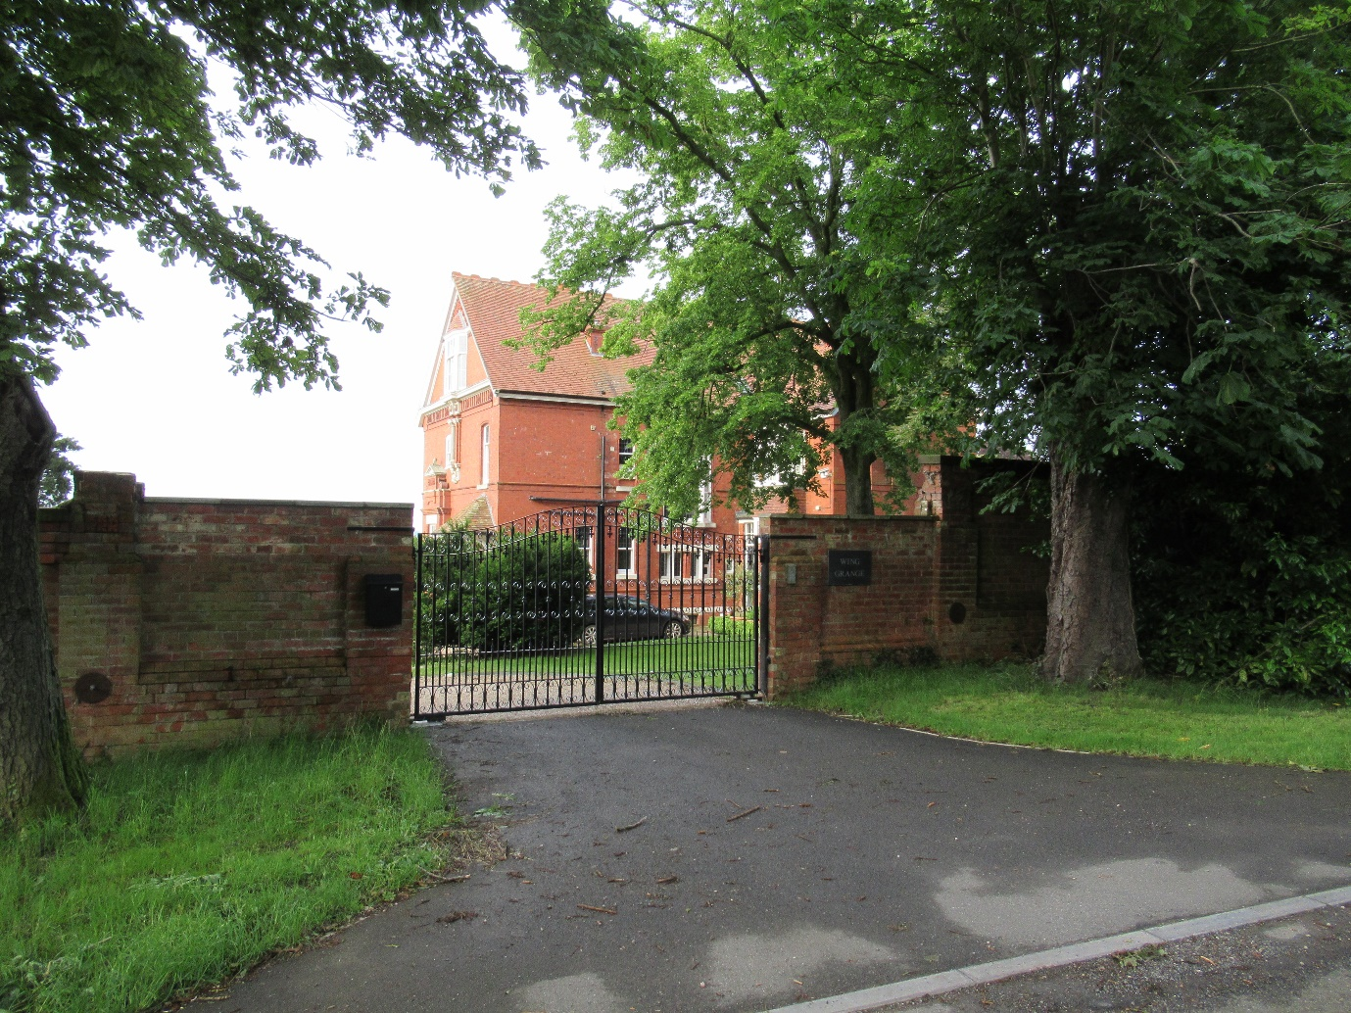
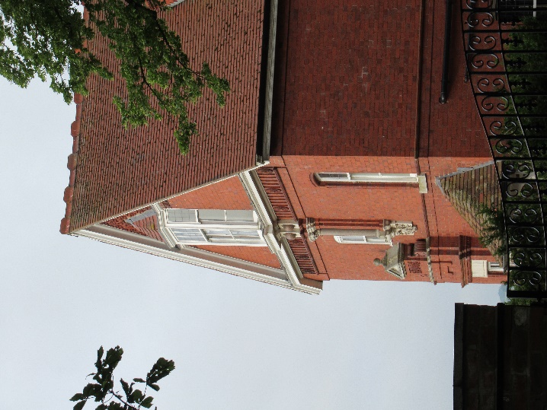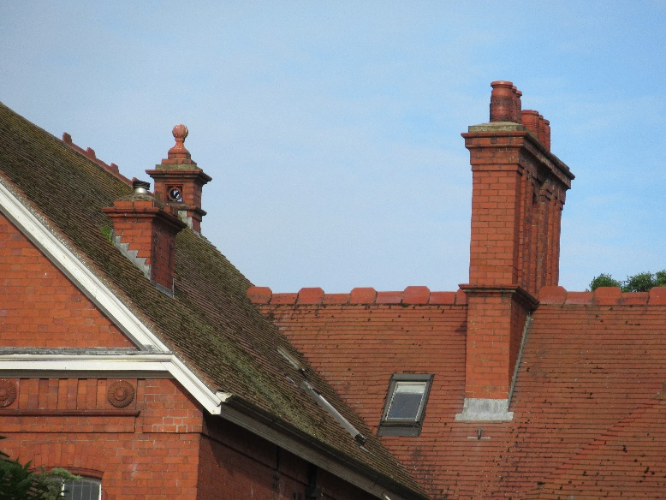
Wing Grange (above) as it is today – entrance and some of the architectural detail on what is a complex and historic non-Listed building. Below, Wing Grange in the 1930’s. One can only speculate as to why this building was never Listed.

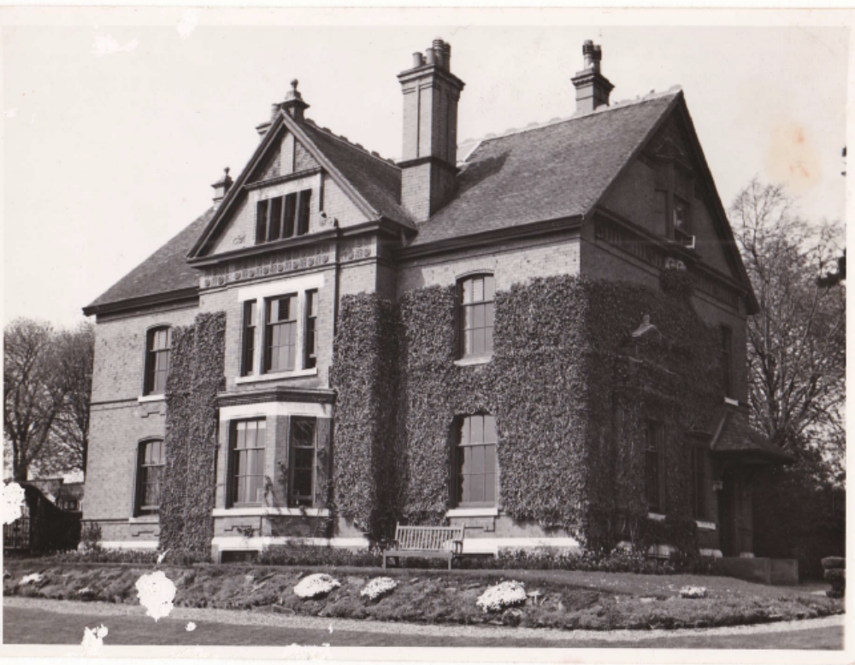
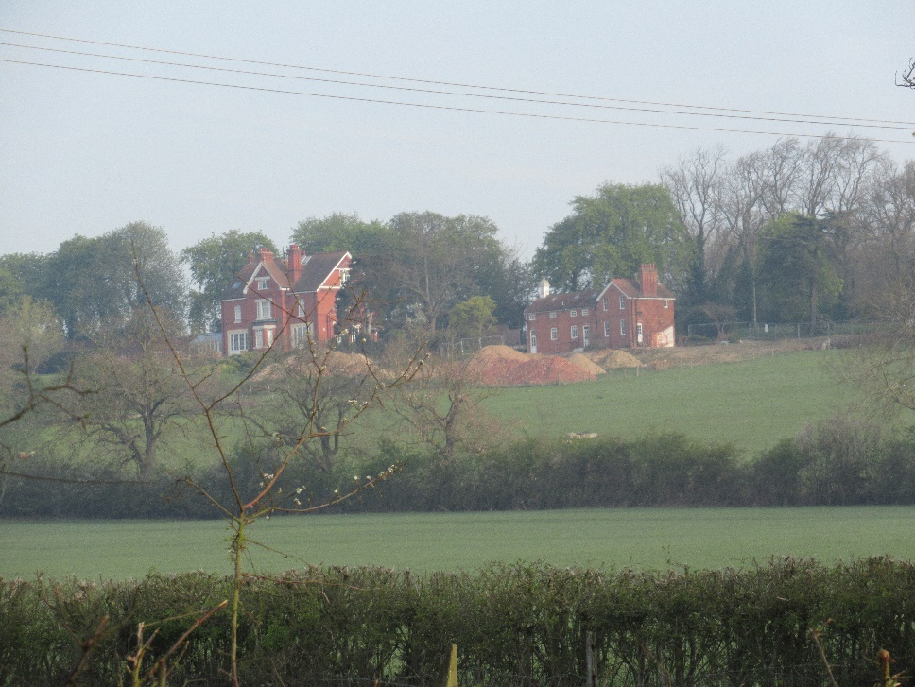
Above, Wing Grange and Dove House, using a telephoto lens from the nearest road on the south side.
Wing Grange was built and occupied, as stated above, by Robert Neil in 1888. It was the first major building in Wing Parish to be built in red brick. William Neil, Robert’s father, was a Director on the board of the Midland Railway and was concerned with the construction of St. Pancras Railway Station from which The Grange draws some of its architectural and building resources. See the brick and terracotta tile detailing on the east and south elevations. Both men in time were Rutland Sheriffs.
Subsequently, The Grange was acquired by Miss Sylvia Brocklebank OBE, who was the daughter of a shipping magnate, Sir Thomas Brocklebank, and she lived at the Grange from 1916 until her death in 1962. She was co-founder of the Women’s Land Army during the first World War, used Wing Grange for the convalescence of soldiers during that same war, was a JP, President of Rutland’s Agricultural Society in 1949, won national awards for pedigree cattle and the handling of horse drawn carriages, and was the first President of Wing Women’s Institute. Her circle of friends, well known magnates in shipping and railways, help to explain the Manton Station being a station stop on the mainline that connected London and Liverpool.
Much later the property became a Resettlement Unit for ex-offenders, which might explain why it wasn’t scheduled for Listing in RCC’s 1984 ‘Listing sweep’ of Wing. After closure it was sold in the 21st Century to be returned to individual residential use.
The history and detailing; bricks, fenestration, roofing, terracotta tiles, relief patterns, cupolas, door headers, eaves and chimneys, together with the emblematic change in the limestone vernacular, taken in conjunction with the St. Pancras connection all suggest that these buildings, The Grange and Dove Cottage, should be Listed and must constitute Local Heritage Assets.

Wing Hollow, Station Road
Taking the right fork in the road at the bottom of Wing Hill and keeping right leads to Wing Hollow on the Manton Road but called Station Road at this point.
Just before the River Chater in the bottom of the valley there is a small settlement, characterised by Cromwell Farmhouse on the left (Listed and formerly the Railway & Crown Bridge Inn) which had a local reputation for rowdy and drunken railway workers, many of whom were transient construction workers, digging cuttings, excavating tunnels, building bridges and laying new tracks, whilst living in camps along the line of construction, from the mid 1800’s to the turn of the century.
As already mentioned, Manton had a station, located just on the northern side of the valley, just outside Wing Parish, a few hundred yards from Cromwell Farmhouse, Manton Junction also had busy shunting yards well into the 20th Century.
On the right hand, eastern side, of the road, there is a cluster of four houses. These houses were originally ‘railway cottages’, probably built for the permanent railway workers employed at the Station and shunting yards. They originally numbered six cottages with ‘two up two down’ rooms of the period, often with a back ‘lean to’ that housed the tin bath. They were all built of common red brick and have slate roofs, again of the period. They now number four houses in total, one having been extended in a southerly direction, essentially replicating its size and has also extended the ground floor frontage.
A second has also extended its frontage and has painted brick at the first floor.
A third appears to have converted two cottages into one and a fourth appears to have done the same and is also now rendered.
There are also several rear extensions.
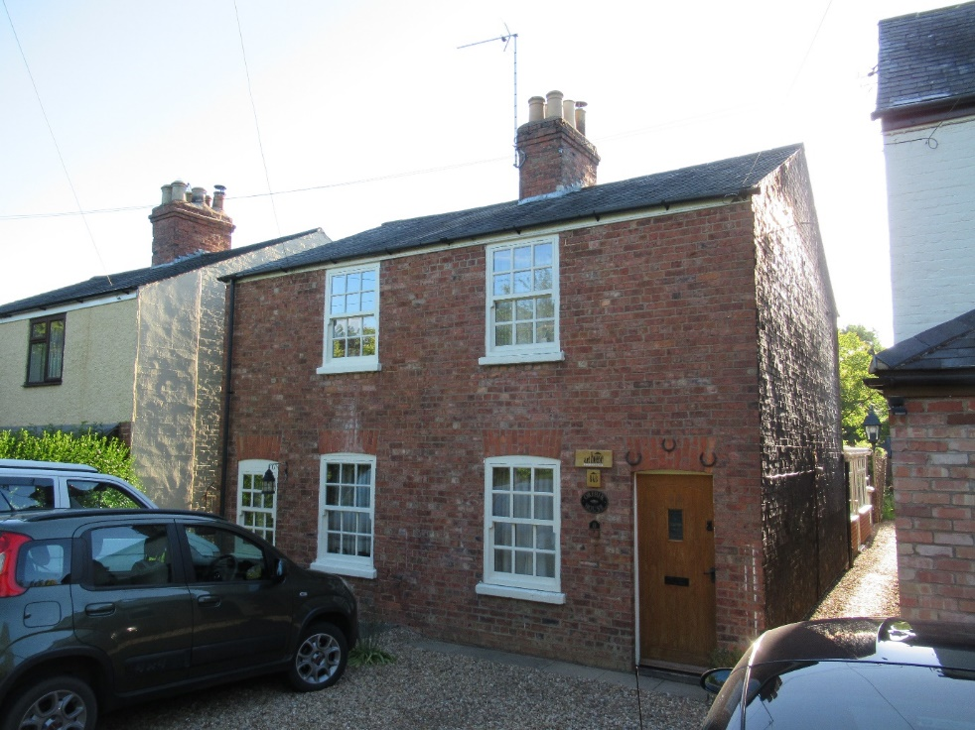
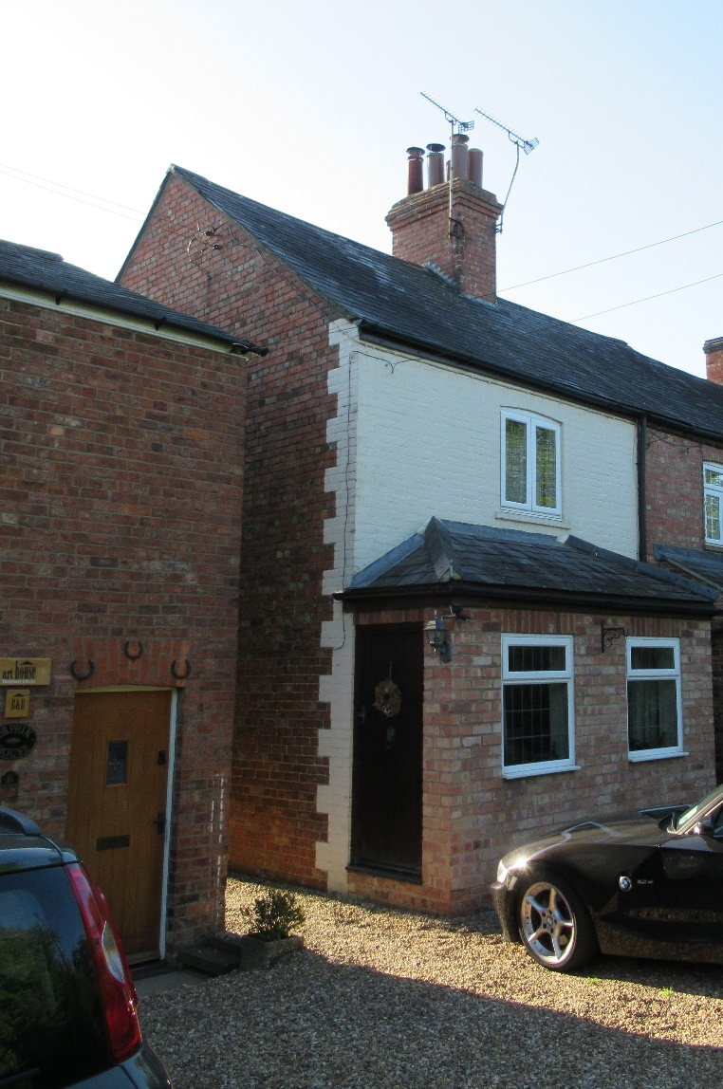

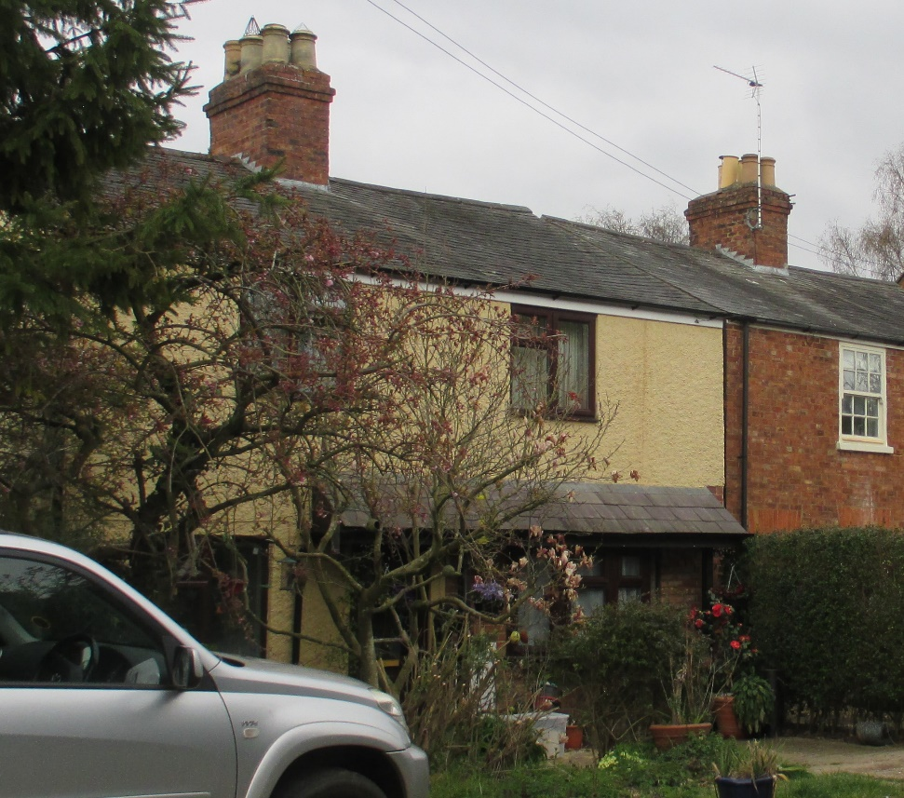

The embryonic nature of the architectural changes has led to an eclectic mix, some fenestration, for example, staying closely to the vernacular style of the period, whilst others have moved to a later modern style, while another has mixed the styles. The interesting thing here is that ingenuity seems to reflect the Rutland motto – ‘Multum In Parvo’ – much in a little, a great deal in a small space. The reality on the ground is that in relation to these properties, in this location, it works!

Conclusions
This last example is an important lesson for the up-coming document ‘Wing Parish: A Design Guide’, which will be a distillation of the Directory of Listed Buildings, the Directory of Non-Listed Buildings, and the pertinent comments made by local residents in the Neighbourhood Plan Wing Village Questionnaire, and as thereby reflected in the Neighbourhood Plan Steering Group Housing Policy Statement.
‘Setting’ is the most important factor. If there is a heavy density of Listed Buildings in a street, then their characteristics should predicate the design considerations of any infill development. In other streets there might be a heavy density of Local Heritage Assets in which case their characteristics should come into play in respect of infill development. In streets with modern or relatively modern architecture then the characteristics of any infill need to be derived from the best of their characteristics, perhaps with architectural references or allusions to some of the older village characteristics. But there needs to be space for change and innovation on appropriate sites. Wing Grange, for example, broke with the architectural history of limestone and might have ‘grated’ against the thematic nature of say upper Church Street and yet had something quite new and invigorating to contribute at the end of the 19th Century in the ‘setting’ chosen. Similarly, in the 21st Century, 5A and 5B, Top Street would not have been appropriate in Middle Street but do bring something quite dynamic to the open spaces that they command, whilst in certain respects etching their modernity with some characteristic aspects of the limestone past.
Fundamentally changing some of the older buildings is another question. Here there needs to be a considerable amount of care taken to ensure the protection of commonly shared resident values regarding that sense of the village environment being fostered by its history. The operation of the present Conservation Area appears arbitrary in that regard and requires redefining, both geographically and in terms of its objectives.
New development outside of the Conservation Area appears to have been architecturally haphazard, neither achieving full vernacular symmetry, nor exploring innovation within agreed and promoted norms/objectives. In addition, the strictures of the defined permitted area of village development, within which infill space availability has been pretty much used up without marked intrusion into the ‘settings’ of the Listed Buildings, argues for redefining that area and subordinating any new small areas for expansion and development to a well-defined Design Guide. Such Design Guide needs to be agreed by local residents, and Rutland County Council, as a precondition within the Neighbourhood Plan for any future planning approval.

David Seviour
22/08/2019

Sources
Historic photographs from Parish Diary Records transcribed by Charles Gallimore 2017 and photographs digitised by David Seviour.
Some other historic photographs from Parochial Church Council parish records, courtesy of Jane Peach and digitised by David Seviour.
Historic photographs of Top Street and aerial photographs from the 1970’s, Tom Roberts, and digitised by David Seviour.
Historic photograph 2 to 6 Top Street with cyclists, ‘The Villages of Rutland’ Rutland Local History Society Vol 1.
Aerial Photographs of Wing 1960’s, Farmer’s Weekly Competition, digitised and reworked by David Seviour.
Peter Tillotson, archival photographs of 13 Middle Street.
All contemporary photographs Alison Seviour (with one or two exceptions by David Seviour).
Rear/side view of Stable Cottage, Reeves Lane, Wendy Dalton.
All the material – textual and photographical, is subject to copyright individually and collectively through David Seviour and his sources.
The map at Appendix I is reproduced by courtesy of Rutland County Council and the map at Appendix II by courtesy of RCC under their Crown Licence.
I am indebted to:
Alison Seviour for all her hard work in capturing contemporary photographic images,
Sydney R. Jones, ‘The Village Homes of England’, edited by Charles Holme. 1912 and 1995,
John & Jane Penoyre, ‘Houses in the Landscape: A Regional Study of Vernacular Building Styles in England and Wales.’ 1978,
R.W. Brunskill, ‘Vernacular Architecture: An Illustrated Handbook’. 2000 Edition,
Those residents who provided me with further information about their homes and those who provided constructive critical comment at the drafting stage.
In the event of any queries contact David Seviour, davidseviour33@gmail.com
Footnote
Six Non-Listed houses do not appear within this Directory for Wing Parish because their owners requested their removal at the consultation stage regarding their respective draft entries and they have been removed out of courtesy.
The decision to take fresh contemporary photography, rather than relying on Google Earth satellite mapping data, 2019, and Google Street-View website photographic imaging data 2009 and 2016, was based primarily on this being a better means of capturing images of properties within their respective ‘settings’ for use within a proposed Wing Village Design Guide and the need in that regard to ensure copyright control.

Appendix I

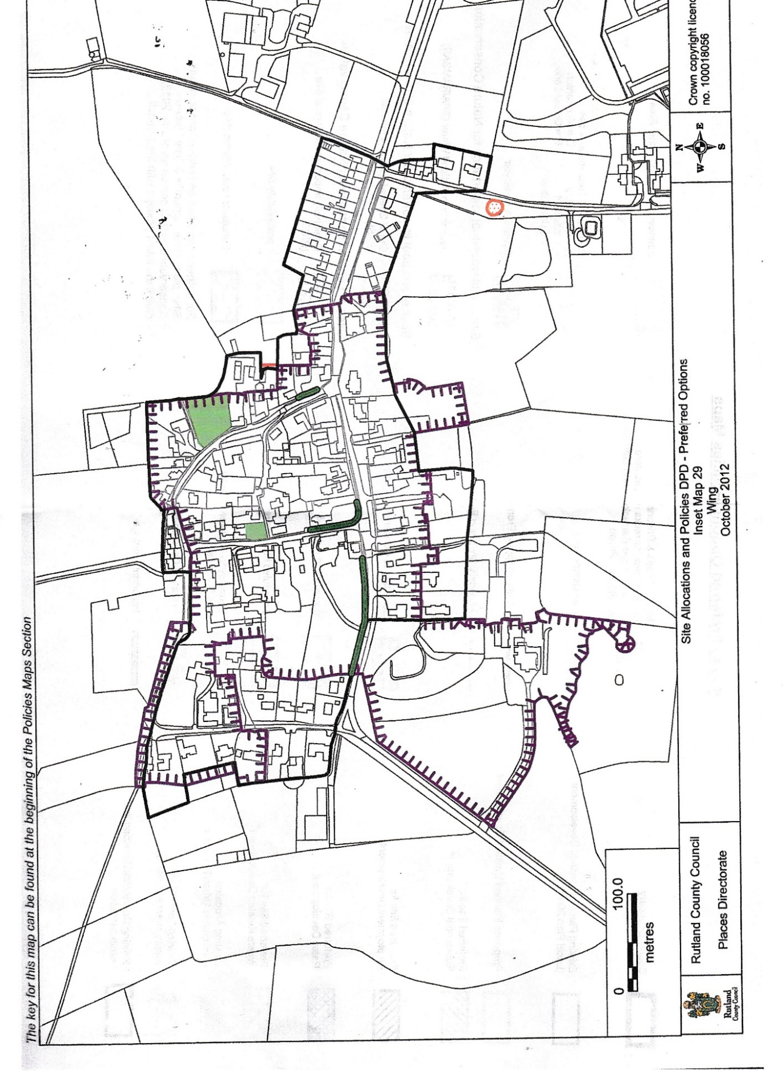
Appendix II
